**Core Java**

* **Java:**
  + Java is made by Sun Microsystems in 1995 and later on bought by Oracle and currently Java trademark is held by Oracle. Java is updated every 6 months.
  + Java is mainly used for Mobile development, Web development as well as Enterprise applications. Kotlin, Scala, Groovy come under java technology. Java is the most readable language, we can read code line by line and it is easy to understand.
  + Java has multiple features such as **WORA (Write Once Run Anywhere), multiple thread, Collection API concept, Exception handling and many more**.
  + Java is an object oriented programming language, so it means everything should be in an object and to create an object we need to have a class.
* **Setup Java Environment:**
  + **IDE:** To write Java, we can use Notepad and WordPad for simple programming but to work with java professionally, we can use different **IDEs(Integrated Development Environment)** such as **VS Code(Light weight editor), Eclipse and IntelliJ,** where we can type the code, compile the code, run the code and debug the code.
    - **VS Code URL:** [**VS Code**](https://code.visualstudio.com/)
  + **Compiler:** To compile the java code, we need to install **JDK (Java Development Kit)** 
    - **JDK URL:** [**Oracle JDK v24**](https://www.oracle.com/java/technologies/downloads/%23java24)
  + Once we complete the installation of IDE and JDK, to verify it, we can run “**JAVA --VERSION**” command to “**CMD**” and it will give you version of Java and JDK installed to the system also by running “**JAVAC --VERSION**” to get the current version and confirmed that compiler installed correctly.



* + While we check the versions and if we get an error then it means that path for java environment has not set up very well.
  + To set up environment variables, follow the following steps:
    - Start > Search “**Edit System Environment Variables**”
    - It will open below window, click on “Environment Variables”.



* + - * Select “path” and click on “**Edit…**” button under “**System variables**”



* + - * Click on “**New**” and add “**C:\Program Files\Java\jdk1.8.0_161\bin**” path or copy the path of **“…\Java\jdk1.8.0_161\bin**” then click “**OK**”.



* + - * Click on “**New…**” under “**User variables for…**” then add below values, and click on “**OK**” and “OK” for main window:
        + **Variable Name:** JAVA
        + **Variable value:** “**C:\Program Files\Java\jdk1.8.0_161\bin**” path or copy the path of **“…\Java\jdk1.8.0_161\bin**”



* **How Java Code Works on Backend:**
  + Java have JVM (Java Virtual Machine), using that we can run java application.
  + Under JVM there is OS (Operating System) comes and under that there is HW (Hardware).
  + Java is a platform independent, means when we write a Java code, it will run on any machine. Only this is required for it is that respective machine need to have JVM.
  + **JVM does not understand the Human readable code or instruction, but it accept only BYTE code. So, to convert this java code into Byte code it uses “Java Compiler”**
  + So, the basic flow is,
    - **Users create Java code > javac compiler compiled code to BYTE code > BYTE code goes on JVM > JMV look for “public static void main(String args[]” syntax to execute the code**.
  + In the real time scenario, there are 100s of files in the java project, so JVM starts with the first file/Main method file or file which contains main method file.
  + While running java code, it also requires some libraries and in java JRE (Java Runtime Environment) fulfill this request. Also, JVM is the part of JRE. JDK is only use by developers.
  + Main method contains one specific signature **“public static void main(String args[])”**

**(NOTE: In java there is only one Main method and only one file which have main method from where java code starts the execution.)**



* + As java follow WORA (Write Once-Run Anywhere), once developer develop application using JDK, and to use that application to other machine, we just have to install JRE and JVM (JDK does not required), and we can easily execute the code at any platform/OS.
* **Java Code Basic Code Structure:**
  + Java code file extension is **“.java”.**
  + Java code execution point is Main method of java where **“public static void main(String args[])”** main method comes.
  + To compile the code use **“javac FileName.java”** and it will create **“.class”** file.
  + Run code use **“java FileName”** command.
  + Java Basic Code Syntax:



* **Java Variables:**
  + Variables are used to store values, which can be either provided by the user, predefined or assigned during the runtime.
  + **If we define variables in class called instance variable.**
  + **If we define variables in the methods call local variable.**
  + **To define values in java, follow below syntax:**
    - DataType VariableName = Value;
    - **The value of variables also called LITERALS.**

**(NOTE: equal to ‘=’ is the assignment operator. It will take the value form right side and assigned to left side in variable.)**



* **Data types in Java:**
  + **There are 2 types of data types in java:**
    - Primitive data type
    - Non- primitive data type
  + **List of Primitive data type:**
    - **Integer**: Stores values without decimal point (0-9)
      * **Subtype of Integer:**
        + **byte**: supports 1 byte.

**Range**: -27 to 27-1 (-128 to 127)

* + - * + **short**: supports 2 bytes.

**Range**: -32,768 to 32,767

* + - * + **int**: supports 4 bytes.

**Range**: -2,147,483,648 to 2,147,483,647

* + - * + **long**: supports 8 bytes.

**Range**:-9,223,372,036,854,775,808 to 9,223,372,036,854,775,807

**(Note: While define, need to add “l” at the end of value.** Ex: long l = 12356l;**)**

* + - **Float**: Stores values with decimal point (0.0-9.0)
      * **Subtype of Float:**
        + **float**: supports 4 bytes.

**As Java define double as a default datatype, and we want to define float data type variable then we need to add “*f*” at the end of the value.**

**If we do not add “*f*”, then it will consider as double data type.**

**Ex:** *float fl= 5.6f;*

* + - * + **double**: supports 8 bytes.

**(Note: While defining decimal value variable, by default java supports “double” data type because while doing calculations, double data type store longer digits after decimal point then float.)**

* + - **Character**: Stores only single character (A’, ‘b’)
      * **Subtype of Character:**
        + **char**: supports 2 bytes.
        + **To define a character data type, we need to define value between single quotes (‘H’) because double quotes (“”) are only for String data type.**
        + **Also character data type stores only one single character.**
    - **Boolean**: Stores only either “**True**” or “**False**”
      * **Subtype of Boolean:**
        + **boolean**: supports 1 bit.
        + **In other programming languages, the values of boolean data type is 0 for false and 1 for true but in java the values are “True” or “False”**

**(NOTE: IF WE TRY TO STORE OUT OF RANGE VALES TO THE SMALL DATATYPE THEN IT WILL THROOW AN ERROR. FOR EXAMPLE, AS BYTE STORE (-128 to 127) RANGE AND IF WE STORE “129” IN IT, THEN IT WILL THROW AN ERROR.)**

* + **In integer data type, if we have long numbers, then we can add underscore (_) between the numbers while defining the values.**
    - **Ex: int num = 10_00_00_000;**
      * **Output = 100000000;**
  + **If we define a alphabet into the character data type then we perform the addition or subtraction operation, it will simply change the alphabet value**
    - **Ex: char c = ‘a’;**

**c++;**

* + - * **Output: b**



* **Data Type Conversion in Java:** *Small -> Large*
  + In java there are two techniques to convert a variable from one data type to another.
    - Type Conversion
    - Type Casting
  + NOTE: We can not perform conversion/casting from char to Boolean datatype, it only supports in the range of numerical conversion between byte to double data type.
  + **Type Conversion:**
    - Convert small data type into large data type without any data loss.
    - It is also known as **Implicit Casting** or **Widening conversion**.
    - Order of implicit conversion:
      * **byte -> short -> int -> long -> float -> double**
    - Example: Converting integer data type to double data type.
    - This type of conversion happens automatically because there is no risk of data loss.



* + **Type Casting:** *Large -> Small*
    - Manually converting a large data type into smaller one.
    - It is also known as **Explicit Casting** or **Narrowing Conversion.**
    - It does not convert automatically because it leads to data loss.
    - Order of Explicit Casting:
      * **double -> float -> long -> int -> short -> byte**
    - Example: converting double data type to integer data type.
    - Syntax:
      * Big DataType Variable = Value;

SmallDataType VariableName = (SmallDataType) Value/BigDataTypeVariable;



**NOTE: Here in this example, we lose 0.99 after converting double to integer value.**

* **Assignment Operators:**
  + List of Operators:
    - Arithmetic Operators
    - Relational Operators
    - Logical Operators
  + **Arithmetic Operators:**
    - **Addition: +**



* + - **Subtraction: -**



* + - **Multiplication: \***



* + - **Division: /**



* + - **Modulus/Remainder: %**



* + **Relational Operators:**
    - Relational operators mainly compare two values or expressions. And it always returns Boolean result (true or false).
    - We can use assignment operator in IF…ELSE conditions, ITERATION LOOPS(FOR, WHILE, DO…WHILE).
    - **Equal to: ==**

**(NOTE: SINGLE EQUAL TO(=) USE FOR ASSIGNMENT OF VALUE WHILE DOUBLE EQUAL TO(==) USE FOR COMPARITION OF VALUES.)**

* + - **Not Equal to: !=**
    - **Greater than and equal to: > >=**
    - **Less than and equal to: < <=**



* + **Logical Operators:**
    - It is mainly used to combine multiple conditions and return a Boolean result (true or false).
    - **Logical AND: &&**
      * When we want all conditions to be true, we need to use the logical AND operator.
    - **Logical OR: ||**
      * When at least one condition among all conditions needs to be true, we use the logical OR operator.
    - **Logical NOT: !**
      * While using NOT operator whatever result we get, it will give opposite of it. For example, if we get the answer TRUE and use the ! OR operator, then it will give FALSE answer.



* **Conditional Statements:**
  + Conditional Statements are used to make decisions or execute a block of code based on certain conditions. It executes a specific block of code on whether a condition is true or false.
  + We can add multiple conditions in the single IF statement using logical operators.
    - EX.: if (x > 10 && x < 20)
  + **Types of conditional statements in Java:**
    - **if statement:**
      * There will be only one block of IF condition. If condition will true for that block the it will execute it otherwise it will move forward to other block.
      * Syntax:
        + if (Condition) { …. }



* + - **if…else statement:**
      * There will be only one and IF and one ELSE block of code. If condition true for IF block then it will skip ELSE block and complete the execution.
      * While condition false for IF block, then it will execute the ELSE block and complete the execution.
      * Syntax:
        + if (Condition) {

------------------

} else{

------------------

}



* + - **Ternary Operator:**
      * The Ternary Operator is a short-hand version of if-else statement.
      * It is used to assign a value based on a condition in a single line.
      * Syntax:
        + Variable = (Condition) ? Value_IF_True : Value_IF_False;
        + Condition = A Boolean expression like a > b, x == y
        + ? = Separates condition from true value
        + Value_IF_True = Value assigned if condition is true
        + : = separates true value and false value
        + Value_IF_False = Value assigned if condition is false
      * It is only use for simple IF-Else condition and mostly use to assign the values.



* + - **if…else if…else statement:**
      * If there will be multiple conditions need to check one by one then we can use IF…ELSEIF…ELSE condition block.
      * Syntax:
        + if (Condition) {

------------------

} else if (Condition) {

------------------

} else {

------------------

}



* + - **Nested if statement:**
      * A Nested if Statement means an if statement inside another if statement.
      * It is used when there are **multiple conditions** to check, and one condition depends on another condition.
      * Syntax:
        + if (Condition1) {

if (Condition2){

--------------------

}else{

-------------------

}

} else{

------------------

}



* + - **Switch statement:**
      * A switch statement is used to execute one block of code among many options based on the value of a variable.
      * It is an **alternative to multiple if-else-if statements** when you are checking the same variable for **multiple constant values**.
      * Syntax:
        + switch (expression/condition){

case value1:

//Code for execute for case value 1

break;

case value2:

//Code for execute for case value 2

break;

case value3:

//Code for execute for case value 3

break;

…. …. …. …. …. …. ….

default:

//Code for execute if none of the case match

break;

}



* **Looping Statements:**
  + Looping Statements are mainly used to repeat a block of code multiple times. Instead of writing the same code again and again, we can use loops.
  + For example, if we want to print numbers from 1 to 100, using a loop we can done this task withing few statements instead of writing same 100 print statements.
  + **Advantages of Loops:**
    - Reduce code duplication
    - Perform repetitive tasks like printing numbers, processing arrays, or reading input
    - Make programs more efficient and readable
  + **List of Loops in Java:**
    - For Loop
    - While Loop
    - Do…While Loop
    - Enhanced For Loop or For-Each Loop
  + ***for* Loop:**
    - For loop is mainly used when there is a number of iterations are known in advance.
    - For loop syntax first includes initialization, condition and increment/decrement in the single line then loop body will come.
    - **Syntax:**
      * for (initialization; condition; addition/subtraction)

{ //Code to execute }



* + - For “*for*” Loop, if we want to skip any of the components (initialization, condition or increment/decrement) we can write outside of loop and skip into the for-loop bracket.
    - Syntax:
      * Initialization;

for (; //Condition; ){

//Code to execute

Increment/Decrement;

}



* + ***while* Loop:**
    - While loop is mainly used when the number of iterations are unknown before execution, and the loop should be continued as long as condition is true.
    - In the while loop, condition is checked before executing the loop body.
    - So, it means that to execute the body of the loop, the condition must be fulfilled. Otherwise, it will not execute the loop body and move to the next statement.
    - While loop mainly use to read data from a file or read a data from the database because we don’t know what the exact number of characters file will be contains or don’t know how many lines of data will have in database. So, for this scenarios while loop is the best option.
    - Syntax:
      * Initialization; //If required

while (Condition){

//Code to execute

Increment/Decrement; //if required

}



* + ***do-while* Loop:**
    - Do while loop is similar to while loop but one major difference is in do-while Loop, first loop body will execute then check the condition.
    - This means that loop body will execute at least once, even if the condition is false.
    - **Syntax:**
      * Initialization;

do{

//Code to Execute.

} while (Condition);



* + **Enhanced for loop: (Introduced in Java 8)**
    - The enhanced *for-loop* is a simplified way to iterate through elements in arrays or collections like List, Set, etc., without using an index.
    - It only works with an Array and Array type of data.
    - In the normal loop, we use counter variable (i=1;) but in for-each loop we don’t need counter variable. It will iterate automatically till the last elements of it.
    - **Syntax:**
      * for (datatype variable : arrayName or collectionName)
      * Ex: int[] **numbers** = {10, 20, 30, 40};

// Enhanced for loop

for (int **num** : **numbers**) { SOUT(**num**); }

* + - **Example 1:**



* + - **Example 2:**



* + - **Example 3:**
      * We can also use “*Enhanced for-loop”* loop with array class.
      * Follow below syntax:

class ClassName{

datatype variableName;

…

}

class main{

psvm(String args[]){

ClassName classObject = new ClassName();

classObject.classVariable = value;

ClassName classArrayObject[] = new ClassName[ArraySize];

classArrayObject = classObject;

for(ClassName variable : classArrayObject){

SOUT(variable.classVariable);

}

}

}



* + - **Advantages of Enhanced for-loop:**
      * Clean and simple syntax
      * No risk of ***ArrayIndexOutOfBoundsException***
      * Best for read-only iteration
    - **Limitations:**
      * You **can’t modify elements** (e.g., remove items from a list during iteration)
      * You **don’t have access to the index** of elements
  + ***for-each* Loop Method:**
    - for-each Loop Method is part of the List<> Interface
    - In for-each() method, it will give you one value at a time and we can perform whatever operation we want on the element.
    - **It does not work with simple Array.**
    - It is only work with Collection framework or any class which implements the Iterable interface such as List, Set, Queue, Map, Streams, etc.

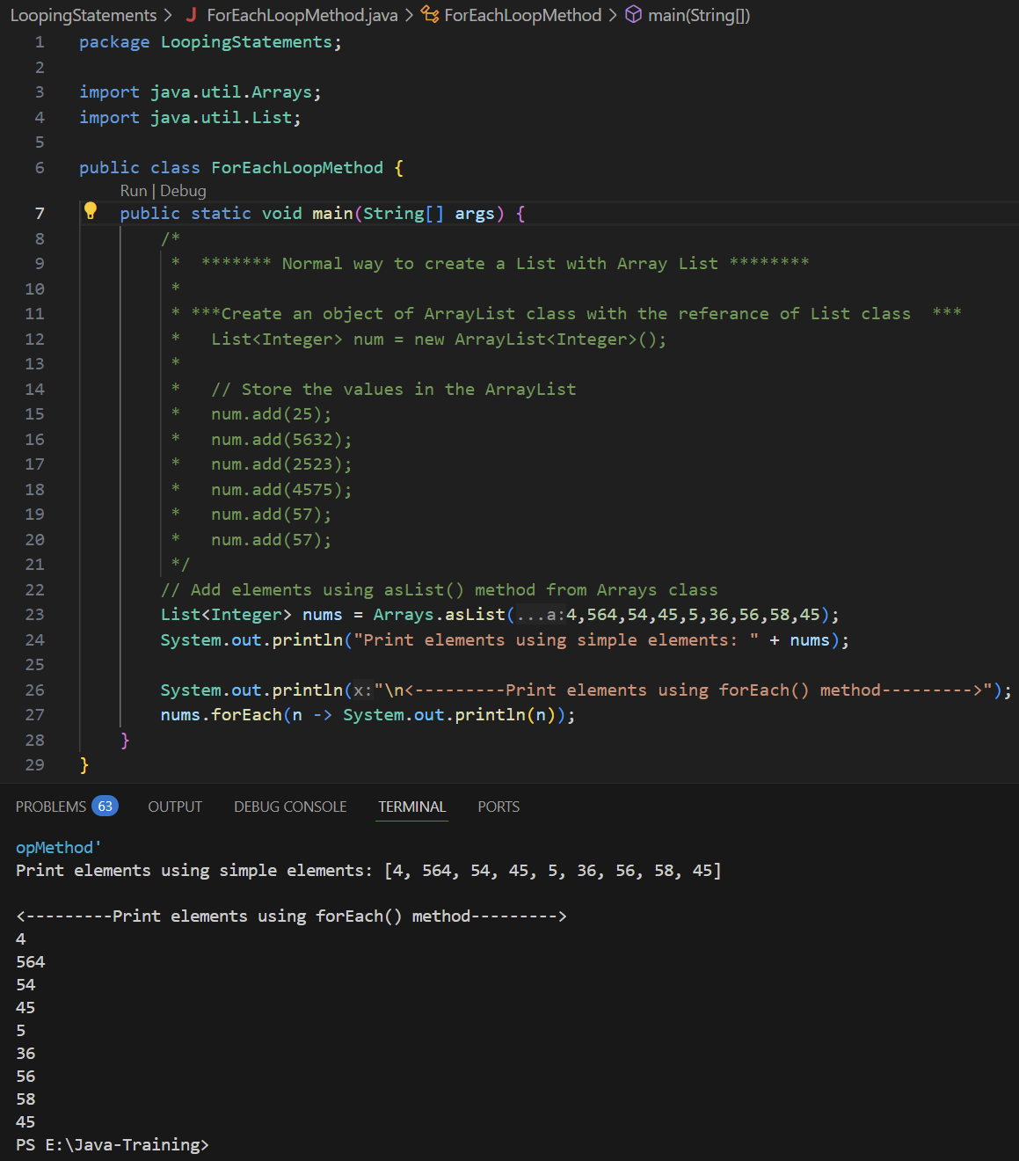

* **Classes and Objects:**
  + Java’s main feature is that Java is the Object-Oriented Programing Language.
  + **Class:**
    - In java developer will create a blueprint or class and JVM(Java Virtual Machine) creates an object of classes.
    - Developer creates class/Blueprint > .class file get compiled and creates a byte code > Byte code goes to JVM where will get the object
    - Class is a collection of elements, methods and variables.
    - Definition:
      * A class is a user-defined data type that acts as a blueprint for creating objects.
    - The class contains the attributes below:
      * Fields/Variables: that holds data
      * Methods: that perform action
    - Syntax:
      * class ClassName {

//Define Fields/Variables

dataType variableName;

//Methods

returnType(void, int, double, etc) methodName() {

//code block

}

}

* + **Object:**
    - Object is an instance of a class, and it is created using the “*new*” keyword.
    - Syntax:
      * ClassName objectName = new ClassName();
    - We can also only define a reference variable of class and later create an object. Follow the syntax below for it:
      * ClassName referenceVariable;

referanceVariable = new ClassName();







* **Polymorphism – Method Overloading and Method Overriding:**
  + Polymorphism is a feature of Object-Oriented Programming that allows one method, class or interface to behave differently based on the object that is calling it.
  + Polymorphism in Java is the ability of an object to take many forms, and it allows the same method or object to behave differently based on the context.
  + **There are two types of Polymorphism:**
    - Method Overloading – Compile time Polymorphism – Early Binding
    - Method Overriding – Run time Polymorphism – Late Binding
  + **Method Overloading – Compile time Polymorphism** 
    - In the overloading method, when there are multiple methods in the **same class have the same method name but different parameters**. (Return type can be different)
    - It occurs within the same class only and also called Compile time polymorphism.
    - Class has multiple methods with the same name but different parameters.
      * Ex. class Addition{

public int add(int a, int b) {return a + b; }

public int add(int a, int b, int c) {return a + b + c; }

}



* + **Method Overriding – Run time Polymorphism** 
    - In the inheritance when the **parent’s class and the child class have same method name with same parameters.**
    - Method overriding occurs when a child class/subclass provides a specific implementation of method that is already defined in its parent class.
    - It only happens in the inheritance.
    - **In method overriding, Method name, Return type and Parameters must be exactly same.**
    - It is also known as Runtime polymorphism and allows **dynamic method dispatch**.
    - The method in the child class **replaces** the one from the parent class during execution.
    - We can add **“@Override”** annotation above the overridden method in the child class.
    - Whenever we create an object of a child class and call an overridden method, the child class method overrides the parent class method because it has the same name and signature. As a result, the parent method is replaced by the child method at runtime.



* **Dynamic Method Dispatch: Work only in inheritance** 
  + **Dynamic Method Dispatch** in Java refers to the runtime polymorphism or method overriding which determines the method to invoke based on the actual object's type, not the reference type. It's a key feature enabling polymorphism.
  + It occurs when a **superclass reference** points to a **subclass object**.
    - Ex. class A {

public void show() {SOUT(“From Parents class.”); }

}

class B extends A {

public void show() {SOUT(“From Child class.”); }

}

public class Main {

PSVM(String args[]){

A objA = new B(); // This is called Dynamic Dispatch

objA.show();

}

}

* + We can also say Type of Parent class and object of child.



* **Array:**
  + In the variable we can only store single value while in Array we can store multiple values of same datatype.
  + **Definition:**
    - Array is a collection of elements/values of same data type that are stored in a single variable.
  + In Array, we can decide the size of array and we cannot store more values than the size of the array.
  + Array has a fixed size that cannot be changed.
  + It stores the elements of the same data type.
  + The index of array starts form 0 and end with (length-1).
  + To get the size of array then we can use (.length) method.
    - **Syntax:**
      * int nums[] = new int[3];

**int temp = nums.length; //store the size of array in the temp variable**

* + When we define an array with the specific size, but we use only certain index then rest of the empty index have default value “0”. It means that even though we don’t assign the values to empty index, it will still occupy the memory.
    - **Ex:** int num[] = new int[4];

num[0] = 1; num[1] = 2;

In this example, we use only 2 index and assign the value so other 2 empty index will have value 0.

* + **Types of Arrays:**
    - Single Dimension Array
    - Multi Dimension Array
    - Jagged Array
  + **Single Dimension Array:**
    - **Syntax: 1 X 1 array**
      * **When there are values that need to be defined during defining an Array:**
        + DataType variableName[] = { value1, value2, … , valueN};
        + **Ex:** int arr1[] = {1, 2, 3};
      * **When there is only define the size of an Array and defining values during runtime:**
        + DataType variableName[] = new DataType[SizeOfArray];
        + **Ex:** int arr1[] = new int[10];
        + **While we define array with size only then by default all the values will be zero.**
      * **Display individual values using index:**
        + SOUT (“Index Value: ” + arrayVariableName[indexNumber]);
        + Ex.: SOUT (“Index Value: ” + arr1[1]);
      * **Update the value manually with index:**
        + **Syntax:** arrayVariable[indexNumber] = newValue;
        + **Ex:** arr1[3] = 15;

(Note: Accessing the values of array manually is not the correct way to play with it. To work on array, we must use iteration statements or loops. That will reduce the repetitive code as well as faster the execution dynamically.)



* + Access and display the value of array using ***for*** loop:



* + **Multi Dimension Array:** 
    - **Syntax: 2 X 2 array**
      * **When there are values that need to be defined during defining an Array:**
        + DataType variableName[][] = { { value1, value2, … , valueN}, { value1, value 2, …, valueN} };
        + **Ex:** int arr1[][] = { {1, 2, 3}, {4, 5, 6} };



**(NOTE: EVERYTIME WE WANT TO INCREASE THE DIMENSION, WE HAVE TO ADD EXTRA SQURE BRACKETS WHILE DEFINING THE ARRAY and EXTRA LOOP FOR EVERY BRACKETS.)**

**For 3-dimensional array:**

**int nums[][][] = new int[][][]; //THIS WILL HAVE 3 LOOP TO ITERATE THE VALUES**

* + **Jagged Array:**
    - Jagged array is a type of array where each row has different number of element or different number of columns.
    - For example, 1st row has 3 elements, 2nd row have 5 elements, 3rd row have 1 element.
      * 1 2 3

4 5 6 7 8

9

* + - **Syntax for how to define number columns for individual rows:**
      * **// Define multi-dim array with number of rows only and leave columns size empty**

DataType arrayVariable[][] = new DataType[sizeOfRows][];

**//Define size of columns for each row**

arrayVariable[columnNumber] = new DataType[sizeOfColumn];

* + - * **Example:**

int num[][] = new int [3][];

num[0] = new int[3]; num[1] = new int[4]; num[2] = new int[2];



* + **We can also create an Array of the class, for that follow below steps:**
    - Create a class and define variables in it.
    - Create object of that class.
    - Create array type of object of that class and provide size.
    - Assign object of that class to the index of the array object.
    - **Syntax:**
      * **//Create class**

class ClassName{

//Define Variables

datatype variable1;

datatype variable2;

datatype variable3;

}

**//Main class**

public class Main{

public static void main(String args[]){

**//Create a object and assign values**

ClassName object1 = new ClassName();

object.variable1 = value1;

object.variable2 = value2;

object.variable3 = value3;

**//Create array type of object and assign the class object**

ClassName arrayObject[] = new className[sizeOfArray];

arrayObject[indexNumber] = classObject;

}

}

* + - To access this data, we can simply run for loop and fetch the data. We can use manual way as well but it will be increase the length of the code as well as repetitive code.
  + **Disadvantages of Arrays:**
    - Array is a fixed size, once we define the size of an array we cannot change it.
    - For the searching operation, array travers between the elements from beginning to end all the time, that will consume too much time for searching operation.
    - Array contains the elements of same datatype so it means in single we can not save multiple datatype values.
      * For example: We have defined the Integer type of array and if we try to save String data in it then it will throw an error, and we cannot perform the operation.
    - **TO OVERCOME THE DISADVANTAGE OF AN ARRAY, WE CAN USE *“COLLECTION” INSTEAD OF ARRAY.***
* **String:**
  + If we want to store a bunch of characters or lines then String is the best option.
  + While assigning value to String, we need to add values between double quotes (“AddString”)
  + String in java is not a primitive data type, but it is a class.
  + **Concepts of String class:**
    - Mutable String
    - Immutable String
  + **Immutable String: String cannot be changed**
    - By default, Strings are immutable. Once we create an object, we cannot change it.
    - **Ways to define String variable:**
      * Direct assign a value but it is not a correct way to define it but we can still use it as java handles create an object on backend side:
        + String variable = “String Value”;

Ex. String s = “Hello World”;

* + - * + With this way, behind the scenes, it will create an object automatically

**(NOTE: WHILE WE USE THIS WAY TO DEFINE A STRING, WE CAN NOT UPDATE OR CHANGE THE DATA OF THE STRING VARIABLE.)**

* + - * Defining by creating String class object, it is a correct way as String is a class and not a primitive data type:
        + String objectReferanceVariable= new String(); //Define empty string variable
        + String objectReferanceVariable= new String(“Hello World”); //Define string variable with value
        + Ex. String s = new String();

String s = new String(“Hello World”);

* + - To concat a string in java or merge two strings in one, we must use plus (+) operator. With String, it does not allow to use other operators.
    - If we create multiple object/reference variables with same data, on the behind the scenes, it will not create separate objects or new memory in the heap, but it will just use the address of object of same value. So, while we compare those both objects, we will get “true”. This is how we can save memories with String class.
      * Ex. //Compare two objects of string which have same values

String s3 = "Name";

String s4 = "Name";

System.out.print("Compare two objects of string which have same values: ");

System.out.print(s3 == s4); **//Output: true**

* + - **Example of simple String operations:**



* + **Mutable String: String can be changed**
    - To make string Mutable, we can use following classes from Java to use:
      * String Buffer
      * String Builder
    - **String Buffer Class:**
      * Syntax: StringBuffer objectVariable = new StringBuffer();

StringBuffer objectVariable = new StringBuffer(“Hello Buffer”);

* + - * While we use StringBuffer, it will give us buffer size of 16 bites.
      * To get the size of string buffer, we can use “.capacity()” method. Even though, we assign any value to string buffer object, we will still keep extra 16 bites of space
      * To convert String type to StringBuffer, we need to use “.toString()” method. We cannot directly assign StringBuffer to String.
      * We can use “.deleteCharAt(indexLocatio)” method to delete the character from particular location.
      * String Buffer is thread-safe meaning that it can be modified without creating new objects and safe to use in multi-thread environments.
    - **String Builder Class:**
      * The functionality as well as methods of String Builder and String Buffer class are same but the only key difference is String Builder class is not thread-safe which make it faster and better suited for single-threaded applications.



* + - **String Buffer Class Example:**





* **Static: Variable**
  + **Static variable means we are making something class member not an object member. So whatever static variables define in the class that belongs to the class not the object.**
  + We can use static variables when there is a common variable that is going to have same value throughout the code.
  + It is used to indicate that a member (variable, method, class or block) belongs to the class itself rather than to the instance of the class. It means that static member is shared among all instances of the class.
    - Example: If we create one static variable in the class, then we create object of that class and change the value with that object. After that that value will remain the same for all of the objects that we are going to create.

class Mobile {

int id;

static String type;

Public void display(){ SOUT(“[ ” + id + “ : “ + type + “ ]”);

}

class Main{

PSVM(String args[]){

Mobile obj1= new Mobile();

obj1.id = 1;

obj1.type = “Smartphone”;

obj1.display(); **//Output: [ 1 : Smartphone ]**

Mobile obj2= new Mobile();

obj2.id = 2;

obj2.type = “Smartphone”;

obj2.display(); **//Output: [ 2 : Smartphone ]**

SOUT(Mobile.type); **//Output: Smartphone**

}

}

In above example, we have created class and define static variable “type”. When we have created an object of Mobile class and assigned “***type=Smartphone***” in one object, it will remain same until we change it and also shared among all objects/instances of the class.

* + We can access static variables both way by creating objects of the class (m1.type) and without creating object through class name and variable name(Mobile.type). **(The correct way is access through class name and variable name.)**
  + **In the non-static method also we can use static variables.**



* **Static: Method**
  + Same as static variables, static method also belongs to the class and not to any object member.
  + Static method can be called without creating an object, but object/instance methods cannot be accessed directly. We need to create an object for it.
  + **In non-static method we can use static variables but in static method we cannot use static variables. For that we need to pass the object of the class in the parameters. (See Example 2)**
  + To call a static method, we can directly call it directly with class name and method name.
    - Ex. Mobile.display();
  + **Syntax:**
    - class ClassName {

static returnType methodName(parameters) {

// method body

}

}

**Example 1:**



**Example 2:**



* **Static: Block**
  + We can also initialize a value in a static variable in the default constructor, but the thing is when we change the static variable value during the code execution, and we again create an object, it will automatically re-initialize the values which we have assigned in the default constructor. To overcome this issue, we can create a static block.
  + Static block will call only once, it does not matter how many objects we create.
  + **Syntax:**
    - class ClassName{

datatType variableName1;

dataType variableName2;

static dataType variableName3;

// Static block

static{

dataType variableName;

staticVariableName = value;

}

}

* + Whenever there is static block and constructor define into the same package/file, static block will execute first then default constructor will execute every time object will create.
  + Whenever we execute a Java program, the **class is loaded first**, and then the **objects are created**.
  + In the JVM, there is a special component called the **Class Loader**, which is responsible for **loading classes into memory**. This class loading process happens **only once per class**, during the program’s execution.
  + When a class is loaded:
    - All **static blocks**, **static variables**, and **static methods** are initialized or executed.
    - Since class loading occurs only once, the **static block is also executed only once**, regardless of how many objects are created later.
  + After the class is loaded and static members are initialized, **object creation** begins, and the **constructor** is called for each object.
  + If we don’t create an object then static block also not called. But if we still want to execute the static block then use below syntax in main method. This will simply load a class:
    - Syntax: Class.forName(“className”);
    - Ex.: Class.forName(“Mobile”);





* **Static: Main Method (public static void main (String args[])):**
  + The main() method in Java is defined as static because it serves as the entry point for the program, and the JVM needs to call it without creating an object of the class. Since static methods belong to the class itself rather than an instance, the JVM can directly execute main() when the program starts.
  + If the main() method is defined as non-static, the JVM will not be able to call it directly, resulting in a runtime error, because it would require creating an object first, and the JVM has no way to do that automatically before the program begins. Therefore, main() must be static for the program to run successfully.
  + **Main method : public** 
    - It means the method is accessible from anywhere.
    - Java’s runtime environment (JVM) needs to call this method from outside the class, so it must be public.
  + **Main method: static**
    - It means no need to create an object of the class to call the main method.
    - When the program starts, no objects exist yet — the JVM needs a method it can run without instantiating the class.
    - Making it static lets the JVM directly call main() using the class name.

**(NOTE: If main wasn't static, the JVM would have to create an object of your class to start the program — which could be impossible or unnecessary if your class requires complex setup or has no constructor.)**

* + **Main method: void**
    - It means the method doesn’t return anything.
    - The main goal of main is to run the application, not return a value.
  + **Main method: main**
    - This is the name the JVM looks for as the starting point of execution.
  + **Main method: (String args[])**
    - This allows command-line arguments to be passed to your program.



* **Encapsulation: getter() setter() methods**
  + It is a part of OPPS.
  + It is wrapping the data (variables) and the code (methods) that work on the data into single unit, typically a class, and restricting access to some of the object’s component.
  + Encapsulation is to make sure that "sensitive" data is hidden from users.
  + **Encapsulation is like a protective capsule around your data.** You decide who can see it and who can change it.
  + **To achieve this, follow below instruction:**
    - Need to make all the variables *“private” –* so no one can’t access it directly from outside of class.
    - Define *getter()* and *setter()* public methods – that to read and update the value.
      * setter() method – use to assign the value
      * getter() method – use to display – access the value

**(NOTE: WE CAN USE DIFFERENT NAME INSTEAD OF getter and setter, but it will be hard to recognize which method used for encapsulation and which are simple method)**

* + **In Encapsulation, to access the private variables, we need to access through methods using object.**
  + **Benefits of Encapsulation:**
    - Data hiding – prevents direct access to fields.
    - Control – you can add logic inside setters/getters (e.g., validation).
    - Easy maintenance – internal code changes don't affect external code.
    - Improved security – restricts how important data is accessed or changed.





* **“*this*” keyword: In variable**
  + When an instance variable of a class and a local variable within a method of the same class have the same variable name, the ***“this”*** keyword is used with the instance variable to distinguish it from the local variable.
  + ***“this”***  is the keyword that represents the current object. Current object mean the object which is calling the method.



* **“this()” keyword: In method / constructor:**
  + When we have child class and parent class with constructors implemented in it and we know whenever we will create an object of a child class it will call parents constructor first and then call child class constructor but if we want to prevent this and only want to call a child class constructor, we can use this() in our child class.
  + It is execute a constructor of same class.





* **Constructor:**
  + A constructor is a special method with the same name as a class and will call when the object got created.
  + One class has multiple parameterized constructors but it only have one default constructor.
  + In real time, whenever we want to assign some values, always use a method and the constructor is the best option. That is the code standard.
  + **Characteristics of a Constructor:**
    - It has same name as the class name.
    - It does not have any return type.
    - It will call automatically called when the class object got created.
    - **Constructor can be overloaded mean can have multiple constructors created with different parameters.**
    - It is mainly used to assign a initial values. (In default type of constructor, with no parameters.)
  + **Syntax:**
    - class ClassName{

//Constructor Creation

ClassName(){

// Code body

}

}

* + **Types of constructors:**
    - Default Constructor
    - Parameterized Constructor
  + **Default Constructor:**
    - Default Constructor does not have any parameters.
    - If there is no constructor defined, still java defined default constructor automatically on backend.
    - Whenever object is created without any parameters, default constructor automatically called.
    - **Syntax:**
      * class ClassName{

className(){

// code body

}

}



* + **Parameterized Constructor:**
    - When we defined constructor by passing some parameters, it is called parameterized constructor.
    - In the parameterized constructor, while creating an object, we need to pass the parameters as we defined it.
    - It is used when we want to provide custom values during object creation.
    - **Syntax:** 
      * class ClassName{

// Define Parameterized constructor

className(dataType variable1, dataType variable2){

// Code body

}

}

class Main{

PSVM(String args[]){

ClassName obj1 = new ClassName(value1, value 2);

}

}



* ***“super()”* Keyword:**
  + ***“super()”*** means call the constructor of a super class.
  + ***With super() if we do not pass any parameter then it will call only default constructor but if we pass any parameter, it will call parameterized constructor.***
  + In java, ***“super()”*** keyword is used to call the methods of parents from child class.
  + While we create a default constructor in both child and parent class and create an object of child class, first it will execute the constructor from parents’ class then will execute constructor from child class both one after another.
  + **When the parent class has a parameterized constructor and the child class also defines a constructor with the same parameters, creating an object of the child class will not automatically call the parent class constructor. In such cases, the *“super()”* keyword must be used in the child class constructor to explicitly call the parent class constructor with parameters.**
  + **Also, by default every constructor’s first statement is “super()” and if we do not mention, java will add it in backend.**
  + **It will execute a constructor of super / parent class.**





* **Naming Convention:**
  + In java, basically we follow Camel casing.
  + **Class and Interface:**
    - Class and Interface name will start with a Capital letter and if there is more than one word there will no space between words and all first letters should be capital letter.
      * Ex. class HelloWorld { … }
      * class Calc { … }
  + **Variable and Method:**
    - Variable and method name should be in small letters and if there are more than one words in the name then we need to keep first word should be in small letter and keep next all word’s first letter in capital letters without any spaces between words.
      * Ex. int id;
      * String studentAddress;
      * public void display() { … }
      * public void getAddress() { … }
  + **Constants Variable:**
    - Constants variable which’s values are not going to be changed, will be define in upper case for all the characters of variable name. If there are more than one words in the variable name then we can use snack case and put underscore (_) between words and keep all characters in the upper case.
      * Ex. double PI;
      * String BRAND;
      * int MY_DATA;
* **Anonymous Object:**
  + Anonymous Object is an object that is created without assigning it a reference variable.
  + We called it as an Anonymous Object because it does not have any name(reference variable).
  + We can use it only once right after creation.
  + As there is no reference variable, we can use it only once right after its creation.
  + **Normal way to create an object of class and call method using created object using reference variable: (In the normal way we can re-use of object)**
    - class Student{

public void show() { … }

}

Reference Variable Name / Object

class Main{

PSVM (String args[]){

Class Name

Student s1 = new Student();

Call method of class using object

s1.show();

}

}

* + **Syntax of Anonymous object:**
    - class ClassName{

public void methodName() { … }

}

class MainClass{

PSVM (String args[]){

new ClassName(); // just create an object

new ClassName().nethodName(); // creating object with calling method

}

}

* + **Advantages:**
    - Saves memory if object is used only once.
    - Makes code shorter and more concise.
    - Useful for quick testing and lightweight operations.
  + **Disadvantages:**
    - You **cannot reuse** the object.
    - Reduces readability in complex code.
    - Debugging may be harder since there's no variable to refer to.



* **Inheritance:**
  + Inheritance is one of the core concepts of Object-Oriented Programming (OOP). It allows one class to inherit the fields (variables) and methods of another class.
  + Write the same code again and again called redundancy which is not good way to code. So to overcome this problem, we use inheritance in which we can use parents class for basic features and by deriving it to child class, we can add some extra features in it.
  + It is a mechanism by which one class (called the **subclass** or **child class**) acquires the properties and behaviors (fields and methods) of another class (called the **superclass** or **parent class**).
  + It promotes **code reusability**, enables **method overriding**, and establishes a **hierarchical relationship** between classes.
  + In inheritance, if we want to access the field (variables) and methods from parents class then we need to use ***“extends”***keyword while we are defining the child class.
  + Parents class called ***“parent, super, base”*** class and child class called ***“child, sub-class, derived class”*** class.
    - **Parents class – Child class**
    - **Super class – Sub class**
    - **Base class – Derived class**
  + **Simple syntax of inheritance:**
    - class ParentsClass{

dataType variable;

public void methodNamr(){

//Method body

}

}

class ChildClass **extends ParentsClass**{

dataType variable;

public void methodNamr(){

//Method body

}

}

* + **Types of Inheritance in java:**
    - Single Inheritance
    - Multilevel Inheritance
    - Hierarchical Inheritance
    - Multiple Inheritance
  + **Single Inheritance: Supported with JAVA**
    - There is only one parent class and only one child class.
    - Only one child class inherits from parent class.



Child Class

Parents Class

* + **Multilevel Inheritance: Supported with JAVA**
    - There is only one parent class that inherits one child class and that child class inherits another sub-child class.
    - A class inherits from a class, which itself inherits from another class.



Sub-Child Class 2 …

Sub-Child Class

Parents Class

Child Class

* + **Hierarchical Inheritance: Supported with JAVA**
    - There is only one parent class and all the child class inherit that same single parent class.
    - Multiple child classes inherit from a single parent class.



Child Class 3 …

Child Class 2

Child Class 1

Parents Class

* + **Multiple Inheritance: Not supported in Java so need to use Interface**
    - In the multiple inheritance, there are two parents’ class and that derives only one child class.
    - Java does not support multiple inheritance.
    - For this, we need to use interface in the code.
    - While we use interface that time while defining child class we need to use “***extends”*** and “***implements”*** keywords to inherit both parents class.
    - OR we can create an 2 interfaces as parents class and in child class will derive it using ***“implements”*** keyword
    - Java does not support multiple inheritance using classes to avoid ambiguity and complexity. The most common issue arises when two parent classes have methods or variables with the same name.

**For Full Understanding**

**of**

**Interface –**

**Go to page No #89**

* **Packages:**
  + To maintain the code file and a file structure in java, we use packages. We create a folder inside folders and separate files as per categories or types.
  + To create a package we need to use ***“package”***  keyword.
    - For file in one step in the folder use simply name of folder.



* + - Where there is folder inside folder and the inside file, then use this: ***“package package1.package2;”***



* + Once we create a package and add files in it, now if we want to use it in the other java file then we need to import it the file where we want to use. For import use the syntax below:
    - **import PackageName.ClassName;**





* + If there are multiple classes in the file and we want to access only some classes then we can use the syntax below:
    - **import PackageName.ClassName;**
  + But if we want to use all the classes from the file then use the syntax below:
    - **import PackageName.InnerPackageName.*;**





* + Same way we created packages, java also have some predefined packages or libraries which we can import as per our requirements.
    - If we use ArrayList use the package below:
      * import java.util.ArrayList;
  + In java, when we write any code, by default java imported ***“ import java.lang.*; ”*** package.
  + **\*** is simply means files so if there is a file folder inside folder then we need to mention both folder names separated with . and then add *.
    - **import PackageName.InnerPackageName.*;**
* **Access Modifiers:**
  + In Java, access modifiers determine the visibility (accessibility) of classes, methods, variables, and constructors. There are four types of access modifiers:
    - Public
    - Private
    - Protected
    - Default
  + **Public: keyword “*public*”**
    - The public modifier allows **access** **from any class or package**. Members marked as public can be accessed anywhere in the program.
    - It can be accessed from anywhere.
    - Public variables, methods, class and constructors we can access from anywhere. We just have to import that package and class into the java file where we want to access it.





* + - **Access Level:** Widest accessibility.
    - **Visibility:** Accessible from any other class or package.
    - **Use Case:** Usually used for methods or variables that are intended to be used widely (public APIs, methods, or attributes accessible from other parts of an application).
  + **Private: keyword *“private”***
    - The private modifier restricts access to only within the class itself. Members declared private cannot be accessed from outside their class.
    - It can be used in the same class. We can’t even use it outside of class.
    - Private method, class, constructors, variables can be accessed within same class only. It cannot be accessed in other classes within same file or other package file.
    - We cannot define and use private variables and methods in the main method. We need to define it in different class and using getter, setter method we can access it.
    - OR else we can define above PSVM(String args[]) method and access it through the object of the class only.





* + - **Access Level:** Most restrictive.
    - **Visibility:** Only accessible within the same class.
    - **Use Case:** Typically used for encapsulation (hiding data and behavior from external access).
  + **Protected: keyword *“protected”***
    - The protected modifier allows members to be accessible within the same package or by subclasses, even if the subclasses are in different packages.
    - Protected variables and methods can be used within same class, package also can be used in different class in the same package.
    - In protected, we can not use outside of the package, its only work in the same package and class and if we want to use it out side of package then can not use it in the main method bust only in the subclass / need to inherit it.
      * One variable v1 is in class A in Test1 package p1 and from another package p2 we have class B and Main class. To access v1 variable in class B we need to first extend it “class B extends A” now we can access v1 variable in class B but can not use it in main method.





* + - **Access Level:** Intermediate.
    - **Visibility:** Accessible within its own class, subclasses (even if they're in different packages), and all classes within the same package.
    - **Use Case:** Useful for inheritance to allow subclasses to access certain members of a superclass.
  + **Default: keyword *“default”***
    - If we don’t provide any access modifier to the class, method, variable or constructor, it will be as a default access modifier for that class, method, constructor or variable.
    - It can be access in the same package.





**Note:**

**Try to keep you class public and keep one class in one file.**

**Try to keep instance variables private.**

**Methods most of the time will be public. If you think methods and variables only use in the sub class of same or other packages than make it protected.**

**Try to avoid default type.**

* ***“final”* keyword:**
  + The ***“final”*** keyword in java used to restrict programmer’s ability to change variables, methods or classes.
  + Once we declare variables as final, we cannot change the value of it.
  + Once we define methods as a final, we cannot override it. Means we can not define another method with the same name in child class.
  + Once we define classes as a final, we cannot make child class of it. Means we cannot extend final class to child class.
  + ***“final”* keyword can be used with:**
    - Variables
    - Methods
    - Classes
  + **Variables:**
    - Once we declare variables as final, we cannot change the value of it.
    - When a variable is declared as final, its value cannot be changed once initialized.
    - **Used primarily for constants means to define PI value or define the value that should be same throughout to whole code and execution.**
    - Must be initialized either at declaration, inside constructor, or in initializer block.



* + **Methods:**
    - Once we define methods as a final, we cannot override it. Means we cannot define another method with the same name in child class.
    - It ensures a method's functionality remains unchanged.
    - It enhances security and predictability.
    - Cannot do Method overriding.



* + **Classes:**
    - Once we define classes as a final, we cannot make child class of it. Means we cannot extend final class to child class.
    - When a class is declared as final, it cannot be subclassed (no inheritance).
    - Prevent inheritance for security or design reasons.
    - No one can extended final class, stopping inheritance.





* **Wrapper Class:**
  + In Java, a Wrapper class is a class that **encapsulates (wraps) a primitive data type into an object**. Wrapper classes allow primitive types to be used as objects, enabling them to be used in collections, frameworks, and APIs that require objects.
  + For every primitive class we have a wrapper class.
  + **Use of Wrapper Class:**
    - Java collections (e.g., ArrayList, HashMap) can store only objects, not primitive types.
    - Needed when working with generics (e.g., List<Integer>).
    - Provide utility methods to manipulate primitive data types, like parsing strings, converting types, etc.
  + **List of Primitive Types and its Corresponding Wrapper Class:**
    - **In java every primitive datatype we are going to have its class.**

|  |  |
| --- | --- |
| **Primitive Type** | **Wrapper Class** |
| byte | Byte |
| short | Short |
| int | Integer |
| long | Long |
| float | Float |
| double | Double |
| char | Character |
| boolean | Boolean |

* + **Syntax for Primitive data type:**
    - **Integer**
      * int num; int num = 20;
      * Integer num = new Integer(20); // Old way
      * Integer num = 20; // Current way
    - Same for other data types.
  + **Autoboxing or Boxing: int to Integer**
    - When we assign primitive data type value to wrapper class that is called Autoboxing or boxing. Storing primitive value to primitive object or a wrapper object that is called Autoboxing or boxing.
      * It converts automatically so it is called Autoboxing or boxing.
      * Ex. int num = 20;

Integer temp = num; // Autoboxing – happen automatically

Integer temp = new Integer(num); //Boxing – doing manually

* + **Auto-unboxing or Unboxing: Integer to int**
    - Getting a value type to an object type called unboxing.
    - When we assign wrapper class value to the primitive type of variable that is called Unboxing.
      * Ex. Integer temp = 20;

int num = temp.intValue(); //unboxing – doing manually

int num = temp; // Auto-unboxing – happen automatically



* + In the wrapper class, we can perform one more operation. When we store any numbers in the String data type (Such as String num = “20”;) and we want to convert that into integer data type and perform some arithmetic operations then we can use Integer wrapper class. For this follow below syntax:
    - String variableName = “string Integer Value”;

int variableName = Integer.parseInt(stringVariableName);



* **Abstract Keyword:**
  + When we are developing an application or implementing a code we know some features of what to implement but some of not sure about it but will need it in future so we can just define that class, method or variable and use it later. So those methods, class and variables we define as an abstract class.
  + We can also call it designing a blueprint for future without providing complete implementation.
  + **Abstract Class:**
    - **When we define any abstract method in the class, that class should be an abstract class otherwise it will throw an error.**
    - **We can have abstract methods only in abstract class.**
    - **Also, whenever we inherit an abstract class, that child class should have use abstract methods and provide implementation in it.**
    - **We cannot call or create an object of an abstract class.**
      * abstract class Car { public abstract void drive(); }

class Main {

PSVM(String args[]){

**Car c = new Car(); // Can not create an object of abstract class.**

}

}

* + - **But we can create a reference of the abstract class.**
      * abstract class Car { public abstract void drive(); }

class XYLO extends Car {

**public void drive() {SOUT(“Car can drive.”); } // Call an abstract method**

}

class Main {

PSVM(String args[]){

**Car c = new XYLO(); // Can create a reference of abstract class.**

**c.drive(); // Call abstract method of child class**

**Whenever we call drive method, it will call the method of child class not parent class.**

}

}

* + - When we define an abstract class, there is no compulsory that we need to define abstract method in it. We can also have non-abstract method in it.
      * It means, abstract class have abstract methods as well as normal methods.
      * We can also create multiple abstract methods in abstract class.
      * How many abstract methods we define in abstract class, all the methods we need to implement in its child class.
      * We can also create a child abstract class of parents abstract class.
    - When we have multiple abstract methods in the parents class and it child class we don’t want to implement all but only some of abstract class then we need to make that child class as abstract class and implement that abstract methods. Now in this scenario, as we created child class as abstract class we no need to implement all the abstract methods in the child class. For other un-implemented features, we can create a child class of that abstract child class and implement remaining features, this class called as a ***“concrete”*** class. And while we calling, we need to create an object of that concrete class.
      * abstract class Car {

public abstract void drive();

public abstract void playMusic();

}

abstract class XYLO extends Car {

**public void drive() {SOUT(“Car can drive.”); } // Call an abstract method**

}

class UpdatedXYLO extend XYLO{ **// This class called as “Concrete class”**

public void playMusic() { SOUT(“Car have Music system”); }

}

class Main {

PSVM(String args[]){

**Car c = new UpdatedXYLO();**

c.drive();

c.playMusic();

}

}

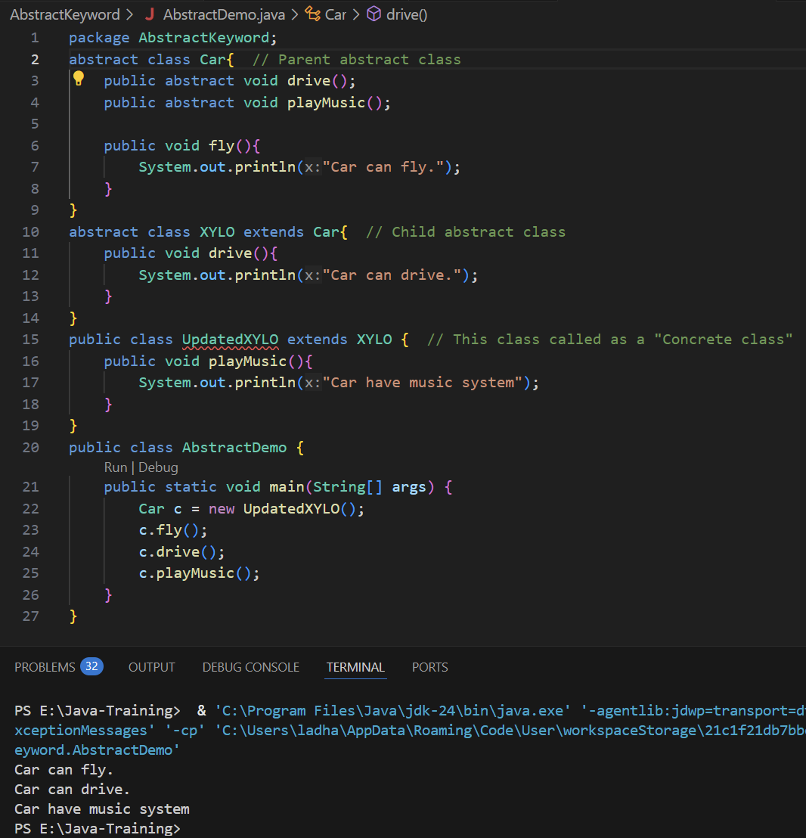

* **Inner Class:**
  + In java Inner class defined class within another class. The purpose of nested classes is to group classes that belong together, which makes your code more readable and maintainable.
  + Inner class used primarily to logically group classes that are **only used in one place**, increase **encapsulation**, and can **access members (even private ones)** of the outer class.
  + **There are different ways to create an Inner class:**
    - Simple Inner Class
    - Static Inner Class
    - Anonymous Inner Class
    - Anonymous Abstract Inner Class
  + **Simple Inner Class:**
    - In this type, there is simple outer class and within same class defines another outer class.
    - To call inner class methods and variables follow below steps:
      * First create an object of outer class.
      * Then create an object of inner class using outer class object.
      * Call inner class methods using inner class object which we have created in above step. **(We cannot call inner class methods with outer class object.)**
    - **Syntax:**
      * class OuterClassName{

dataType outerClassVariableName;

public void outerClassMethod(){

// Method body

}

class InnerClass{

dataType innerClassVariableName;

public void innerClassMethod(){

// Method body

}

}

}

public class Main{

PSVM(String args[]){

OuterClassName objectOuterClass = new OuterClassName();

objectOuterClass.outerClassMethod();

InnerClassName.OuterClassName objectInnerClass = objectOuterClass.new InnerClassName(); // Create inner class object

objectInnerClass.innerClassMethod(); // Call inner class method

}

}

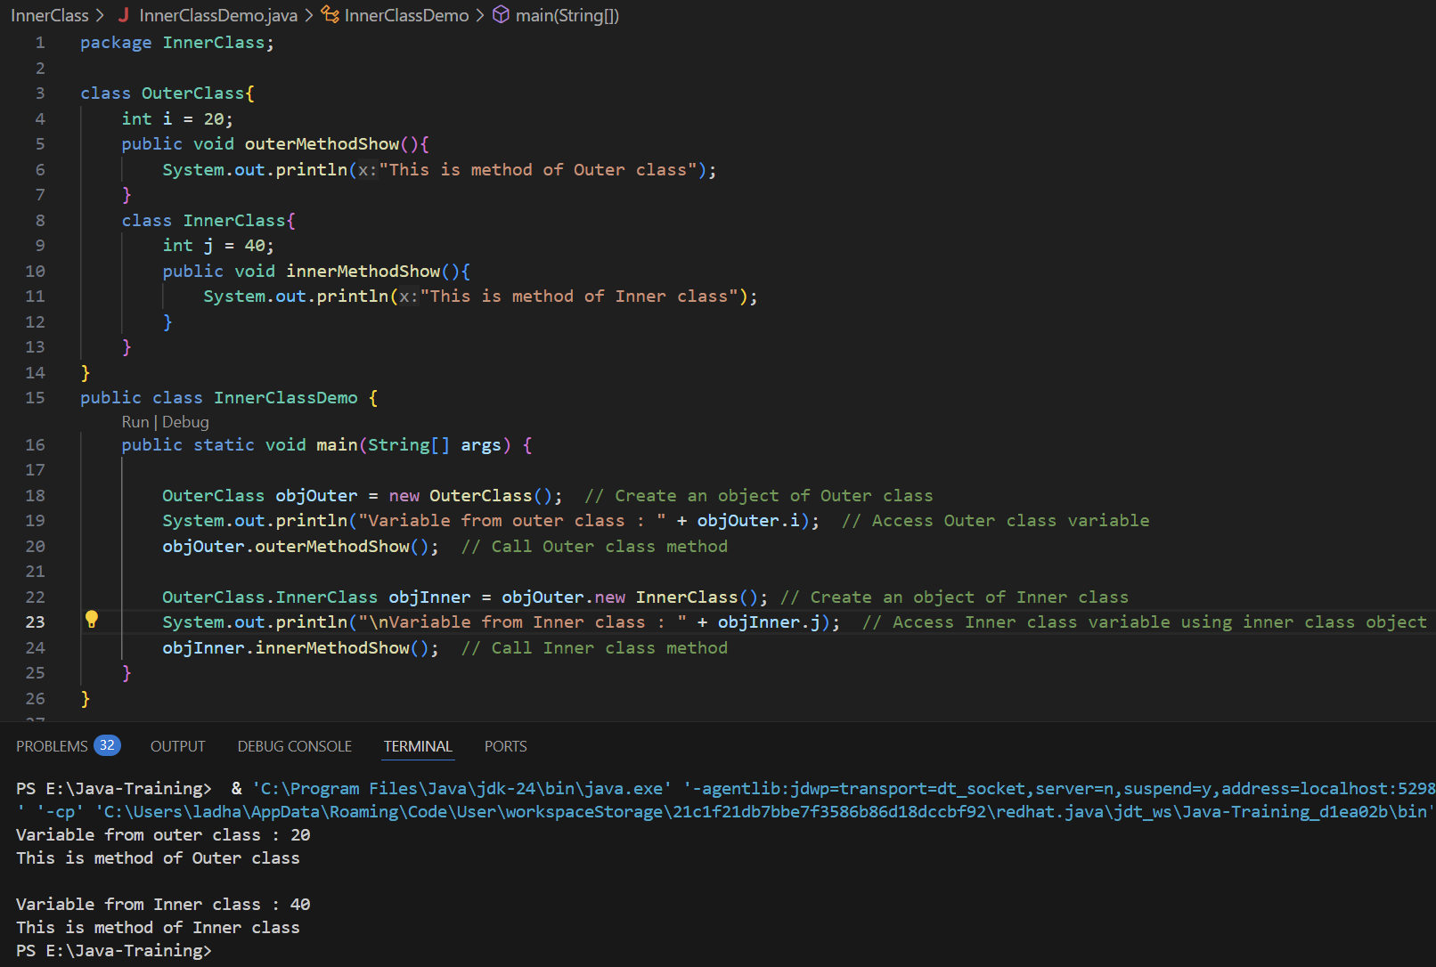

* + **Static Inner Class:**
    - We can create an inner class as a static class and we no need to create an object of that inner class.
    - To call inner static class we don’t need an object, we can directly refer Outer Class and we can use below syntax:
      * OuterClassName.InnerClassName innerObject = new OuterClassName.InnerClassName();
      * We can use this syntax only when inner class is static. This syntax will not work for non-static inner class.
    - When we define inner class static, we can not make outer class static. We can only use public, abstract or final class in outer class.

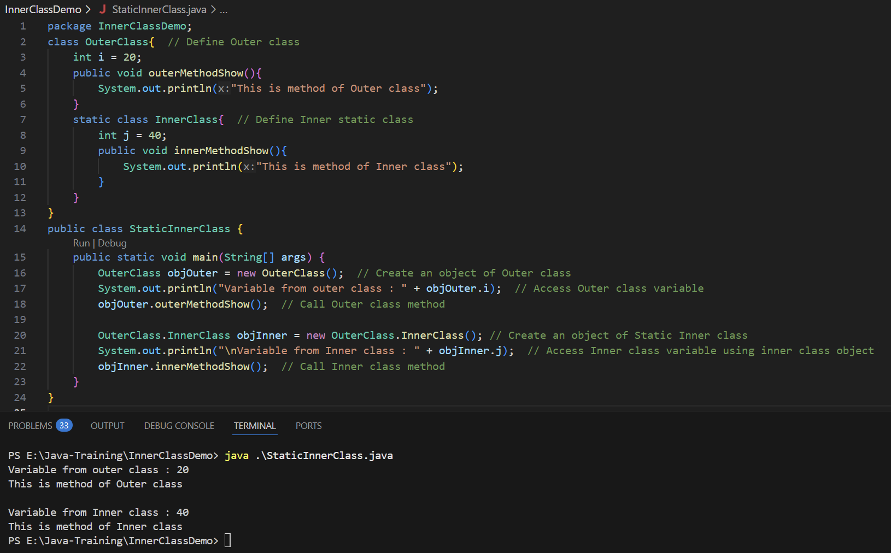

* + **Anonymous Inner Class:**
    - When we know that class and method going to use only once during the execution that time we use Anonymous(Nameless) inner class.
    - To create an anonymous class, we need to create in main method while creating an object of outer class. Follow below syntax:
      * class OuterClassName{

dataType variableName;

public void outerMethod(){

// Method Body

}

}

public class MainClass{

PSVM(String args[]){

OuterClassName objOuter = new OuterClassName(){

void outerMethod(){

//Method Body

}

};

objOuter.outerMethod();

}

}

* + - While we create an anonymous inner class, we cannot create new methods in the anonymous class. We need to use whatever method created in the outer class.
    - As in anonymous inner class, we need to use same method defined in the outer class, means that whatever method body contain in outer class will be replaced with anonymous class method body and we will lose the data of Outer class.

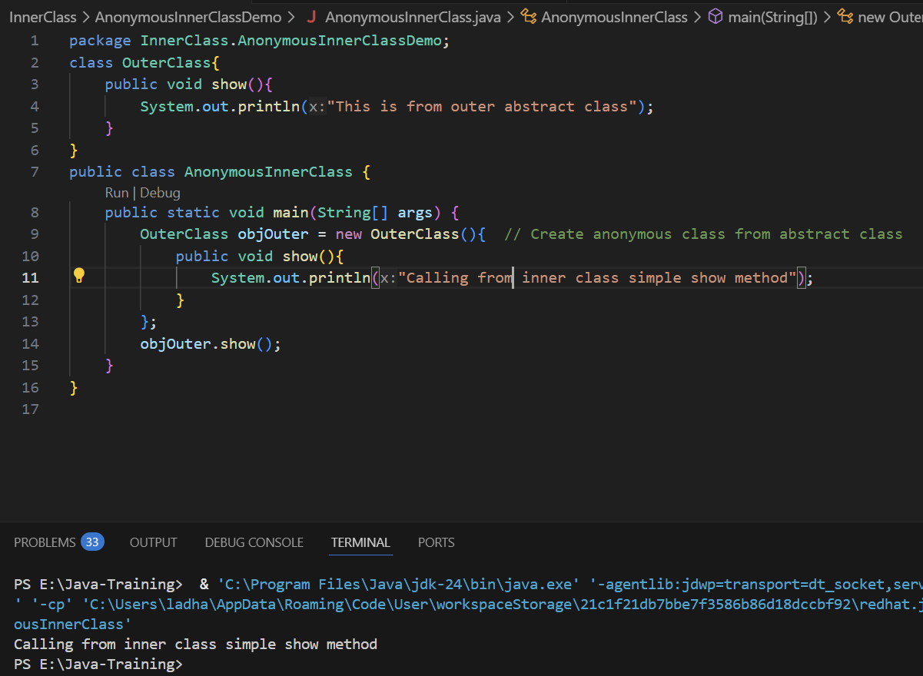

* + **Abstract Inner Class:**
    - When we know that class and method going to use only once during the execution that time we use Anonymous(Nameless) inner class.
    - To create an anonymous class, we need to create in main method while creating an object of outer class. Follow below syntax:
      * abstract class OuterClassName{

dataType variableName;

public void outerMethod(){

// Method Body

}

}

public class MainClass{

PSVM(String args[]){

OuterClassName objOuter = new OuterClassName(){

void outerMethod(){

//Method Body

}

};

objOuter.outerMethod();

}

}

* + - While we create an anonymous inner class, we cannot create new methods in the anonymous class. We need to use whatever method created in the outer class.
    - Also, if the outer class is the abstract class then we need to use all of them in the anonymous class.
    - As in anonymous inner class, we need to use same method defined in the outer class, means that whatever method body contain in outer class will be replaced with anonymous class method body and we will lose the data of Outer class.

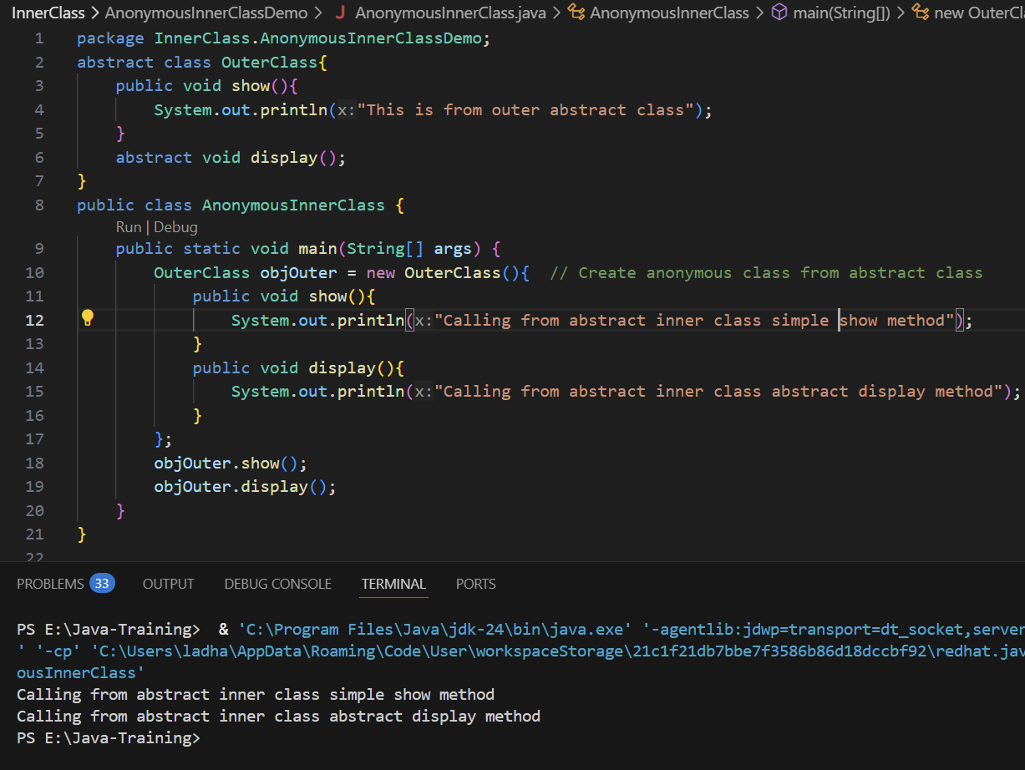

* **Interface:**
  + Interface is a blueprint for the class.
  + When we create an interface, it is completely abstract class means that in interface we just have to define a method (without method body code) and we must have to implement all of those methods in the child class.
  + In simple definition, Interface says what to do but not show how to do it. Means it have all the methods defined and method body need to implement in the child class and by every child class, the behavior of method will be change as per the requirement.
  + An Interface contains,
    - Must use “interface” keyword to define the interface
      * **Syntax:** interface InterfaceName { //defineMethods() }
    - Only declare method and does not provide method body.
    - Can also have constants or final static variables.
    - A child class that implements the interface must provide the implementation of all the declared method in the interface.
  + **Whatever method we define in the interface it automatically becomes public abstract methods (so we no need to write “public abstract”, we can simply write “void show();”), and all the variables become public static final (constant, such as PI).**
  + **To inherit interface to child class, we need to use “implements” keyword while declaring child class.**
  + **Syntax:**
    - **interface** InterfaceName{ // Define Interface

// Constant Variable

double PI = 3.14;

// Define Abstract Methods

void interfaceAbstractMethod_1();

void interfaceAbstractMethod_2();

}

class ChildClassName **implements** InterfaceName{ // Define child class

public void interfaceAbstractMethod_1(){

//Method body

}

public void interfaceAbstractMethod_2(){

//Method body

}

}

public class Main{

PSVM(String args[]){

ChildClassName objName = new ChildClassName();

objName. interfaceAbstractMethod_1();

objName. interfaceAbstractMethod_2(); } }

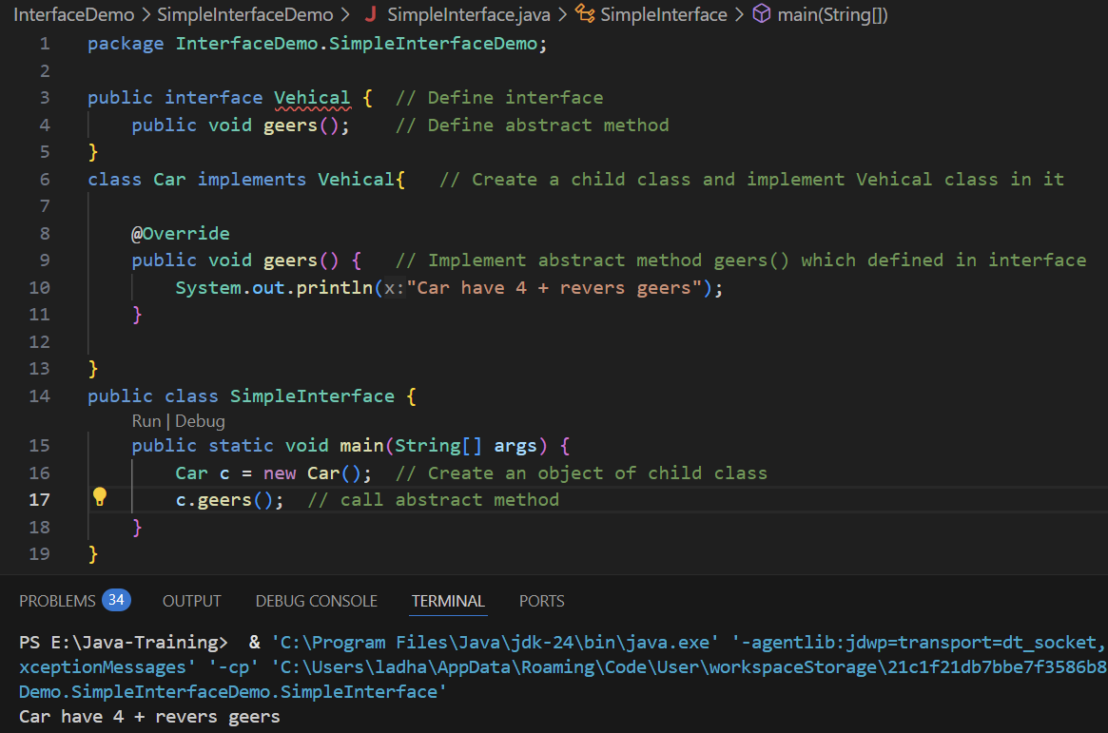

* + **In the interface,** 
    - **All the methods are automatically public abstract. So we no need to write specifically “public abstract” keywords. We can simply define it with the syntax below:**
      * interface InterfaceName {

// define abstract method in the interface

returnType methodName();

}

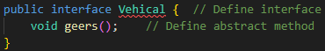

* + - **We cannot create an object or instantiate in of interface, but we can only create a reference of it.**
      * InterfaceName referanceVariable; // Can create a reference
      * InterfaceName obj = new InterfaceName(); // Cannot create an object

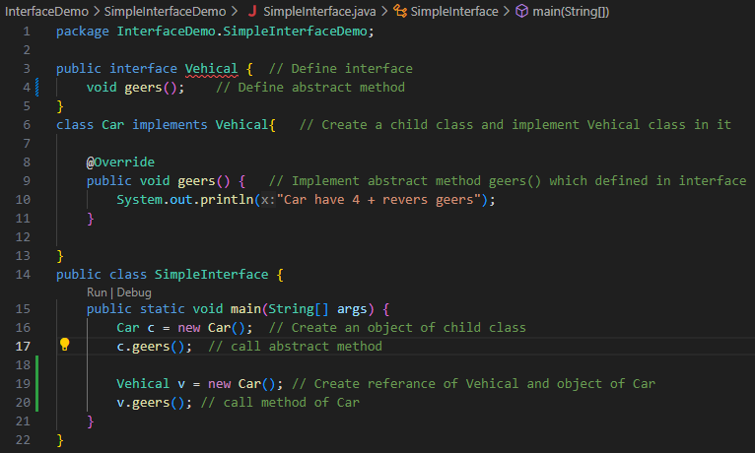

* + - **To implement the methods of interface, we will have to create a child class and inherit the interface using “implements” keyword and implement interface methods.**
      * **Syntax:** interface InterfaceName { // Define interface

void methodName(); // Define method in interface

}

class childClassName implements InterfaceName { // Create child class

public void methodName() { //implement abstract method from interface

// Method body

}

}



* + - **While we create an object, we can not create an direct object of interface. We need to create an object of child class and then call the method or else we can define a reference variable of interface and create an object of the child class.**
      * **Syntax:**

interface InterfaceName { // Define interface

void methodName(); // Define method in interface

}

class ChildClassName implements InterfaceName { // Create child class

public void methodName() { //implement abstract method from interface

// Method body

}

}

public class ClassName {

PSVM (String args[]) {

// 1st way to create an object and call method

InterfaceName referanceVariable;

referanceVariable = new ChildClassName();

referanceVariable.methodName();

OR OR OR OR OR

InterfaceName referanceVariable = new ChildClassName();

referanceVariable.methodName();

// 2nd way to create an object and call method

ChildClassName objName = new ChildClassName();

objName.methodName();

}

}



* + - **We cannot define normal variables in the interface because whatever the variables will define in the interface will be automatically by default “final and static”. It means that we need to initialize the value of variables that will remain same and immutable (because it is final variables).** 
      * Syntax:

interface InterfaceName {

dataType variableName = value;

}

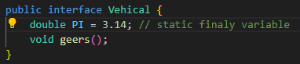

* + - * As interface variables are static variables we can directly call and access it using name of the interface in the main method or anywhere.
        + Syntax:

interface InterfaceName {

dataType variableName = value;

}

public class Main {

PSVM(String args[]) {

// Display interface variable value directly using interface name

SOUT(InterfaceName.variableName);

InterfaceName.variableName = newValue; // we can not change its value due to it is final variable of interface

}

}

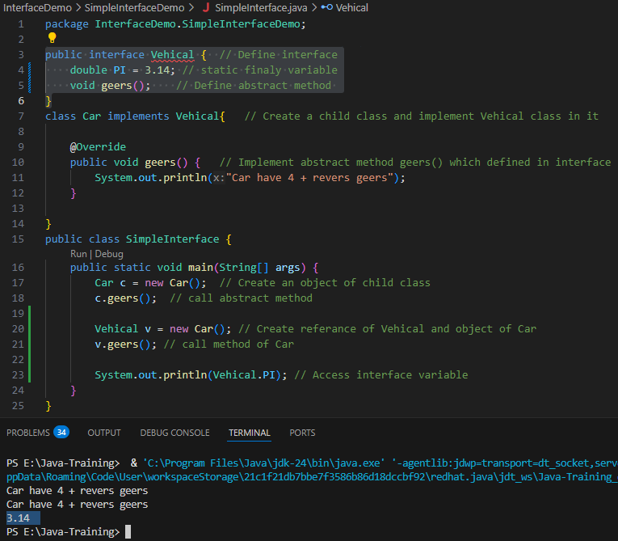

* + - **The reason behind the interface variables is static is that we cannot create an object of the interface so we cannot initiate the value during runtime.**
    - **And variables are also final because it does not have main memory in the heap.**
    - **We can create multiple interfaces and also we can inherit it all of the created interfaces in the child class together. For that we can follow the syntax below:**
      * interface InterfaceName1 {

// body of interface 1

returnType methodNameInterface1();

}

interface InterfaceName2 {

// body of interface 2

returnType methodNameInterface2();

}

class ChildClassName implements InterfaceName1, InterfaceName2 {

// Body of Child Class and implementation of all the interfaces’ methods

public void returnType methodNameInterface1() { // Method body }

public void returnType methodNameInterface2() { // Method body }

}

**[NOTE: In the abstract class we cannot perform this. We cannot implements/extend/inherit multiple abstract classes in the child class]**

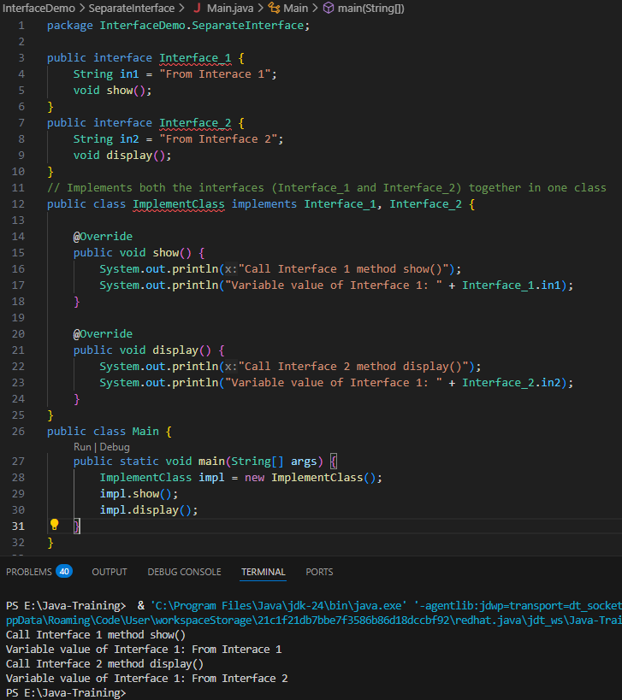

* + - **While we will have multiple interfaces creates and want to inherit one interface to another interface, we can perform that with “extends” keyword. See below syntax:**
      * interface InterfaceName1 {

// Body of interface

}

interface InterfaceName2 {

// Body of interface

}

interface InterfaceName3 **extends** Interface 2 {

// Body of interface

}

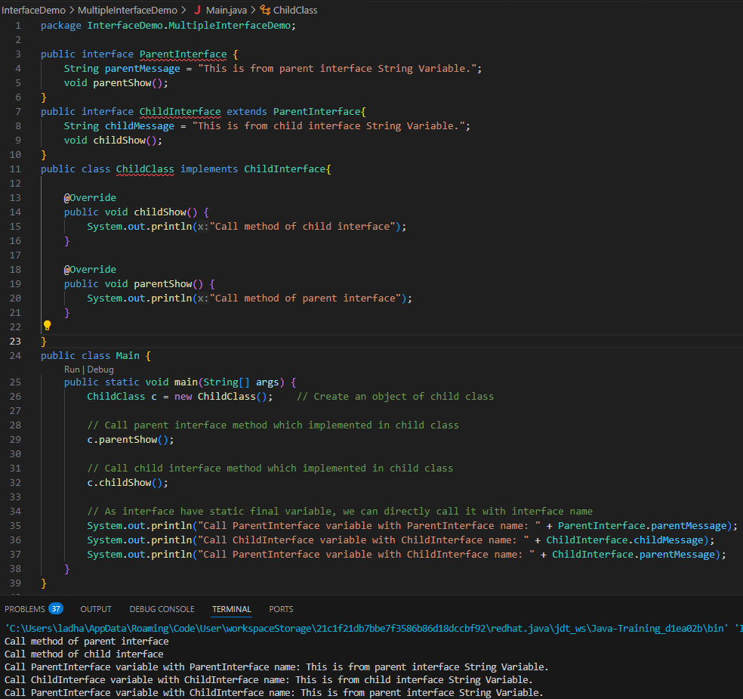

* + - * **While we inherit an interface to interface we no need to implement parent interface in the child interface but while we implements the interfaces in the child class that time we need to implement all the parent and child interface methods.**

**PARENT CLASS 🡪 INHERIT CHILD CLASS 🡪 USE EXTENDS KEYWORD IN CHILD CLASS**

**PARENT INTERFACE 🡪 INHERIT CHILD CLASS 🡪 USE IMPLEMENTS KEYWORD IN CHILD CLASS**

**PARENTS INTERFACE 🡪 INHERITS CHILD INTERFACE 🡪 USE EXTENDS KEYWPRD IN CHILD INTERFACE**

* + **Types of Interfaces:**  We can divide interface into 3 types. As we know in interface we can only declare methods and all the methods in the interface are public abstract by default.
    - Normal Interface: **Have multiple methods**
    - Functional Interface / SAM Interface: **Have only one method**
    - Marker Interface: **Does not have any methods**
  + **Normal Interface:**
    - The interface which has multiple methods defined or two or more methods defined called Normal interface.
    - **Syntax:**

interface InterfaceName {

void methodOne();

void methodTwo();

… … … … … … … …

void method();

}

* + **Functional Interface / SAM Interface:** SAM stands for Single Abstract Method
    - The interface which has only one method defined called Functional interface or SAM Interface – Single Abstract Method Interface.
    - **Syntax:**

**@FunctionalInterface**

interface InterfaceName {

void method();

}

* + - **With this interface, we can use *“@FunctionalInterface”* annotation to indicate that your interface is a SAM interface or Functional Interface.**
    - As this type of interface has only one interface, it allows to implement using a lambda expression.

**Functional Interface Example:**

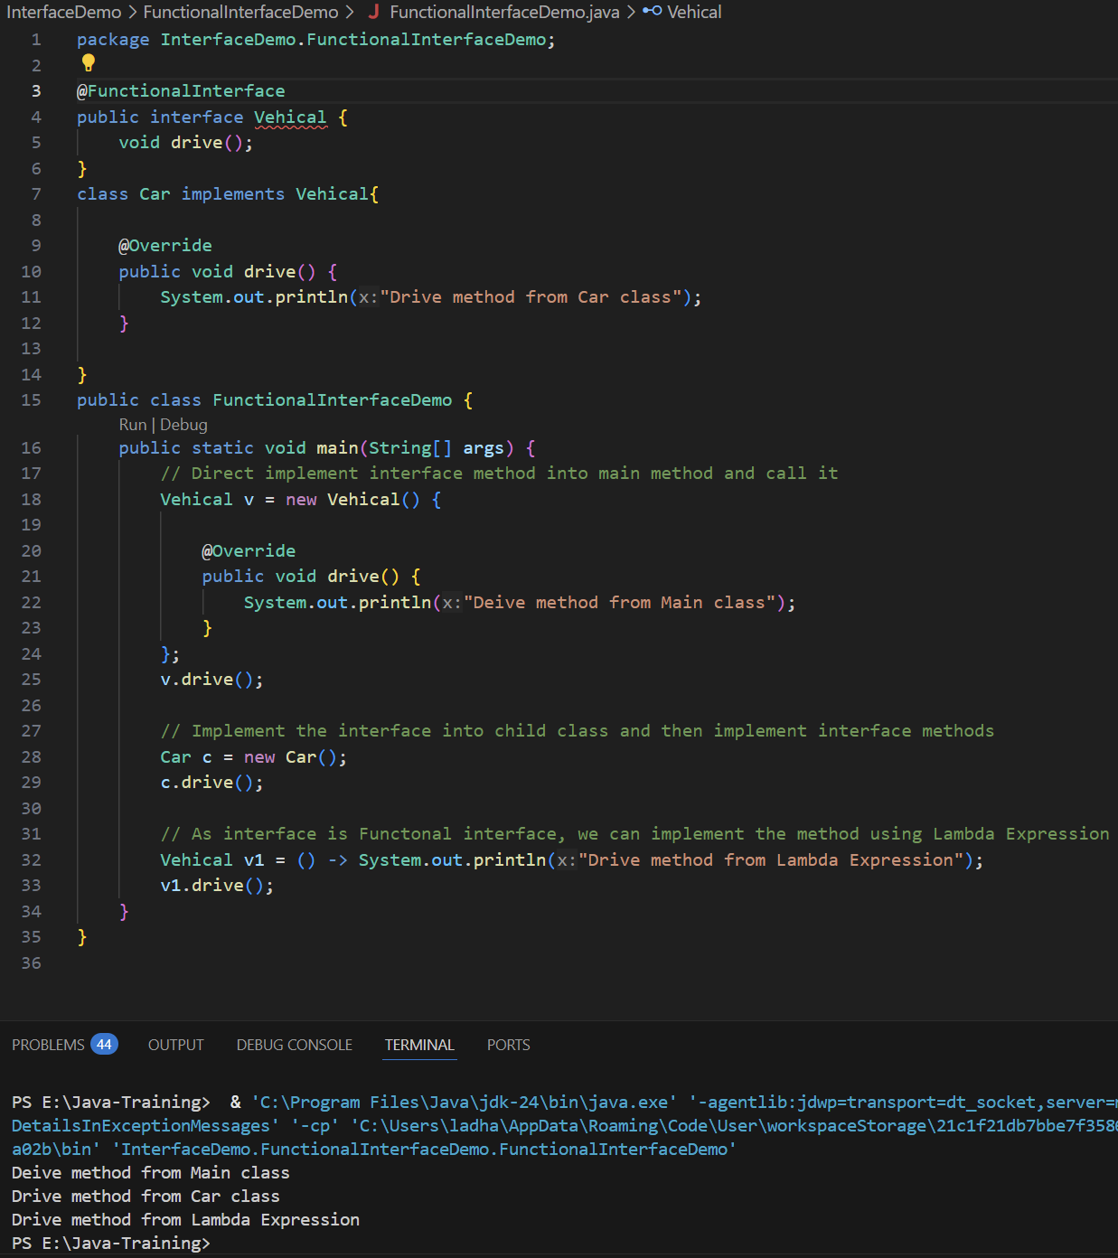

* + **Marker Interface:**
    - This type of interface does not have any methods or fields define in it means it is blank interface.
    - It use to update something to the compiler. It is mainly use in concept of “Serializable” means we can take the object and store the values of the object into hard-drive.
    - In the real world, while we playing game and save it. After reopen the game and during load the game to resume where we left the game. That time Marker interface use.
* **“enum” keyword: (short for enumeration): enum is a class**
  + ***“enum”*** is the special data type used to define a collection of constant variables.
  + These constants variable values are fixed and predefined.
  + Enum is a type of class, but we cannot extend it to child class.
  + Enums are mainly used to predefine the response messages for HTTPs request error codes.
    - Such as, for 200 – Success response, for 500 – Network connectivity issue
    - **Enums are useful when you want to represent a fixed set of known values, like days of the week, directions, or states in a process.**
  + **Syntax:**
    - **Define Enum:**

enum EnumName {

Constant_1, Contant_2…; // These values are called Named constats.

}

[Here, enum is a type of class as in java everything in class and all the Constant_1.. are the object of enum.]

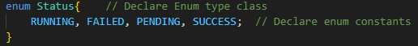

* + - **Call Enum: Call it in main method**

EnumName variableName = EnumName.Constant_1;

* + - **In enum, all the constants values have number or position number. And it stats with 0, 1 ,2,…n.**
      * In above constant, Constant_1 have 0 number location. Constant_2 have 1 number location.
      * To get the location of the enum constant, we can use ordinal() method. **Follow the syntax below:**

enum EnumName {

Constant_1, Contant_2…; // These values are called Named constats.

}

In main method:

EnumName variableName = EnumName.Constant_1;

SOUT(variabableName.ordinal());

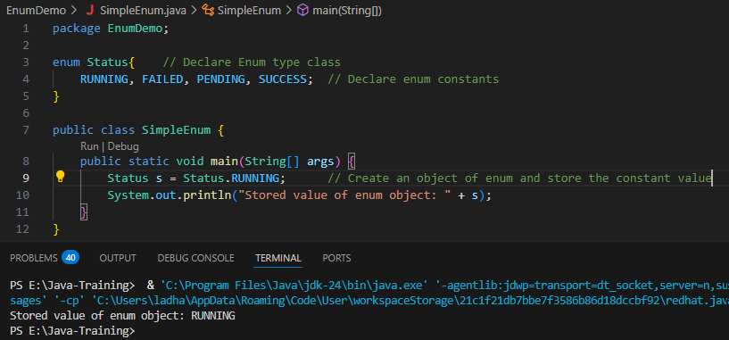

* + - To fetch all the values of the enum, we can use values() method and enum constants are consider as array so we need to create an array object of enum and call values() method in for loop to fetch all the values. Follow the syntax below:
      * **Syntax:**

enum EnumName {

Constant_1, Contant_2…; // These values are called Named constats.

}

In main method:

EnumName[] arrayObjectVariable = EnumName.values(); // Create an array object of enum to store all the values of enum constants.

for (EnumName objectVariable : arrayObjectVariable) {

SOUT(objectVariable); // Print simple values

SOUT(objectVariable + “ : “ + objectVariable.ordinal); // Print values and its index value

}

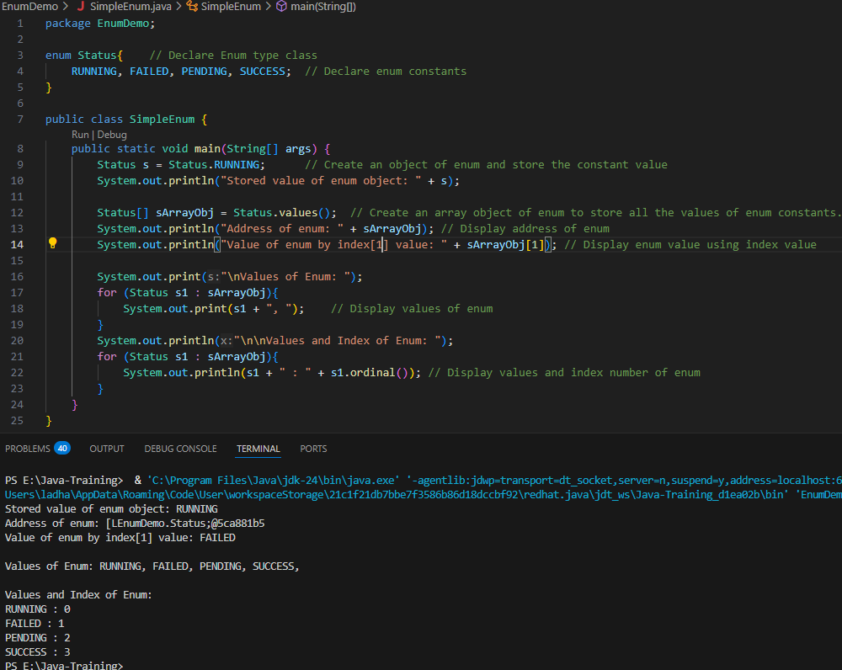

* + **enum with IF…ELSE:**
    - While we get some response from server and based on that want to print some message, that time we can use enum with IF-ELSE by compering the enum value with response value.

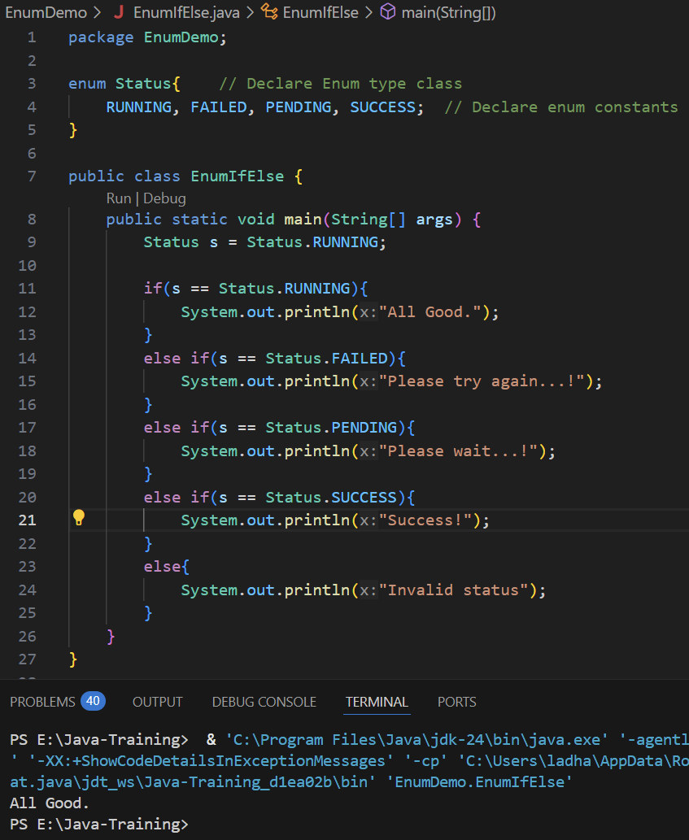

* + **enum with SWITCH Case:**
    - We can pass whatever response value from server get in Switch variable and based on its value we can set message for each response in the each switch case.

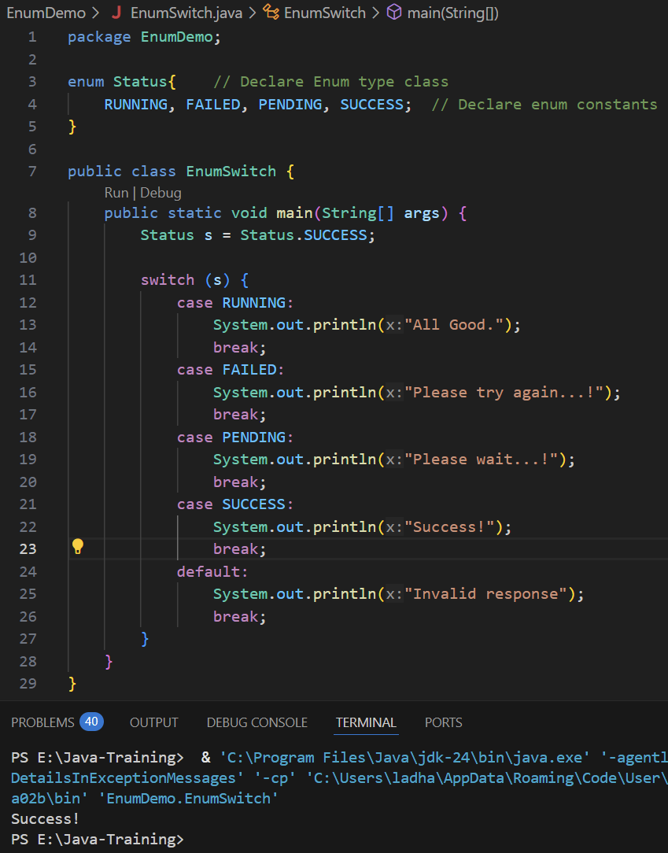

* + Enum is a type of class, but we cannot extend it to child class. **BUT we can create a method and constructors of enum class.**
  + We can also assign some values to the constant variable. To achieve that we need to define a variable and define a parametrized private constructor of enum class. Also to change the value or fetch the value, we need to use getter() and setter() methods. From the main method, we can call it and fetch the values also change the values. Use loop to fetch all the values. For that follow the syntax below:
    - Enum EnumName {

Constant_1(value1), Constant(value2),…; // Define a constant variable with value

private dataType variableName; // Define a variable that holds a value

private EnumName (dataType variableName) {



this.variableName = variableName;



}

public dataType getVariableName() {

return variableName;

}

public dataType setVariableName(dataType variableName) {

this.variableName = variableName;

}

}

public class Main {

PSVM(String args[]) {

EnumName objectVariable = EnumName.ConstantVariable;

// Display enum constant variable with its value

SOUT(objectVariable + “ : “ + objectVariable.getMethod());

for(EnumName objVariable : EnumName.values()) {

SOUT(objVariable + objVariable.getMethod());

}

}

}

[NOTE: WHILE WE ARE ASSIGNING THE VALUES TO THE ENUM VARIABLES, WE HAVE TO ASSIGN VALUES TO ALL OF THEM. WE CAN’T LEFT SOME ENUM VARIABLES WITHOUT VALUES BECAUSE WE USE PARAMETERIZED CONSTRUCTOR ONLY. ]

[NOTE: DO NOT CHANGE THE ORFER OF DECLARATION IN ENUM CLASS.]

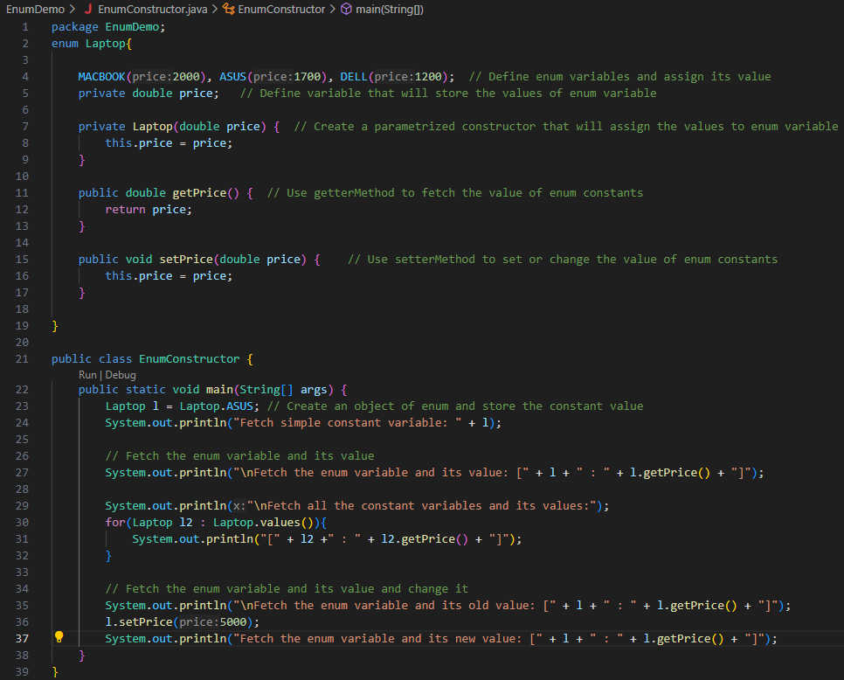

**Output:**

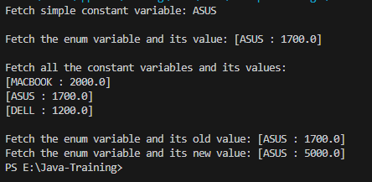

* + While we are assigning the values to the Enum variables, we have to assign values to all of them. We can’t leave some Enum variables without values because we use parameterized constructor only. To overcome this issue, we can define default constructor of Enum class and in that we can assign predefined value or leave it empty. So, whenever we do not assign any value to Enum variable, it will take the value from default constructor.

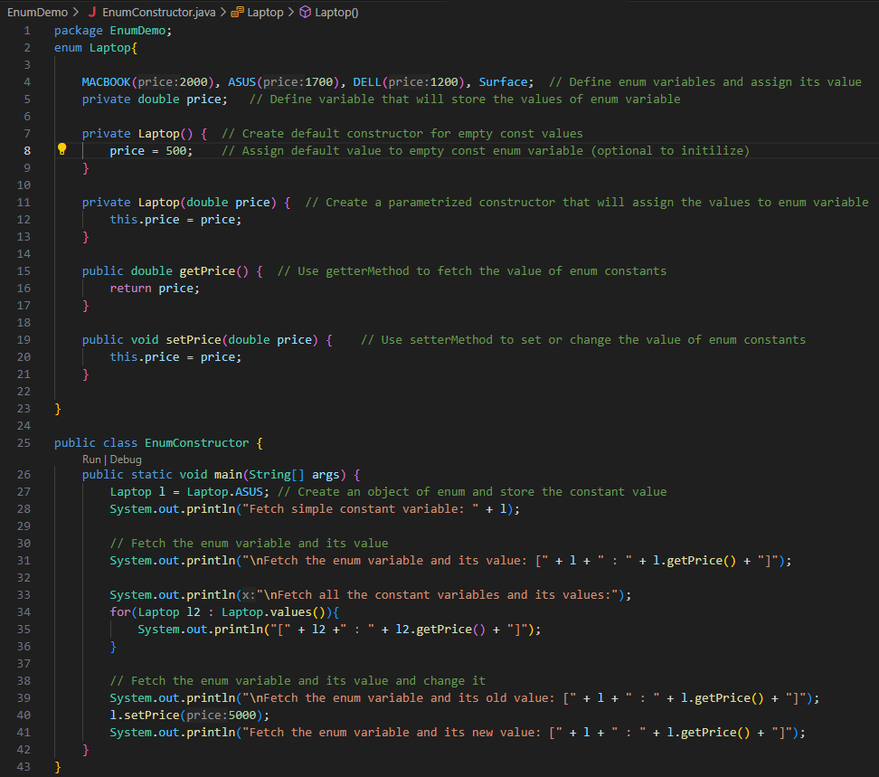

**Output:**

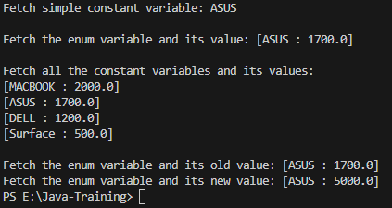

* **Annotations:**
  + It simply means supplements to the compiler or to the runtime or can be also called metadata.
  + During code execution, if we want to pass/supply some extra information to the compiler or to the runtime.
  + An annotation is a special form of syntactic metadata that can be added to Java code—classes, methods, variables, parameters, etc. It begins with **@** and is followed by the **annotation** name.
    - Ex.: @Override
  + In core java, we don’t use annotations much but while we work on frameworks such as Hibernate Framework and Spring Framework, we use annotations very much.
  + There are different annotations pre-created in Java and among them some of will work on class level, some will work on method level and some will work on variable level. And in some cases, we can create our own annotations.
    - @Deprecated – it is class level annotation. It means use the class but do not use the class because soon the class will remove from Java language or there are better alternative for it.
    - @Override – It is method level annotation. In inheritance, we are going to perform method overriding, that time we will use @Override annotation. As we are using this annotation for method overriding, our parent and child method name must be same, otherwise this will throw an error.



* **Lambda Expression:**
  + Lambda expression introduced in Java 8. It is mainly use in the SAM Inerface or Functional Interface which have only one method defined.
  + **Syntax for Lambda expression:** without any parameters
    - **First we need to create a Functional Interface and then we can call it in main method with the reference of interface.**

@FunctionalInterface

interface InterfaceName {

returnType methodName();

}

public class MainClass {

PSVM(String args[]) {

InterfaceName objName = () 🡪 SOUT(“Some Message”);

objName.methodName();

}

}

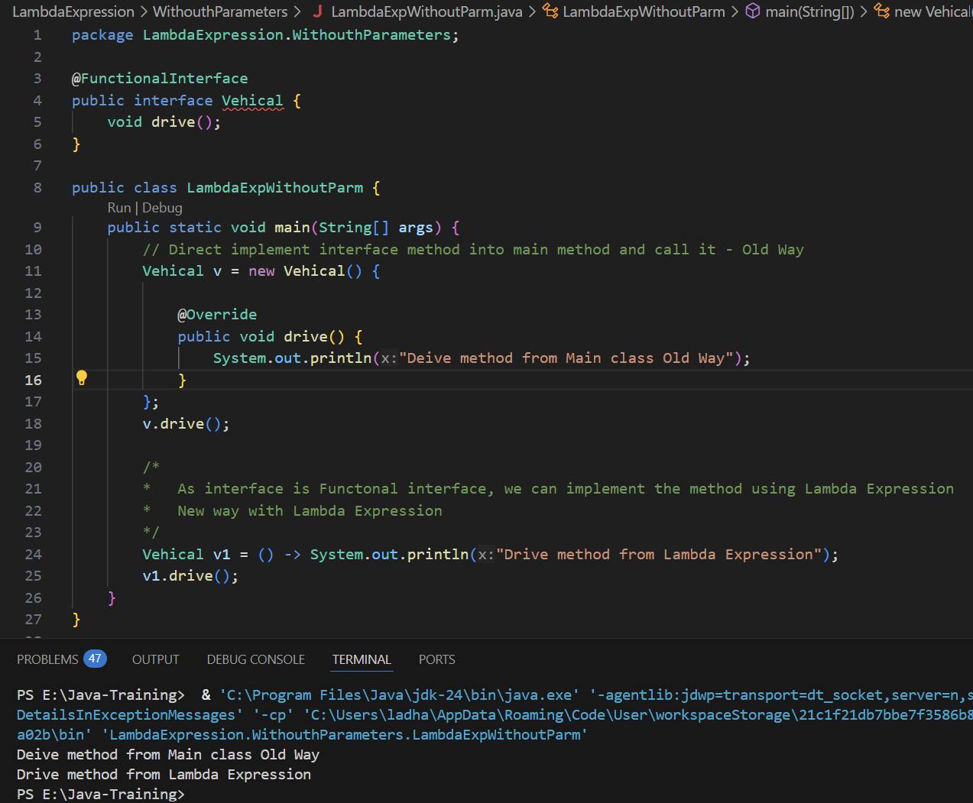

* + **Syntax for Lambda expression:** with one parameter without any return type in interface method

@FunctionalInterface

interface InterfaceName {

returnType methodName(dataType variableName);

}

public class MainClass {

PSVM(String args[]) {

InterfaceName objName = (variableName) 🡪 SOUT(“Some Message”); **// We no need to provide datatype while passing parameter bcoz we have already mentioned in method into the interface**

objName.methodName(value);

**OR OR OR OR OR OR OR OR OR OR OR OR OR OR OR OR OR OR OR OR**

InterfaceName objName = variableName 🡪 SOUT(“Some Message”);

objName.methodName(value);

}

}

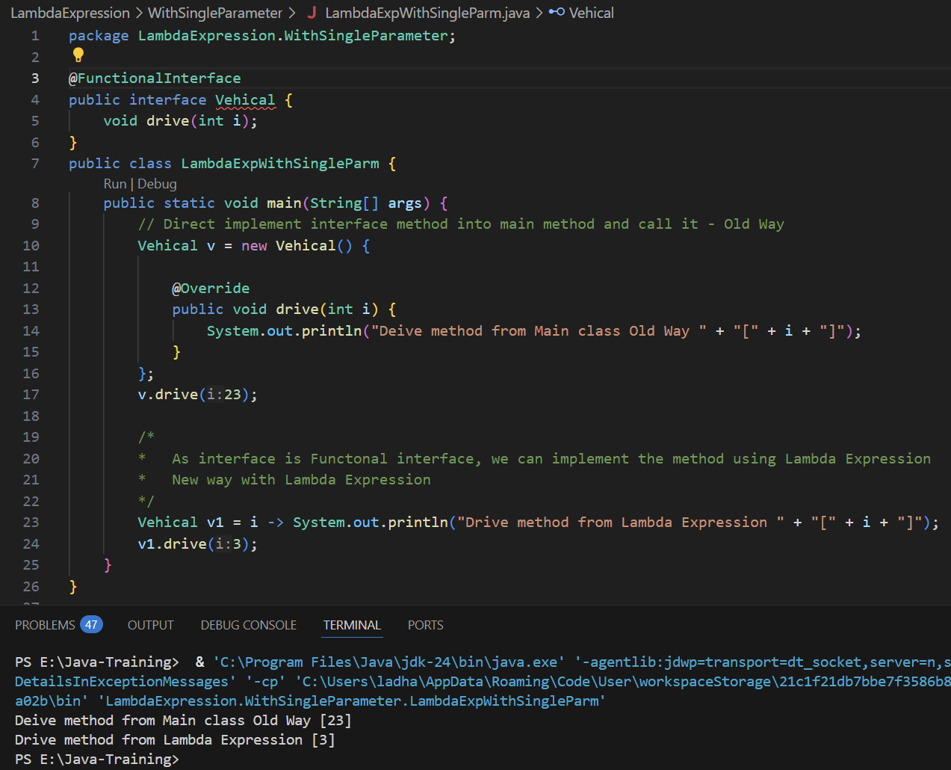

* + **Syntax for Lambda expression:** with one parameter with return type in interface method

@FunctionalInterface

interface InterfaceName {

returnType methodName(dataType variableName1, dataType variableName2, …);

}

public class MainClass {

PSVM(String args[]) {

InterfaceName objName = (variableName1, variablName2, …) 🡪 variableName1 + variableName2…;

dataType tempVariable = objName.methodName(value1, value2, …);

SOUT(tempVariableName);

}

}

**For this line *“****InterfaceName objName = (variableName1, variablName2, …) 🡪 variableName1 + variableName2…;****”* whenever we have to write only one statement and that is “return” statement, we no need to add “return” keyword before pass variable as a parameter.**

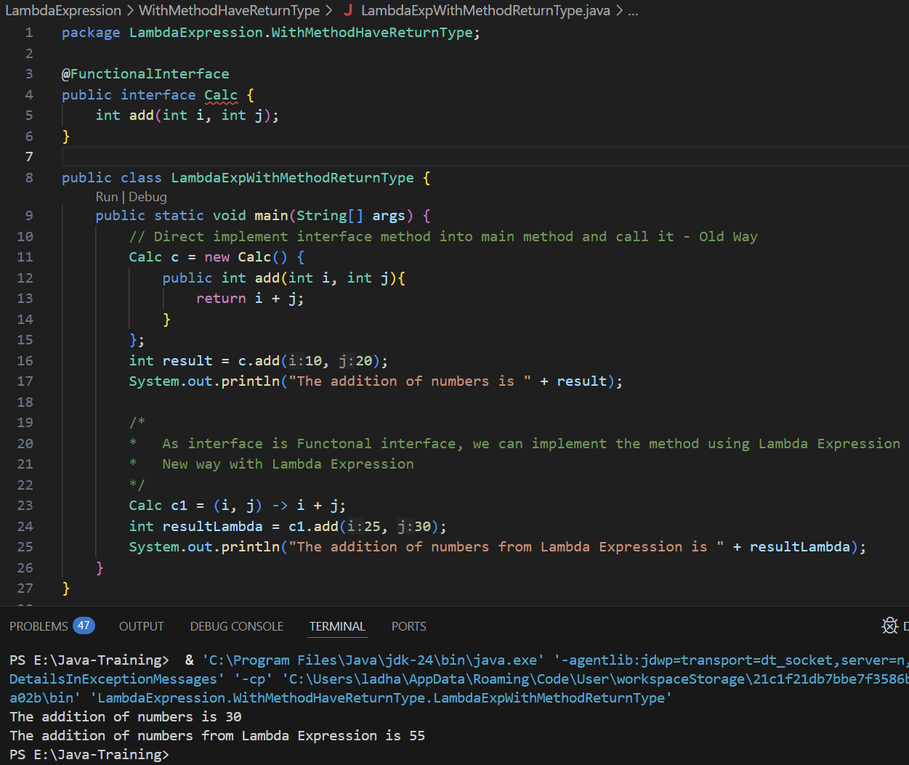

* + **Syntax for Lambda expression:** with multiple parameters

@FunctionalInterface

interface InterfaceName {

returnType methodName(dataType variableName1, dataType variableName2, …);

}

public class MainClass {

PSVM(String args[]) {

InterfaceName objName = (variableName1, variableName2, …) 🡪 SOUT(“Some Message”); **// We no need to provide datatype while passing parameter bcoz we have already mentioned in method into the interface**

objName.methodName(value1, value2, …);

}

}

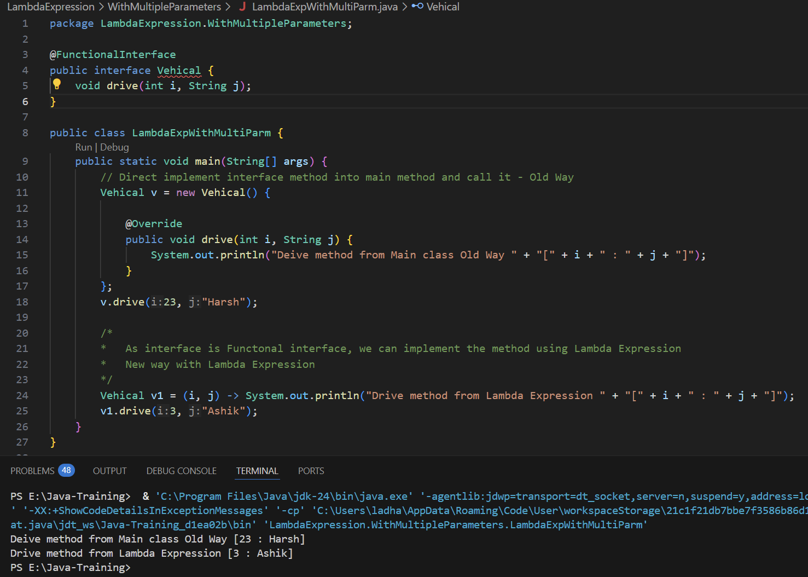

* + **Lambda expressions: Conclusion**
    - It works with only Functional Interface which has only one method to implement it.
* **Exceptions: (try-catch-finally block)**
  + **Exception** is an object that describes an error condition that occurs or could occur during the execution of a program. When any error occur, java will create an exception object and “throws” it and the program can “catch” the exception and handle it gracefully.
  + In java, exceptions are event that interrupt or disrupt the normal flow of the program execution.
  + Exceptions mainly handle the RUNTIME ERRORS so that program does not crash unexpectedly.
  + **Types of error in Java:**
    - Compile-time Error
    - Runtime Error
    - Logical Error
  + **Compile-time Error:**
    - This type of Error occurs only during compile time of the code.
    - It is detected by the Java Compiler before program runs or executed.
    - **Example:**
      * Syntax Errors such as missing semicolon (;), brackets, etc.
      * Type mismatches such as assigning String value to integer data type
      * Use undeclared values or forgot variable declaration
      * Calling methods which do not exist
    - **How to fix Compile-time errors:**
      * Read the error message and follow the instructions like which line has error occurs and what is missing to declare or what is syntax mismatch.
      * Correct the syntax mismatch and type mismatches in the code.
    - This type of errors are easy to solve by looking at the code without debugging it.
    - In the Compile time error, program cannot compile and execute it.
  + **Logical Error:**
    - **When the is a mistake in the program logic that produces incorrect output, it is called logical error.**
    - In this type of error, program will compile and run successfully but its output will be incorrect.
    - **Example:**
      * Incorrect formulas
      * Using wrong loop conditions
      * Writing a statement in wrong order
    - **How to fix Logical Error:**
      * Debug and UNIT TESTING the code and check the logical flow of the code
      * Review algorithms and flow execution
    - In this type of error, code will be executed successfully without any errors but whatever the output it generates, it will be incorrect and unexpected.
  + **Runtime Error:** *try-catch-finally block*
    - **It is called EXCEPTIONS.**
    - This type of error will occur while program is running or during run time of code.
    - In this type of error, program compiles successfully but it crashes during the execution due to unexpected conditions such as Index out of bound, Divide number with zero, etc.
    - In the runtime error, in the code whenever it got an error, the execution will stop immediately from that line and throw an error. It will skip execution rest of the code and throw an error.
    - But while we use the try-catch block in the code and add critical lines which might generate an error to the try block and in the catch block we add message, it will execute the whole code and provide error message too which we added in the catch block.
    - **Examples:**
      * ArithmeticException – number divided with zero
      * NullPointerException – accessing an object that is null
      * ArrayIndexOutOfBoundException
    - **How to fix Runtime Error:**
      * To fix runtime Error, we need to use exception handling blocks which contains **try-catch-finally**.
      * While we write a try catch-block, in try whichever code lines are critical and could throw an error need to add in the try block and in the catch block we can write error messages or print predefined error message.
  + “***try-catch***” block:
    - Simple Syntax:

**try{**

*// Error Critical Statements*

**}**

**catch (ExceptionType OR Exception objectName) {**

*// Add code and error message that handle the exception*

**}**

* + - **The flow of try-catch block:**
      * try block will execute and if exception occur then Java will immediately exit the try block and transferred to the catch block (if we add specific exception type then it will execute that and if we add main Exception class then will execute that one.)
      * Even if try block have multiple lines added but got exception in very first line, it will not execute rest of the other lines and jump out of the try block and start executing catch block.
      * But if there is no exception occurs, then it will skip the catch block and execute rest of the code.
      * By adding object of exception "ae" in the print statement, it will print the predefined exception message

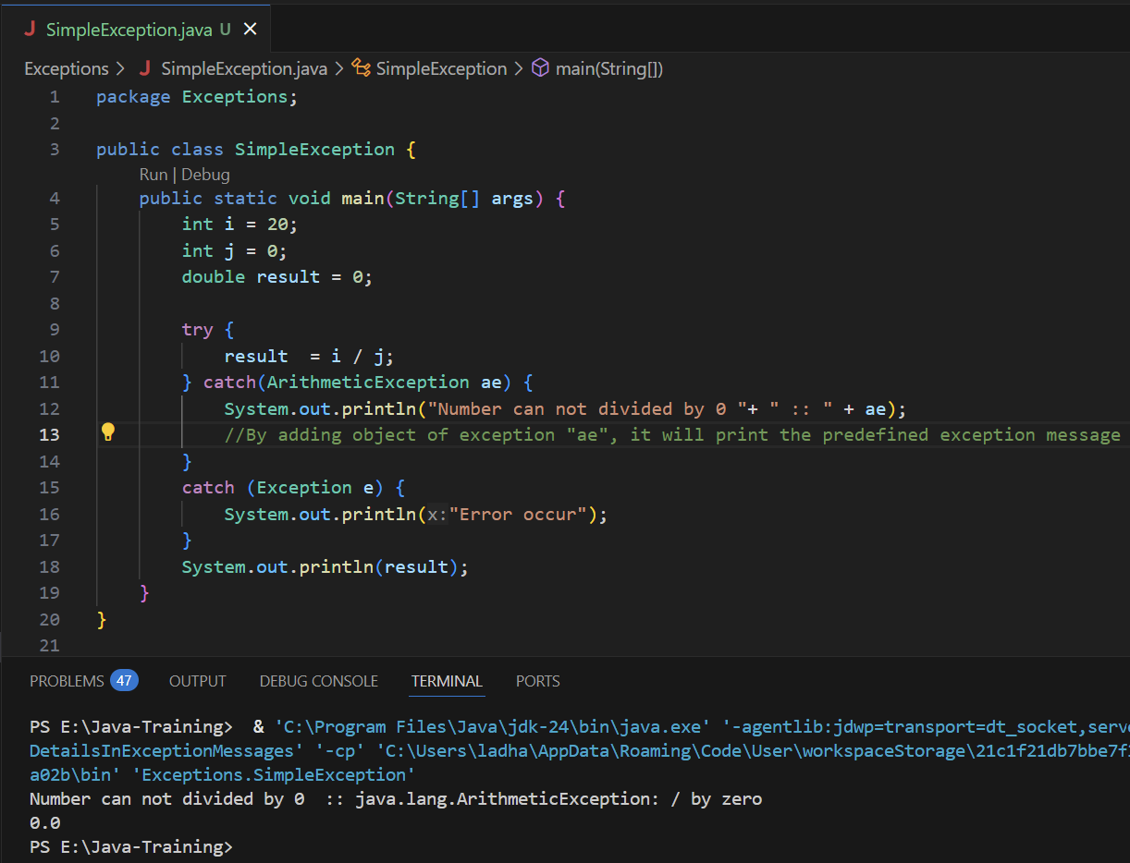

* + - While we do coding, we will get multiple types of exceptions but if we write only one catch block then we could not deliver appropriate message or exception instruction. So, to overcome this issue, we need to write multiple catch blocks with specific exceptions.

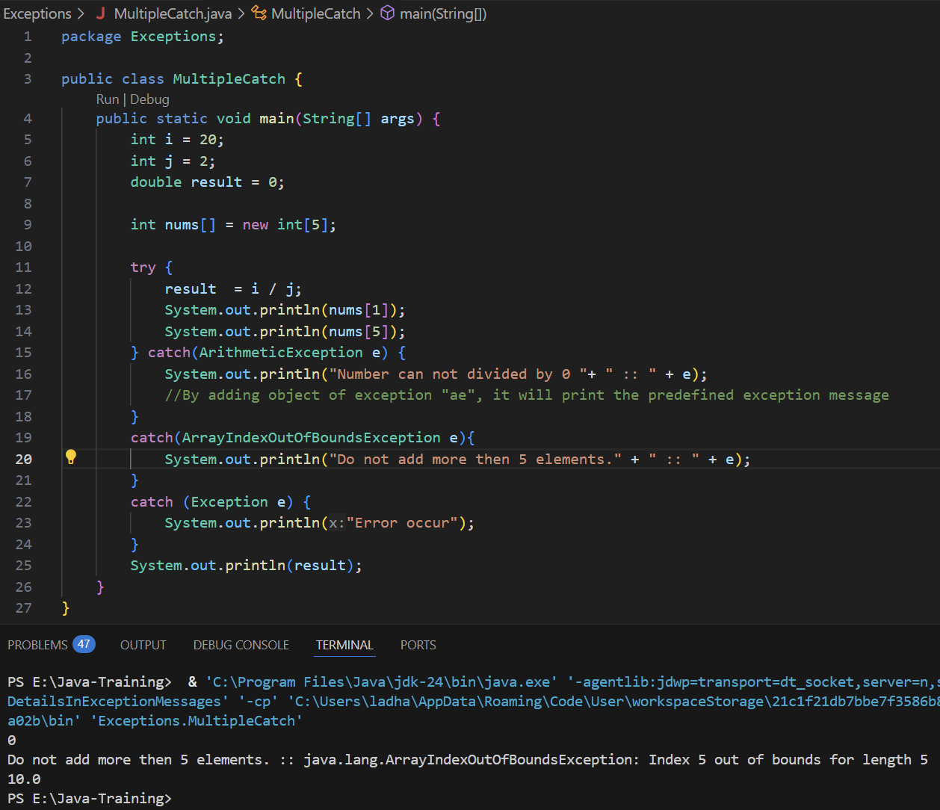

* + - While we write an exception for possible errors and we are not sure what type of error will occur then it will run MainException class catch block. If we want to know what type of error occurred then we can simply pass exception object to print statement.

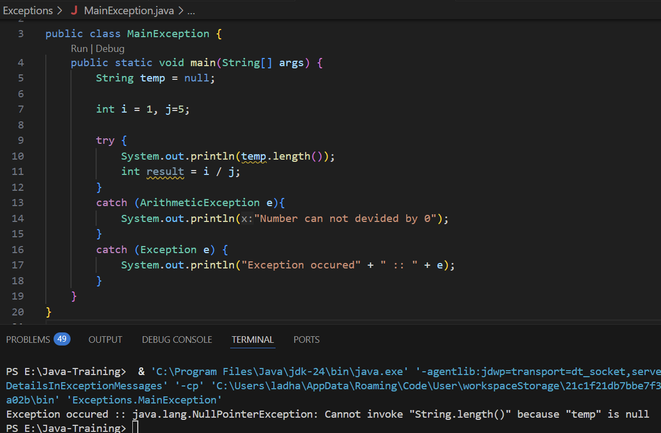

**(NOTE: IF WE ARE GOING TO USE AN EXCEPTION PARENT CLASS “EXCEPTION E” IN CATCH BLOCK ALONG WITH SPECIFIC EXCEPTIONS CATCH BLOCK THEN WE NEED TO KEEP PARENT EXCEPTION CATCH BLOCK “catch (Exception e)” AT THE END OF ALL THE SPECIFIC EXCEPTION CATCH BLOCK OTHERWISE IT WILL THROW AN ERROR.)**

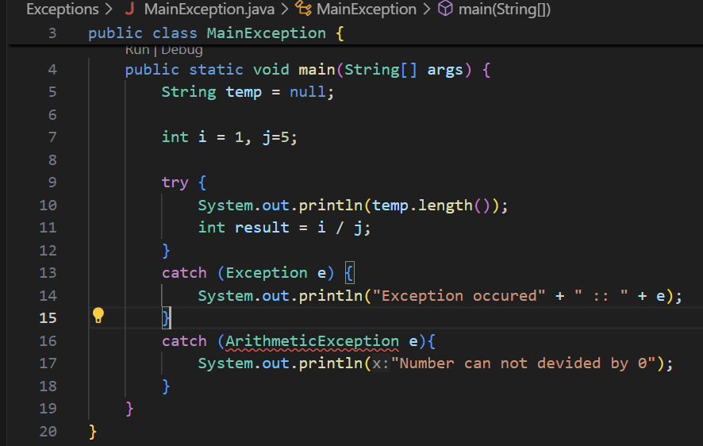

* + **Exception Class Structure:**

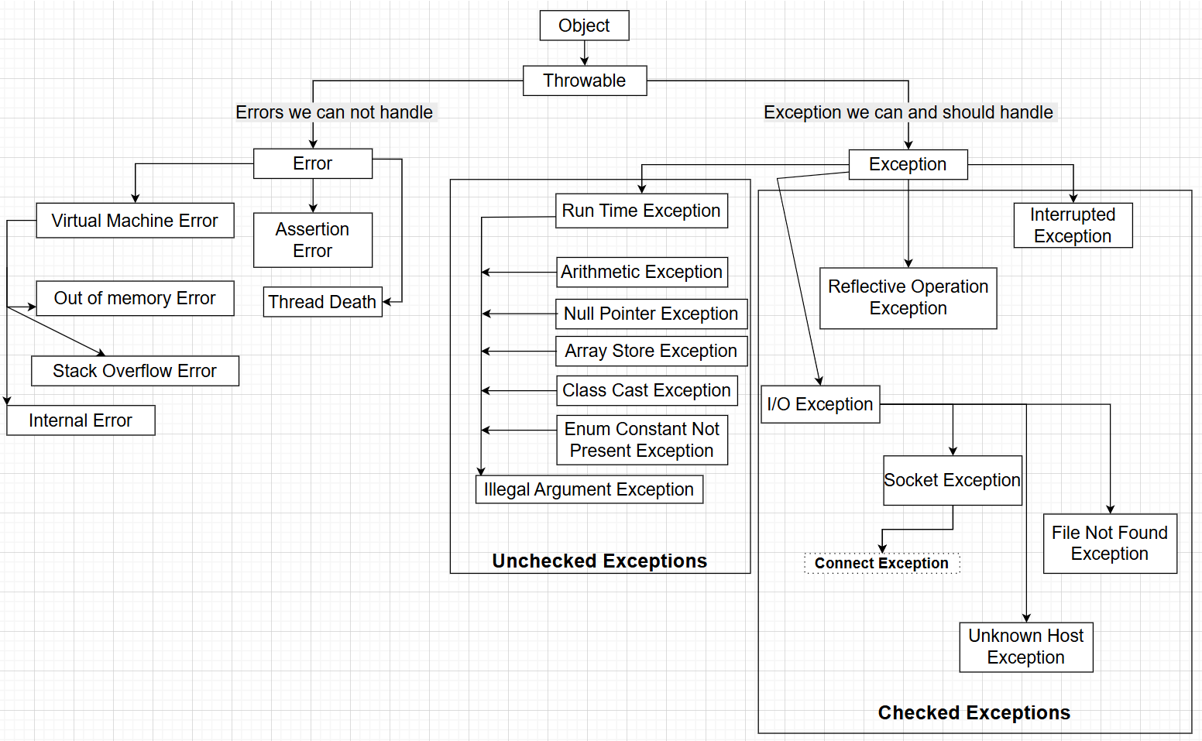

* + **All the Runtime exceptions are unchecked exceptions means that there is no compulsory to handle it.**
  + **While except Runtime exceptions, other are unchecked exceptions means we have to handle it.**
  + **All the errors we cannot handle . So, whenever it occurs, we need to restart the execution of the code.**
  + **All the exceptions we can handle so for that we need to write a code.**
  + “***try-catch-throw***” block:
    - During exception, instead of generating error messages for the exceptions, we handle it and try to resolve it then we need to “***throw***” exception by writing conditions in “***try***” block and “***catch***” block will catch that exception and handle it. In the catch block we need to write handling code or default message.
    - Whatever type of exception we throw in try block, we will have to make catch block of it.
    - If we want to add message during exception occurred, then put message in the exception constructor.
    - **Syntax:**

**try {**

**// Code**

**throw new ExceptionTypeClass(“Add message”);**

**}**

**catch (ExceptionTypeClass object){**

**// Code**

**}**

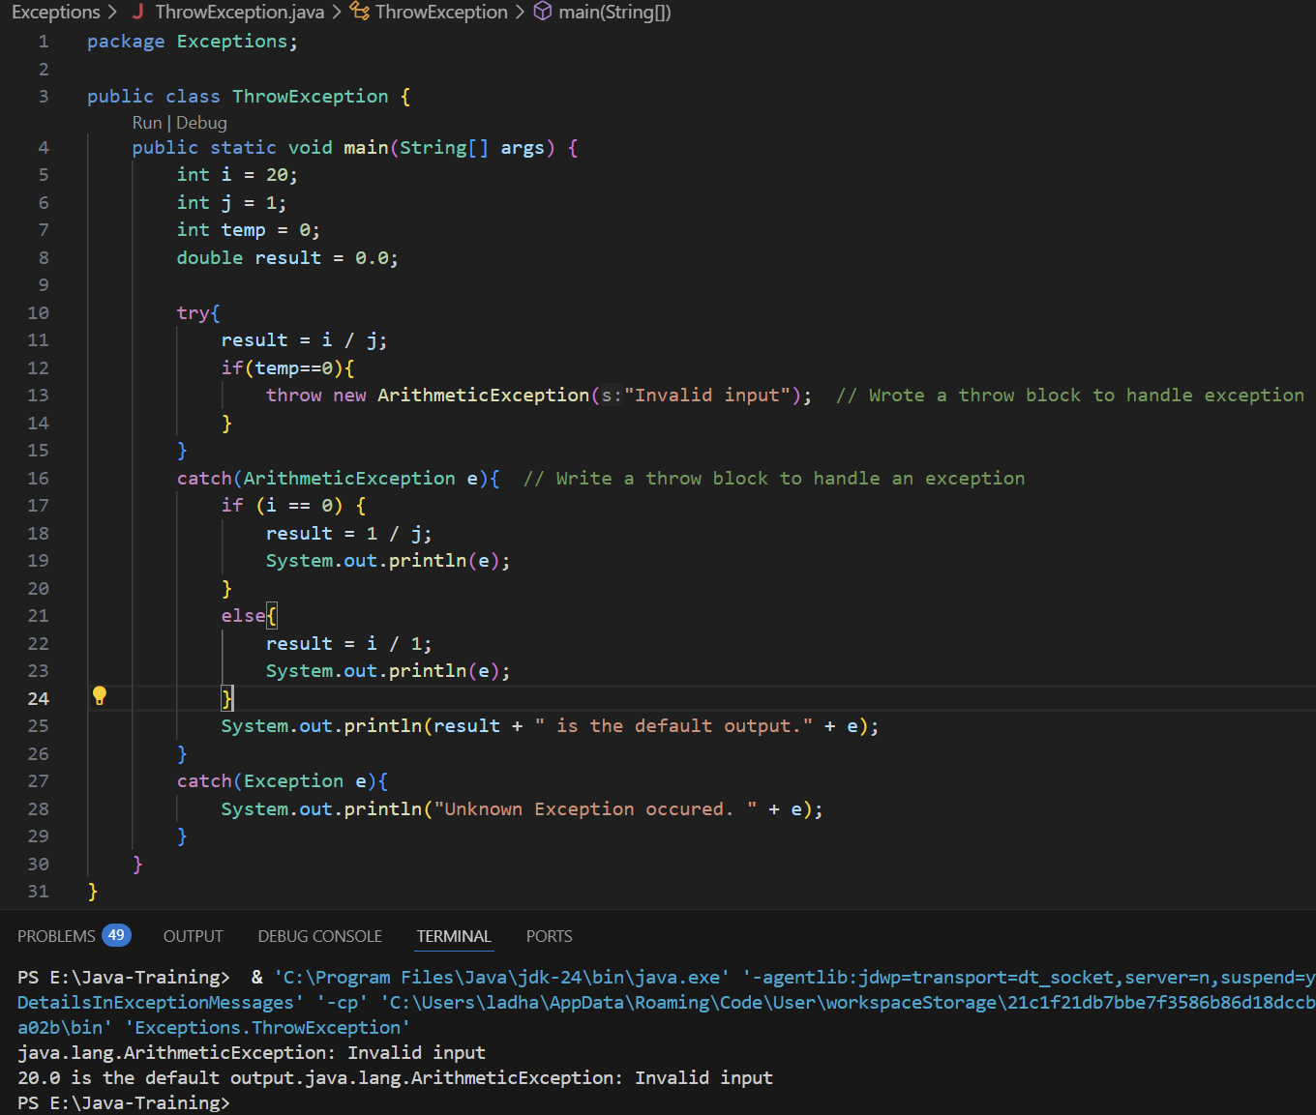

* + **Create User Defined Exception block:**
    - If we want to make our own exception and throw and display message accordingly then we need to follow the steps below:
      * **Step 1:** Create an class that needs to extends Exception class
      * **Step 2:** In the class create a constructor that accepts a String parameter and add super method with String parameter
      * **Step 3:** In the main method class try block, throw the exception with the message using the name of the constructor we created for user defined exception.
      * **Step 4:** In the catch block also use same constructor name to handle exception
      * **Syntax:**

class UserDefinedExceptionClassName {

public UserDefinedExceptionClassName(String string) {

super(string);

}

}

public class Main{

PSVM(String args[]){

try {

// Try block code

throw UserDefinedExceptionClassName(“Pass Message”);

}

catch (UserDefinedExceptionClassName e){

// Code to handle exception

}

}

}

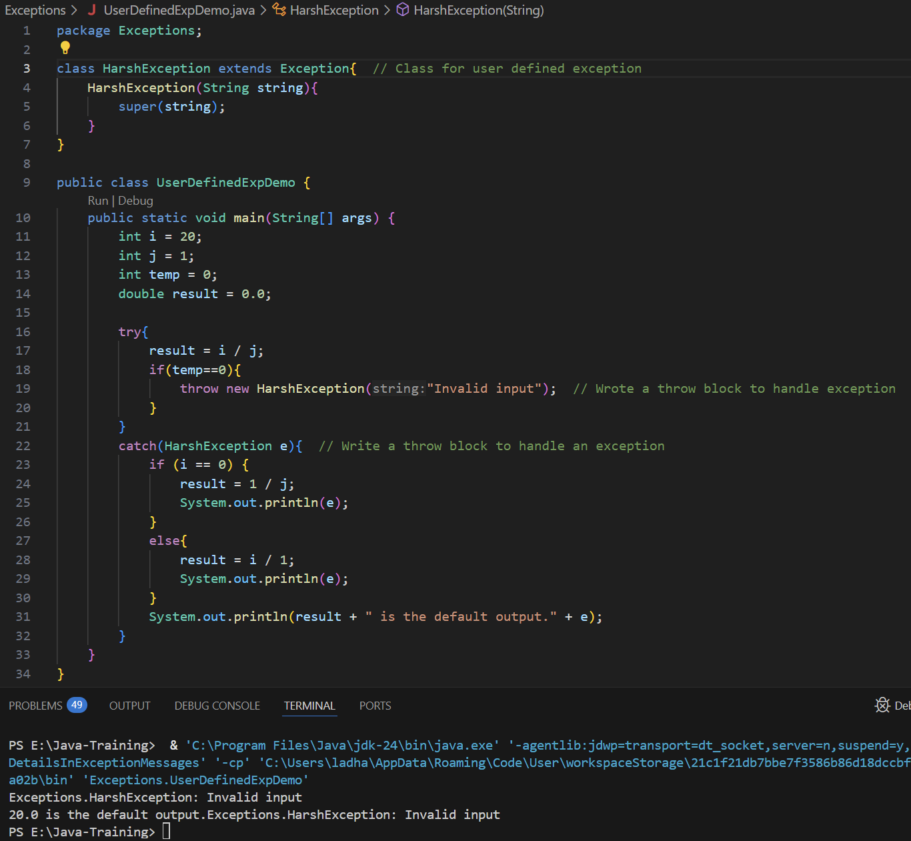

* + **Ducking exception using “*throws*” keyword:**
    - While we have multiple methods implemented in the application and want to handle exception handle by only last class where actual try…catch blocks written then we can use ***“theows”*** keyword for each of the class and the last class will handle the exception.
    - That last class could be any class or main method.
    - Whenever we use throws keyword, at least one class have to catch the exception. Otherwise it will throws an error.
    - It is not good idea to add throw exception in main method. At least last class main method class that need to catch the exception and inside that need to implement try-catch block.

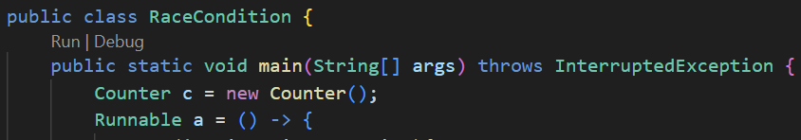

* + - throws keyword we need to write while method of class declare.
    - **Syntax:**
      * class ClassName{

public returnType methodName() throws ExceptionType or Exception {

// code to implement

}

}

public class Main {

PSVM(String args[]) {

// Code to implement

try {

// Try block code

}

catch (ExceptionType or Exception objectName) {

// catch block code

}

}

}

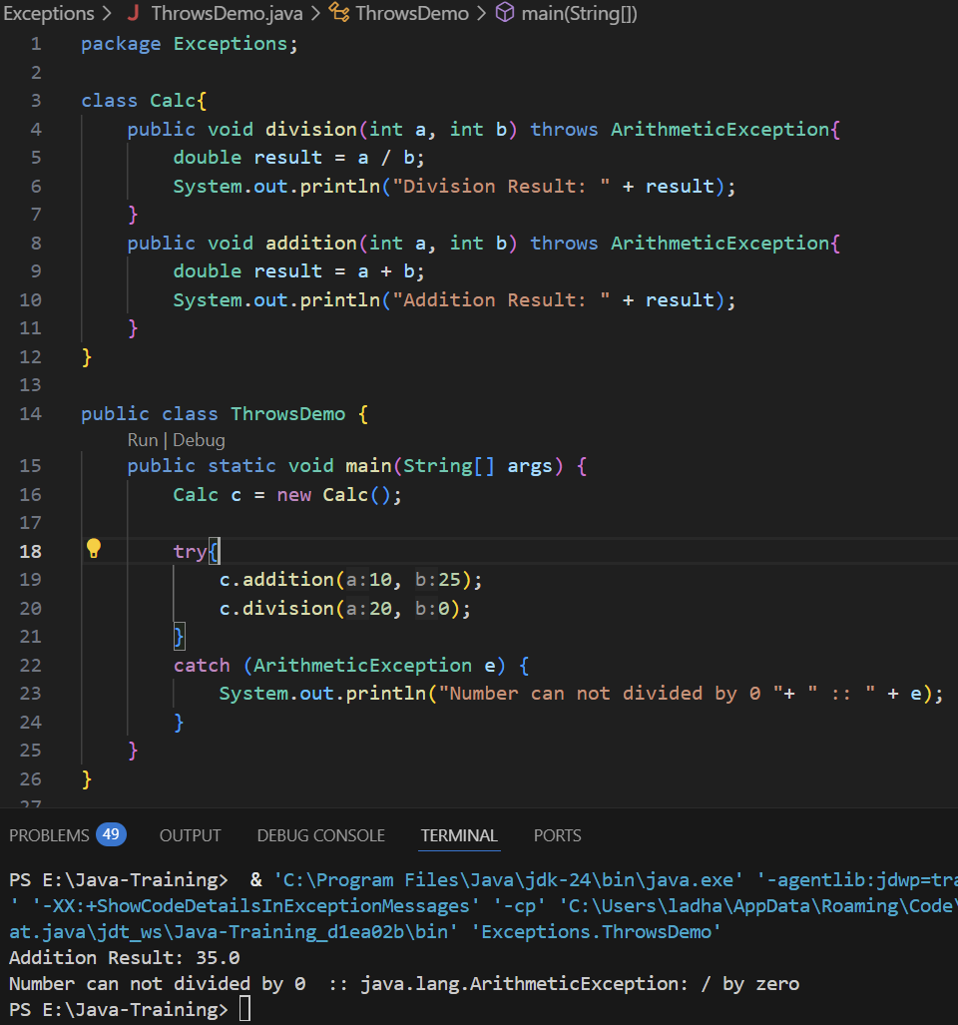

* + ***try-catch-finally*** block**:**
    - While we use try block then there is compulsory to use catch block along with it. Which try will detect and throw the exception and catch will simply catch the exception and handle it.
    - But if we don’t have scenario that can handle the exception then we can use finally block instead of catch block.
    - We can also use try-catch-finally block.
    - Flow of finally block is that whether we got an exception or not finally block will definitely execute.
      * If we got an exception, first try block will execute, then catch block will handle it and then finally block will execute.
      * If there is not any exception then first try block will execute, then finally block will execute.
    - The main use of finally block is, whenever we want to close a resource such as close file, close db connection, etc.
    - In real-world scenarios, when we perform operations on files such as reading, writing, or deleting, there may be situations where we either do not have specific exception handling logic or we have already added a catch block. In both cases, it is important to ensure that the resource (e.g., the file) is properly closed. To guarantee this, a finally block should be used to close the resource regardless of whether an exception occurs.
    - **Syntax:**

try{

// Try block code

}

catch (Exception/ExceptionType e){

// Catch block code

}

finally{

// Finally block code

}

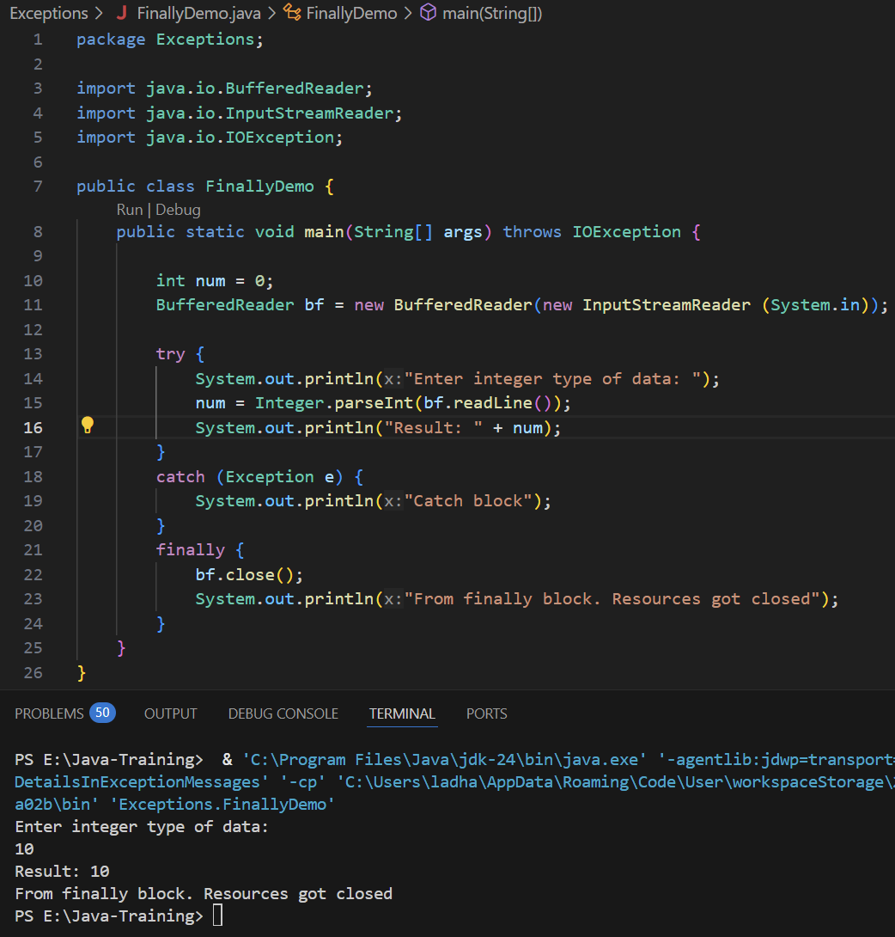

* + - In the version of java v7.0 there is new syntax introduced try with resources. In that we can simply pass the resources in the try block in the parent braces “(…)”.
    - Java will automatically close the resources when the execution is completed. It means that we no need to write finally block to close the resources manually.
    - On the backend, there is a Closeable interface which extends AutoCloaeable class which close the resources automatically with the help of try.
    - **Syntax:**

try (

ResourceType1 resource1 = new ResourceType1(...);

ResourceType2 resource2 = new ResourceType2(...)

) {

// Try block code

}

catch (Exception/ExceptionType e){

// Catch block code

}

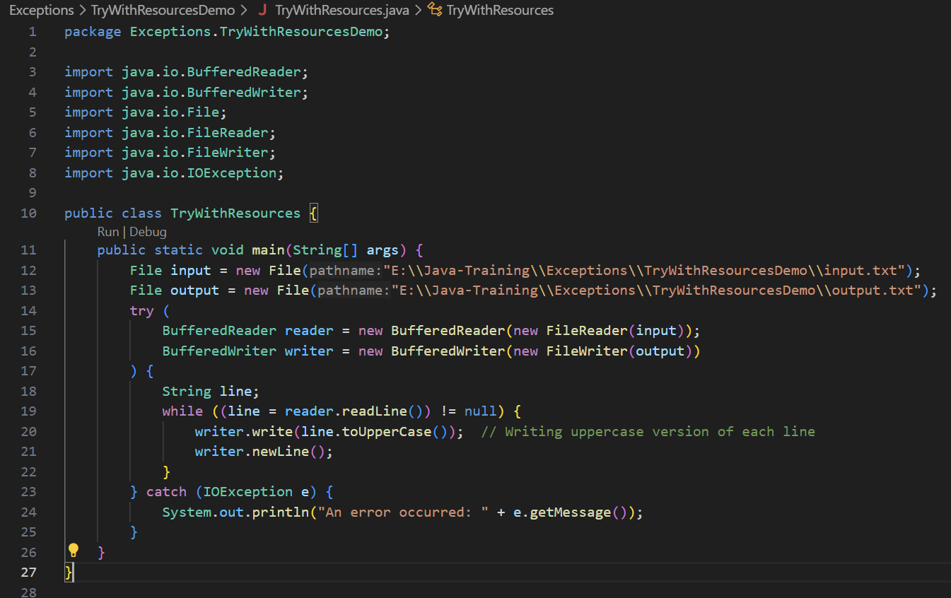

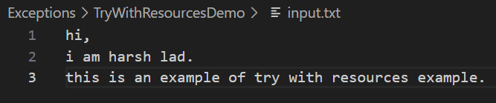

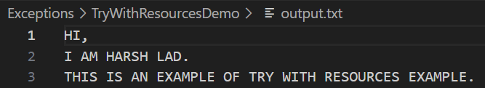

* **How to take input from User:**
  + To take an input from User in Java, there two ways to perform it:
    - Using BufferedReader class
    - Using Scanner class
  + Whenever we use any of the class, we will have to import necessary package according to which class we use.
  + **Take an input Using BufferedReader class:**
    - While we use ***BufferedReader*** class to take input from the user, we will have to ***import java.io.InputStreemReader;*** package.
    - While we use ***BufferedReader*** class, follow the steps below:
      * Import ***java.io.InputStreemReader***; package
        + *import java.io.InputStreemReader;*
      * Create an object of ***InputStreamReader*** class and pass ***System.in*** as a parameter
        + *InputStreamReader in = new InputStreamReader(System.in);*
      * Create an object of ***BufferedReader*** class and pass an object of ***InputStreamReader*** class ***in***
        + *BufferedReader bf = new BufferedReader(in);*
        + *If we want to skip above step, then pass object of InputStreamReader class directly to BufferedReader class.*

***BufferedReader reader = new BufferedReader(new InputStreamReader(System.in));***

* + - * Define a variable where we need to store the value and convert value explicitly as readLine() method stores value as String type. Follow the syntax below:
        + **For Integer type input:**

int variableName = Integer.parseInt(bf.readLine());

SOUT(variableName); // Display value of user provided input

* + - * + **For String type input:**

String variableName = bf.readLine();

SOUT(variableName); // Display value of user provided input

* + - * + **For Double type input:**

double variableName = Double.parseDouble(bf.readLine());

SOUT(variableName); // Display value of user provided input

* + - * + **For Float type input:**

float variableName = Float.parseFloat(bf.readLine());

SOUT(variableName); // Display value of user provided input

* + - * + **For Long type input:**

long variableName = Long.parseLong(bf.readLine());

SOUT(variableName); // Display value of user provided input

* + - * + **For Boolean type input:**

boolean variableName = Boolean.parseBoolean(bf.readLine());

SOUT(variableName); // Display value of user provided input

* + - * + **For Char type input:**

char variableName = bf.readLine().chatAt(0); // Read 1st character

SOUT(variableName); // Display value of user provided input

* + - * BufferedReader class is actually a resource because for example, while we open a file or a open a DB connection, its developer responsibility to close it. Same way when we use BufferedReader class we have to close it using close() method. For that follow the syntax below:
        + ***BufferedReader bf = new BufferedReader(new InputStreamReader(System.in));***

***// Code to implement***

***bf.close();***

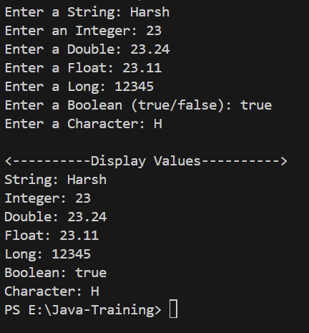 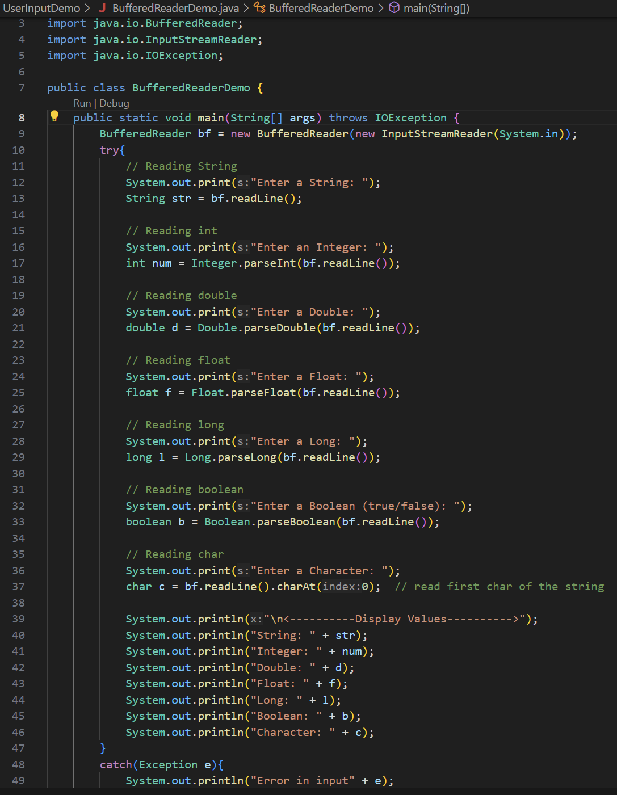

* + **Take an input Using Scanner class:**
    - While we use **Scanner** class to take input from the user, we will have to ***import java.util.Scanner;*** package.
    - In the Scanner class, we no need to
    - While we use **Scanner** class, follow the steps below:
      * import ***java.util.Scanner*** package
        + import ***java.util.Scanner;***
      * Create an object of the scanner class and pass the parameter ***System.in***:
        + ***Scanner sc = new Scanner(System.in);***
      * Define a variable where we need to store the value:
        + **For Integer type input:**

int variableName = sc.nextInt();

SOUT(variableName); // Display value of user provided input

* + - * + **For String type input:**

String variableName = sc.nextLine();

SOUT(variableName); // Display value of user provided input

* + - * + **For Double type input:**

double variableName = sc.nextDouble();

SOUT(variableName); // Display value of user provided input

* + - * + **For Float type input:**

float variableName = sc.nextFloat();

SOUT(variableName); // Display value of user provided input

* + - * + **For Long type input:**

long variableName = sc.nextLong();

SOUT(variableName); // Display value of user provided input

* + - * + **For Boolean type input:**

boolean variableName = sc.nextBoolean();

SOUT(variableName); // Display value of user provided input

* + - * + **For Char type input:**

char variableName = sc.next.chatAt(0); // Read 1st character

SOUT(variableName); // Display value of user provided input

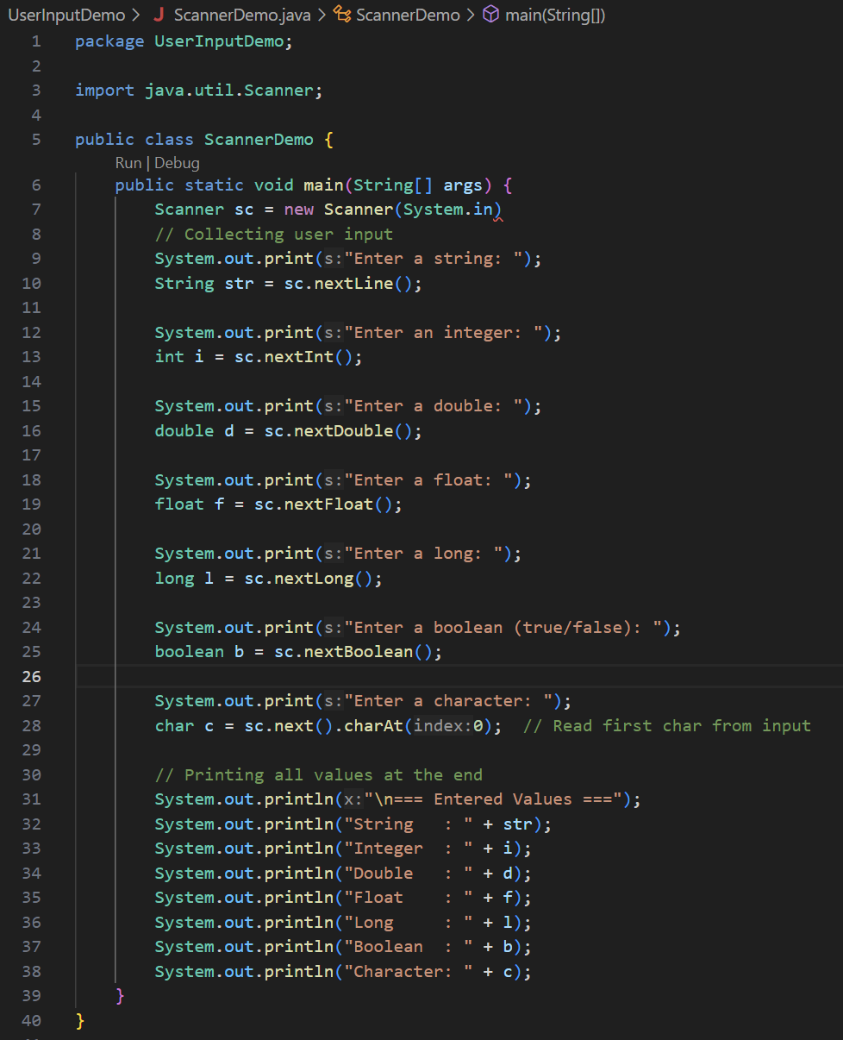

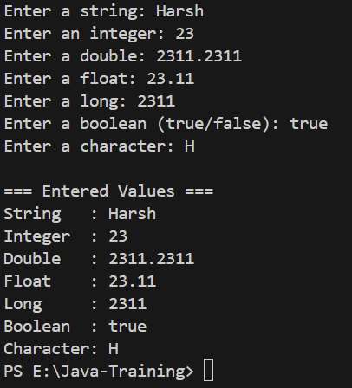

* **Threads:**
  + Thread is a lightweight process in java- smallest unit of execution within a program.
  + In the multiple task running on same time and dividing task in the small unit and everything parallelly.
  + If we want to execute more then one method that time we can use thread.
  + **Most of time we don’t create or write threads by ourself, most of the time we will use certain frameworks, and it will create threads in behind the scenes. But it’s always better to get hands on in certain core concepts.**
  + **There are two ways to create Threads:**
    - Extending “***Thread***” class
      * class ClassName **extends** Thread
    - Implementing “***Runnable***” interface
      * class ClassName **implements** Runnable
  + Create Thread by Extending “***Thread***” class:
    - In whichever class we want to use thread we need to extend thread class to that class.
    - In the every thread class, we need to implement a ***“run()”*** method.
    - While calling a thread class from other class or main method, we need to call a ***“start()”*** method with the object of the thread class.
    - **Syntax:**

class ClassName_1 extends Thread {

public void run() { // Run method of Thread. Need it compulsory

// Add code

}

}

class ClassName_2 extends Thread {

public void run() { // Run method of Thread. Need it compulsory

// Add code

}

}

public class Main {

PSVM(String args[]){

ClassName_1 objectName_1 = new ClassName();

objectName_1.start(); // Start method of Thread. Need it compulsory

ClassName_2 objectName_2 = new ClassName();

objectName_2.start(); // Start method of Thread. Need it compulsory

}

}

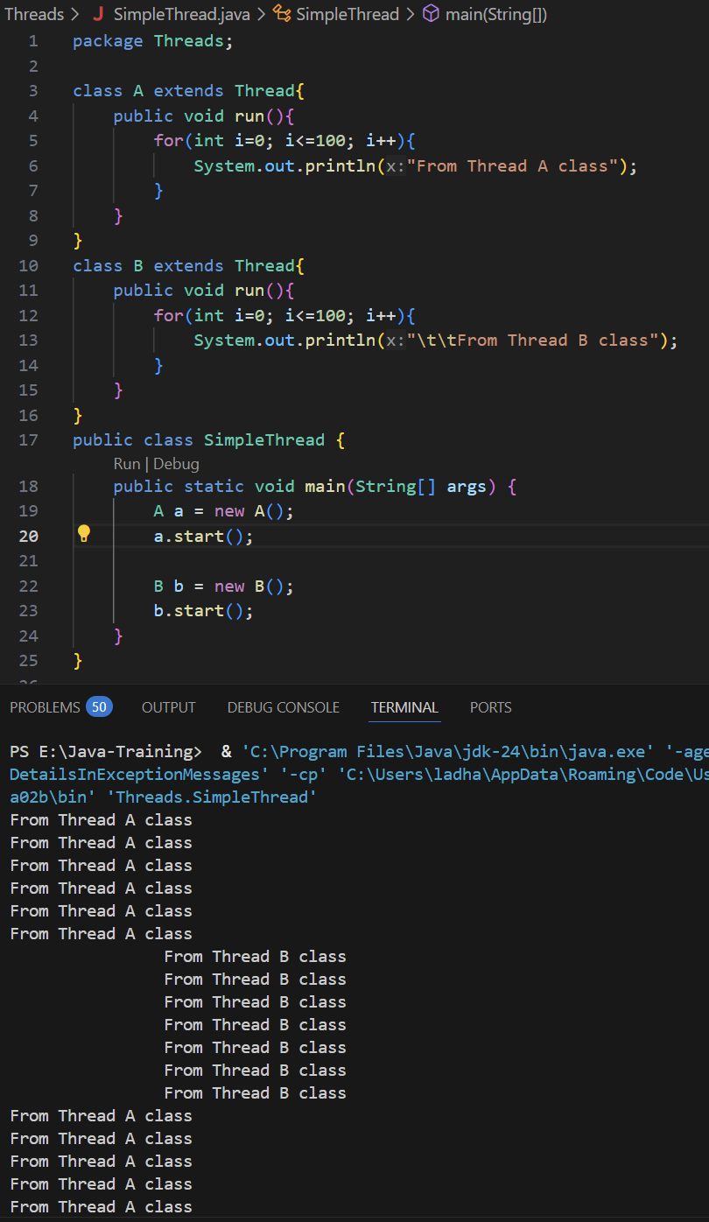

* + - In the thread we can set the thread priority as well as check the thread priority.
      * To set priority, use objectName.***setPriority(Add number between 1 to 10);***
      * To get priority, use objectName***.getPriority();*** method
    - In the thread priority, we can set between 1 to 10 in that 1 is the least priority and 10 is the highest priority or maximum priority **and 5 is the default, normal or medium priority**.
      * To set priority with the constant then use the syntax below:
        + objectName.setPriority(Thread.**MAX_PRIORITY**);
        + objectName..setPriority(Thread.**MIN_PRIORITY**);
        + objectName..setPriority(Thread.**NORM_PRIORITY**);
    - Thread runs based on the schedulers and even if we set the thread priority, still schedular algorithm will decide the which process run first based on the algorithm.

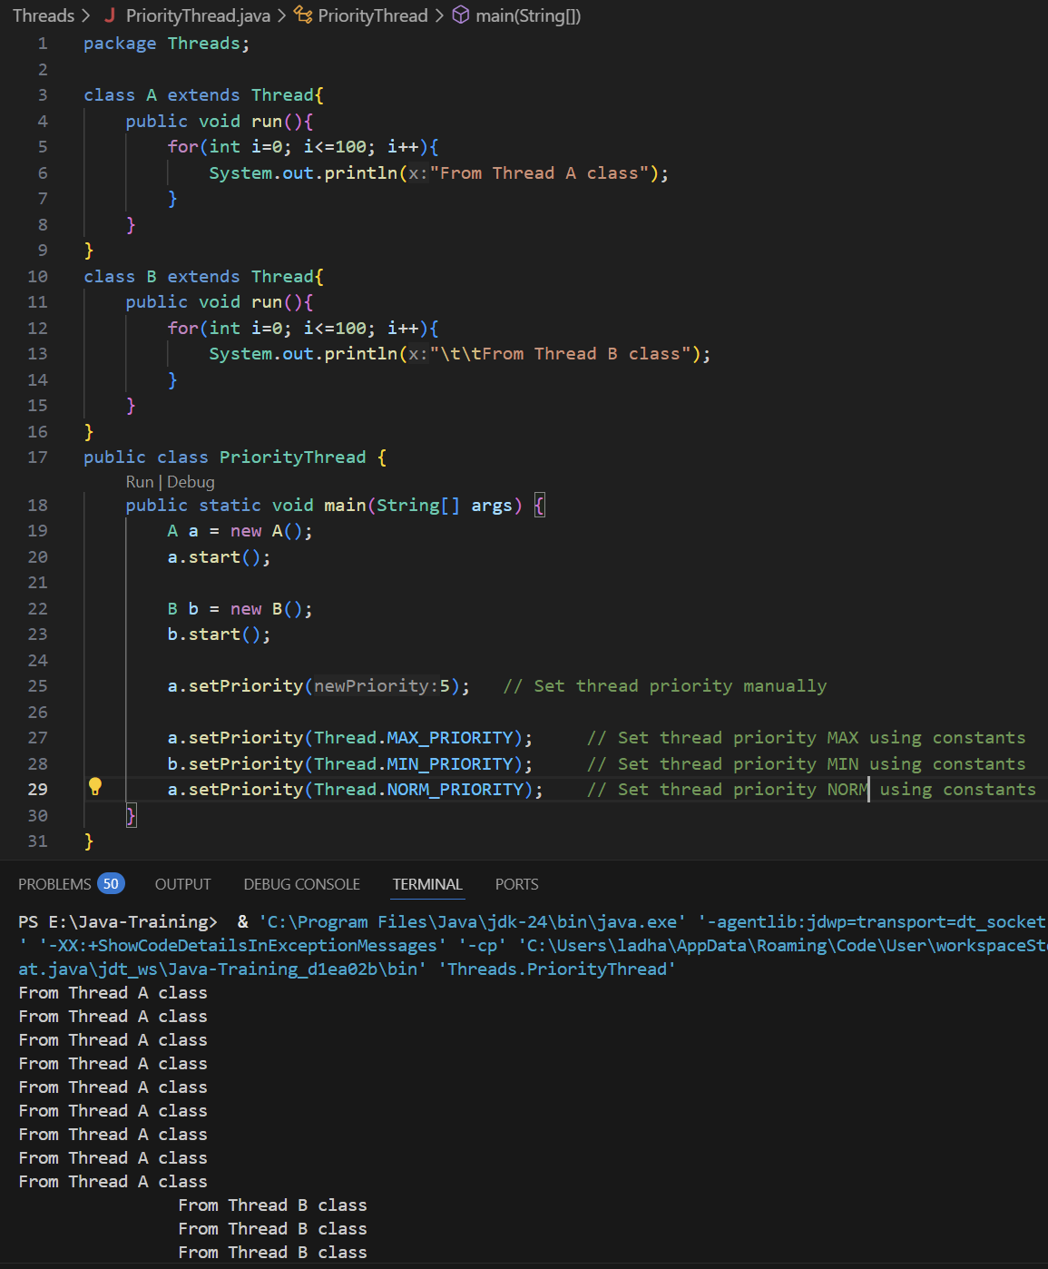

* + - To make thread wait for certain milliseconds to execute, we need to use ***“sleep(timeInMilliseconds)”*** method in the thread class or main class where we want to pause the execution of the process.
    - This sleep() method could throw “InterruptedException” which is checked exception the must have to handle it. So, we need to write wrapup sleep method in the try-catch block.
      * **Syntax:**

class ClassName extends Thread{

// Code to execute

try { **Thread.sleep(waitTimeInMilliSeconds);** }

catch (InterruptedException e) { // code }

}

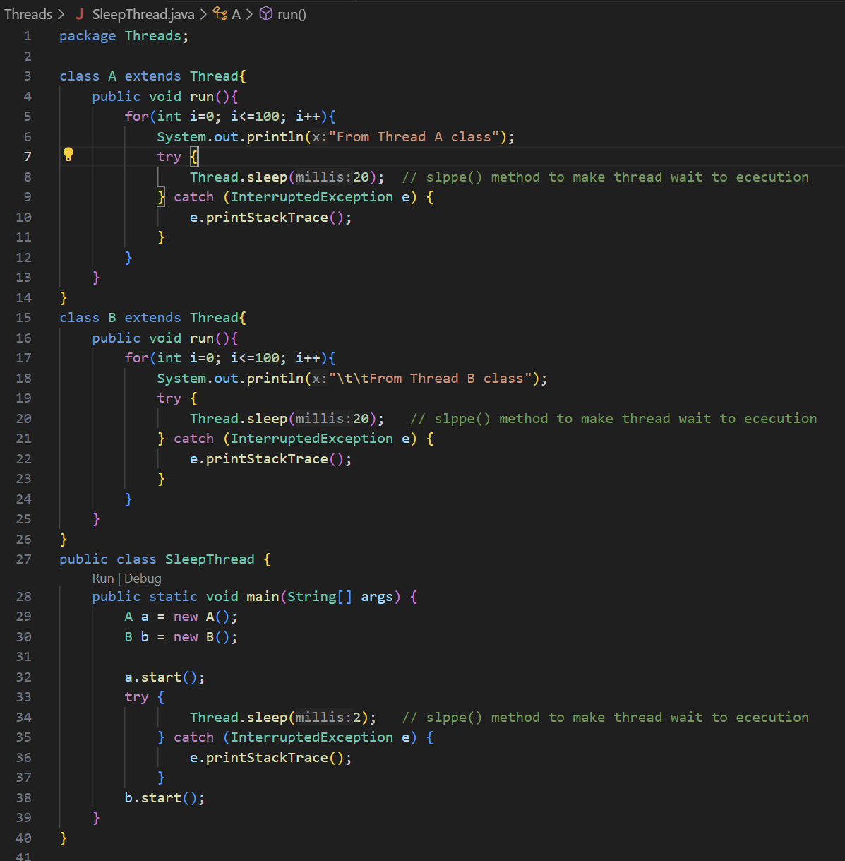

* + Create Thread by Implementing “***Runnable***” interface:
    - Runnable interface use in thread creation while we want to extend some other class and use thread as well.
    - In Java, it does not support multiple inheritance so in that case we can implement “Runnable” class and extend other class.
    - Runnable interface does not have thread method so we need to create a separate object of the Thread class and then we can use the feature of the Thread class in Runnable interface.
    - While we use *Runnable* interface to create a thread, we cannot use *start()* method directly. So for that first we need to create a object of Thread class using that object we need to call the *start()* method.(Because start() method belongs to Thread class but not Runnable interface.)

And also while we create an object of the class which we implemented Runnable interface, we need to take a reference of the Runnable interface and object of the class.

Follow the syntax below:

**Syntax:**

class ClassName implements Runnable {

// Thread code

}

public class Main {

PSVM(String args[]) {

//Create a reference of Runnable interface and create an object of class

Runnable classObjectName = new ClassName();

// Create a Thread class object and pass classObjectName to the Thread constructor in the parameter

Thread threadObject = new Thread(classObjectName);

// Call the start() method using threadObject

threadObject.start();

}

}

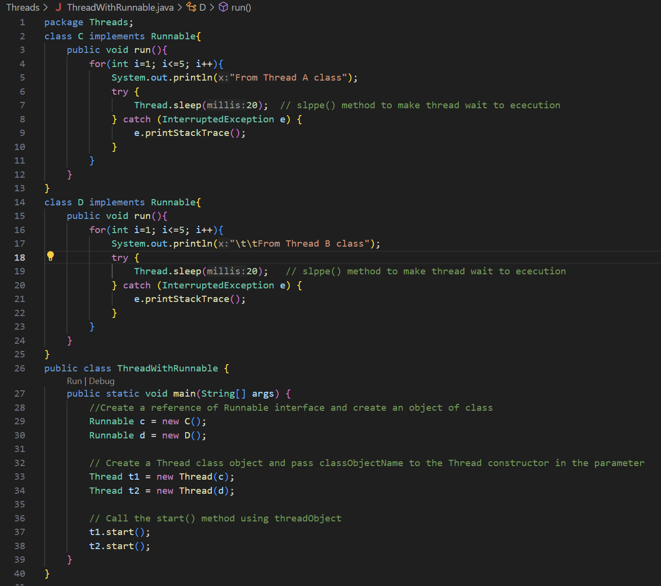

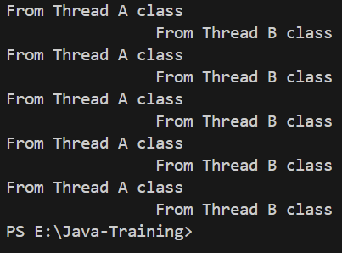

* + **Implement Thread using Lambda expression using Runnable interface:**
    - **As Runnable interface is a functional interface (have only one method defined), we can use Lambda Expression for it.**

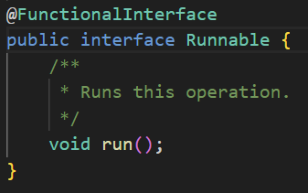

* + - In the main method first we need to create an anonymous class and inside of that class we need to implement the run() method Runnable.
      * **Syntax:**

public class Main {

PSVM(String args[]){

Runnable objectName = () 🡪

{

// Thread code

};

Thread t1 = new Thread(c);

        // Call the start() method using threadObject

        t1.start();

}

}

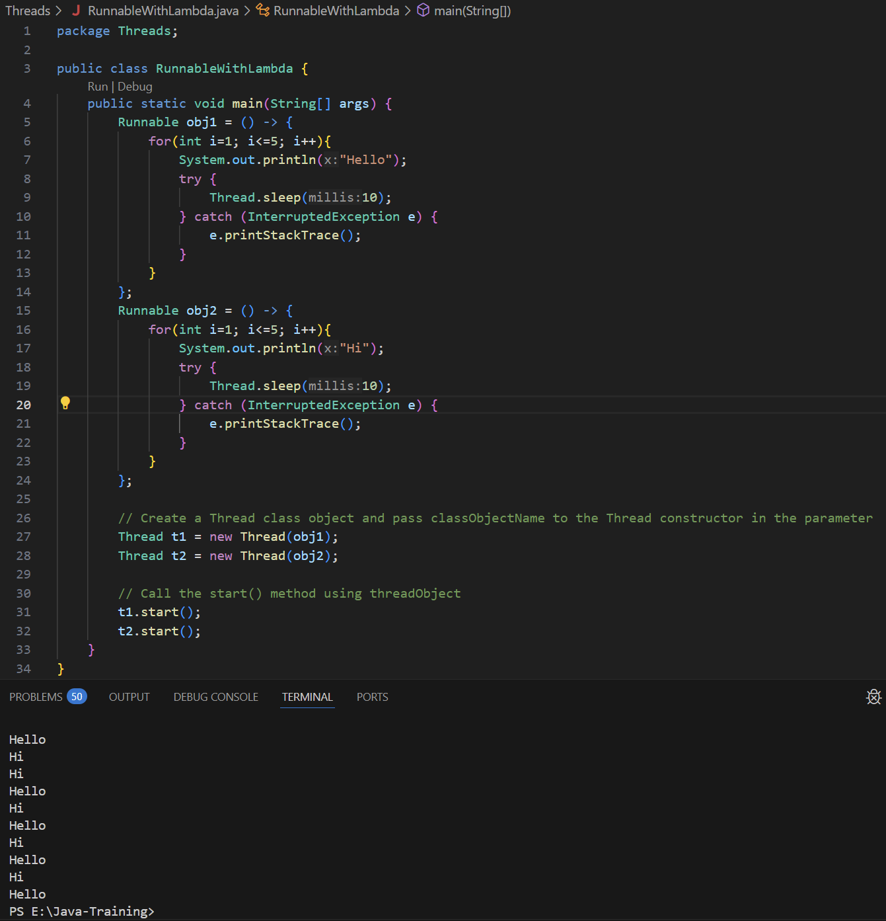

* + **Race Conditions in Threads:**
    - Threads and Mutation (Changing values) at the same time is not a good idea or good practice. So, whenever we work with thread try always work with the data which is immutable.
    - When we use the method that make some mutation then make it thread safe. Thread safe simply means only one thread can work at one time with that method.
    - **A race condition in Java occurs when two or more threads access shared data and try to change it at the same time, but the final outcome depends on the timing or sequence of their execution. This can lead to unpredictable behavior and bugs that are often hard to detect and reproduce.**
    - For this situation we can use join() method. join() method allow main thread to wait to other threads come back and join but due to race condition it could produce unpredicted results. See the example below:

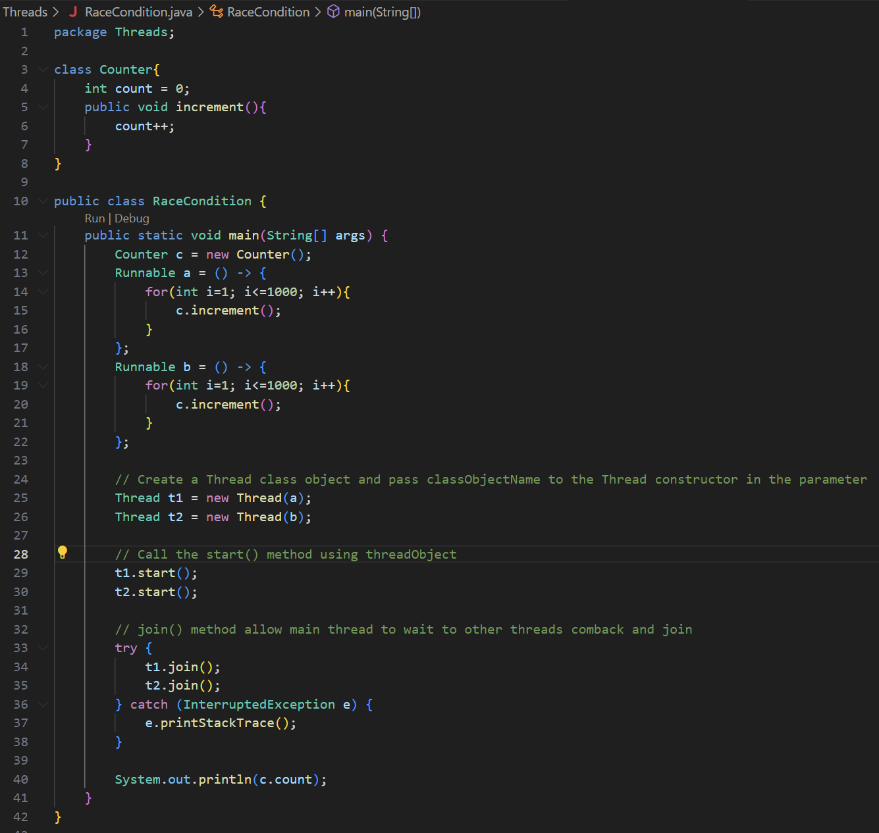

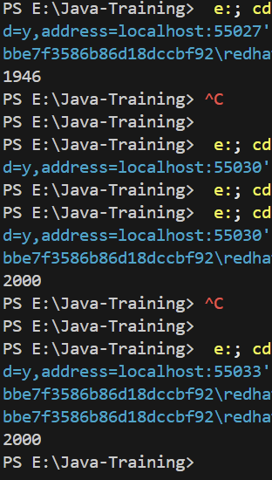

* + - In the above example we have declared shared variable “count” in the Counter class and also declared increment() method that will increase the value by 1 whenever it calls.
    - In the main method, we have created an object of counter class and that will shared by both threads.
    - Then we have created and defined two threads and each one will runs a loop for 1000 times and each iteration, it will call increment() method.
    - Then we have start the execution of thread using start() method. At the same time both thread execution will start. The expected result after both thread iteration will complete, output will be 2000.
    - We also have use join() method that will cause main thread to wait until t1 and t2 thread to finish the execution.
    - At the end we have use print statement to display final output after both thread execution will complete.
    - While analyzing the output, we can see that it is producing unwanted or unpredicted output. Sometimes it displays 1946, 2000(correct output), 1996 etc. Code should be produce 2000 output all the time but due to race condition, both thread trying to access increment() method same time and change the value of count it produce wrong output.
    - **To overcome the issue of a race condition and ensure that only one thread accesses the resource or executes the method at a time, the “*synchronized”* keyword should be added when defining the method. This ensures that other threads wait until the currently executing thread completes its execution.**
    - **Syntax:**

public ***synchronizer*** void methodName() {

// Code for method implementation

}

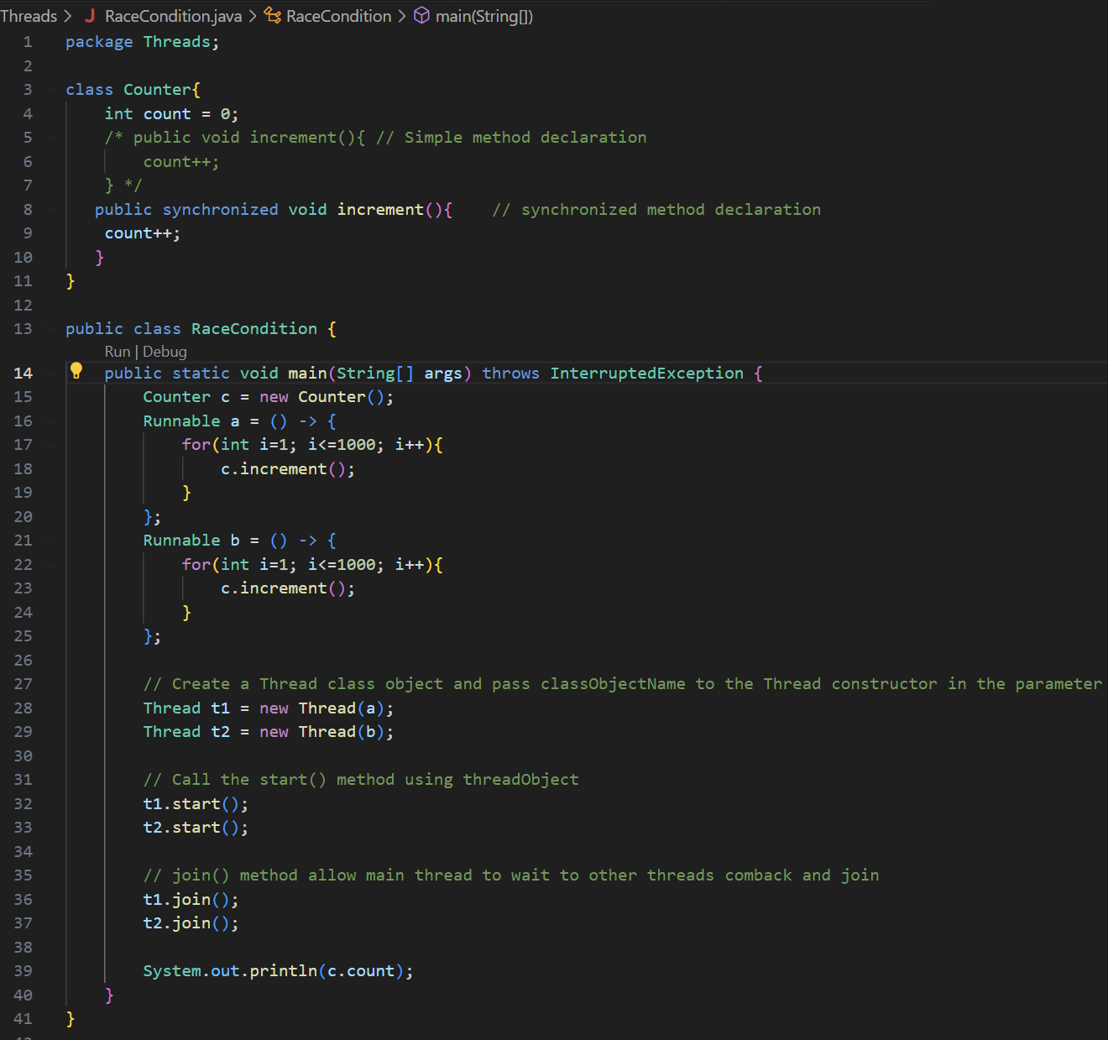

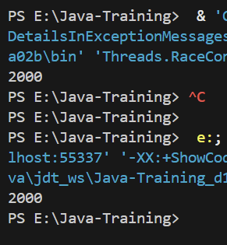

* + **Threads state:**
    - **New State:** Every time we create a thread it goes into ***New*** state.
      * **Thead t1 = new Thread();**
      * This will create a new thread, and thread will be in new state.
    - **Runnable State:** When we call start method, thread will go into runnable state. In this state the execution of the thread has not been started but waiting for the schedular.
      * **t1.start();**
    - **Running State:** When our thread is actually running on the CPU that is running state. And when the run() method got called, thread will be in the running state.
      * **t1.run();**
    - **Waiting State:** While thread is running or it is in the running state and if we want to pause the execution or keep thread on hold that time thread will be in the waiting state. To make thread in waiting state, we need to call sleep() method or wait() method.
      * **t1.sleep(); OR t1.wait();**
      * **While thread is in waiting state from running state and want to start its execution again then it will redirect to the Runnable state using notify() method.**
        + **t1.notify(); // This will redirect thread to runnable state.**
    - **Dead State:** While out thread is in running state and we want to make it dead then with the help of stop() method, we can terminate the execution of thread suddenly.
      * **t1.stop();**
      * **This can lead to without giving chance to release the resources like file handles , locks, etc. and it may leave shared objects in inconsistent state.**
      * **If a thread is updating a shared resource and stop() is called midway, data corruption can occur.**
      * **Once the thread execution will complete, it will automatically in the running state.**
      * **We can also call the stop() method while thread is in the Runnable state.**

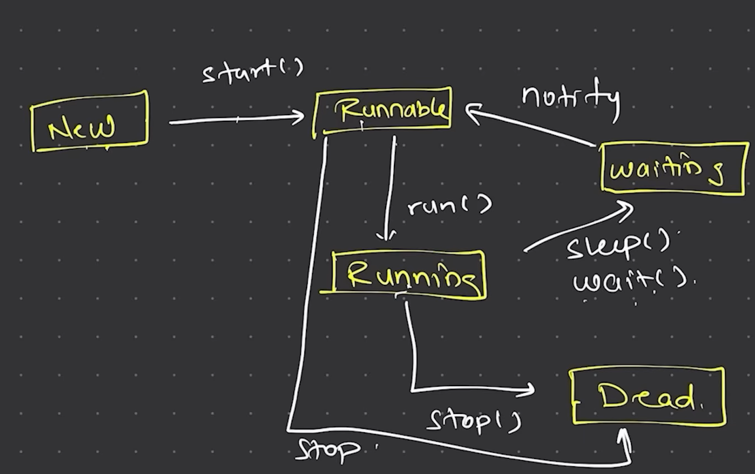

* **Collection:**
  + There are three concepts of Collection:
    - Collection API 🡪 Concept **introduced in Java v1.2**
    - Collection 🡪 Interface
    - Collections 🡪 Class
  + Whenever we want to group the elements with different datatype then we can use Collection.
  + There are certain limitations with array such as we cannot change its size, we cannot store multiple datatype values in the single array. To overcome all these issues, we can use Collection API.
  + To print elements in array we need to use iteration statements such as for, while loops to store and fetch the data while in Collection, we can use predefined method to store the data and simply using Object of collection we can fetch or display data.
  + In the we have indexing to get the position of the data while in collection there is no indexing.
  + Collection API is only works with an object.
  + **[API is a some kind of library or a feature which we can simply use it, we don’t have to implement it.]**
  + In the collection API, it supports all the Data Structure concepts pre-defined and we just have to use it and no need to write its code manually.
  + **Collection 🡪 Interface:** 
    - Collection interface is belongs to java.util package. So, while we use Collection interface we will have to import ***java.util.Collection*** package.
      * ***import java.util.Collection;***
    - Collection API works with the object.
    - There are more collection classes that implements the collection interface. Below is the hierarchy of Collection Framework:

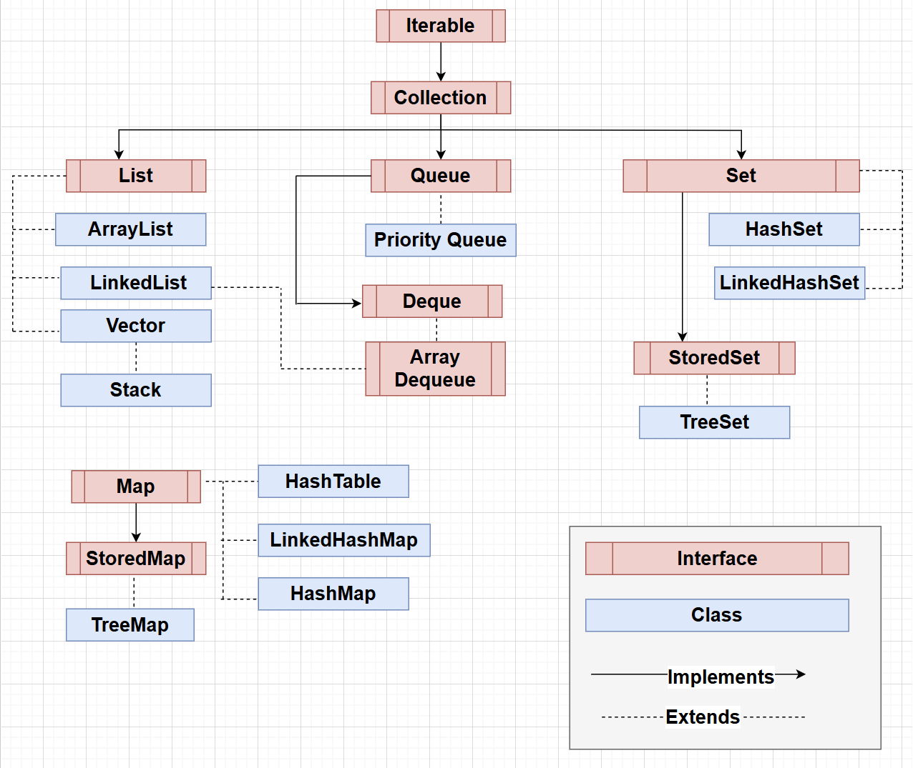

* + - **Syntax to create an ArrayList in Collection API, add elements and print array values: (Simple Way)**

// Create object of ArrayList reference of Collection without declaring its type(int, float, etc.).

Collection objectName = new ArrayList();

// Add values to the list using add() method. These values are not actually numbers but these are object types.

objectName.add(value_1); // Value is objectType not a dataType value

objectName.add(value_1);

// Printing vales directly using objectName

SOUT(objectName);

For this way we cannot fetch the data from the list using loops or iteration statement while we define Collection with simple way because the simple way syntax we use to define a Collection is store the object type value not a number type value so that we cannot store it in the integer value.

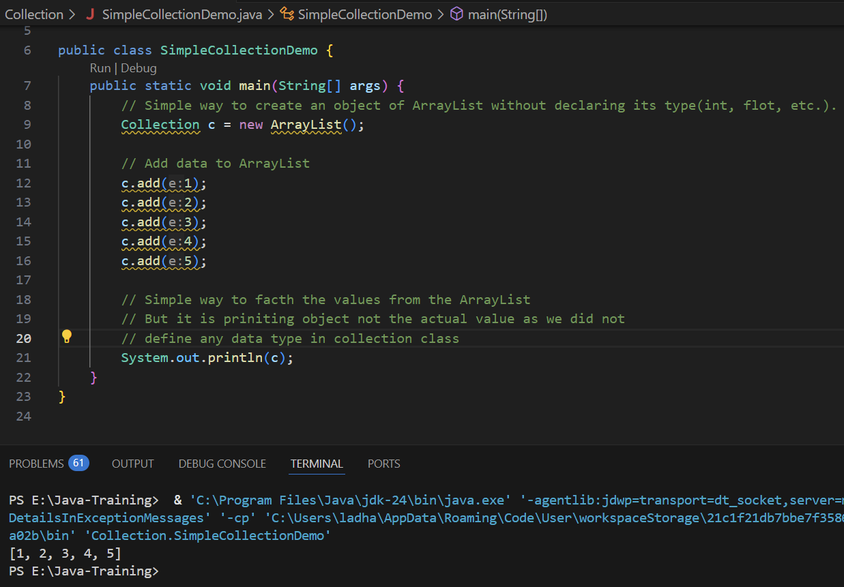

* + **Collection with ArrayList():**
    - To overcome this issue, use below syntax all time while we Create an object of any collection. We need to define a dataType while we create an object of any Collection class. While we create an object of Collection class that time we need to add the Data type wrapper class name between <>: Collection is normally work with the objects
      * **Syntax:**

Collection <DataTypeWrapperClassName> objectName = new CollectionClassName< DataTypeWrapperClassName>();

* + - * **Example:**

Collection<Integer> nums = new ArrayList<Integer>();

* + - While we use Collection, we need to impoet Java.util.Collection package.
    - While we use above syntax, now we can use iteration statement to fetch the values and now whatever the values we will store, it will be actual value and not an object.
    - If we just want to store and the fetch the values then Collection is the best option but if we want to play with index then List is the best option.

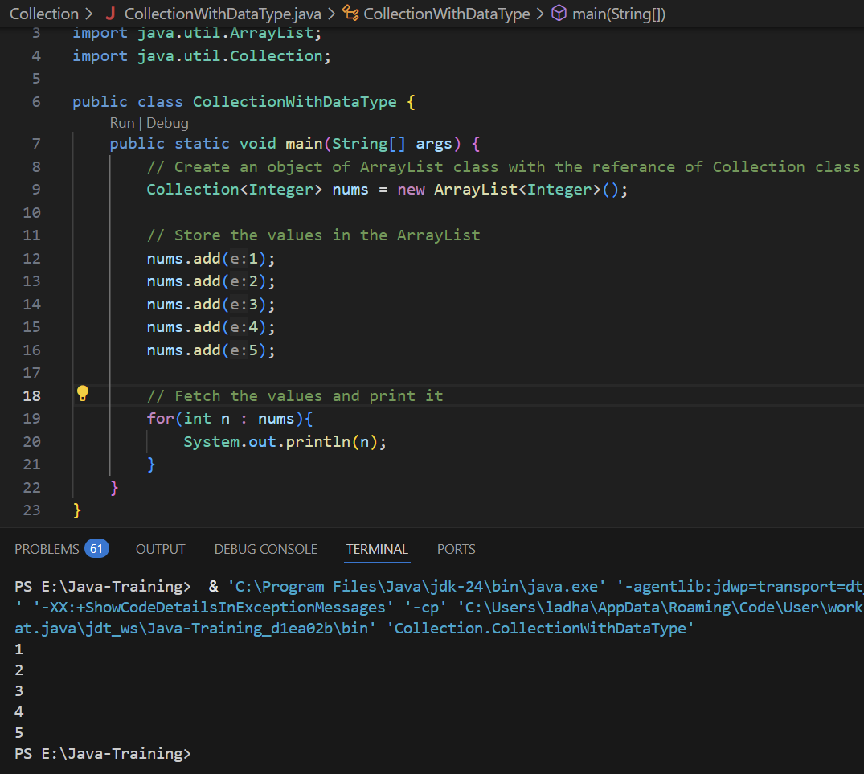

* + **List with ArrayList():** 
    - If we just want to store and the fetch the values then Collection is the best option but if we want to play with index then List is the best option.
    - When we use ArrayList, we need to import java.util.ArrayList package
    - List also supports duplicate values while Set only supports Unique value.
      * **Syntax:**

List <DataTypeWrapperClassName> objectName = new CollectionClassName< DataTypeWrapperClassName>();

* + - * **Example:**

List<Integer> nums = new ArrayList<Integer>();

* + - List have some method too. Check in below example:

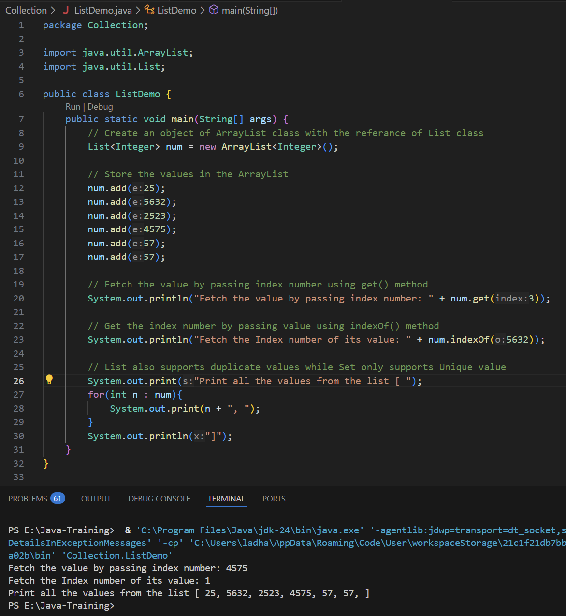

* + - Another way to add elements to Array List is use method asList() from Arrays class.
    - While we use **asList()** method, we can add elements same time when we will create an object of **ArrayList** and for printing the elements, simply we just have to pass object of Arrays List in the print statement. Also we have to **import java.util.Arrays** package. See the syntax below:
    - **Syntax:**

import java.util.Arrays;

List<DataType> objectName = new Arrays.asList(value1, value2, value3,…,valueN);

SOUT(objectName);

* + - **Example:**

List<Integer> nums = Arrays.asList(4, 564, 54, 45, 5, 36, 56, 58, 45);

System.out.println(nums);

// Output: [4, 564, 54, 45, 5, 36, 56, 58, 45]

* + **Set with HashSet():** 
    - While we want to store all the unique values in the list then Set is the best option.
    - **As in List we can store duplicate values also, in the List we cannot store duplicate values.**
    - While we use HashSet with Set, we need to import java.util.HashSet package and java.util.Set package.
    - Set does not sorted the values as well as does not support index value due to it does not store duplicate value.
    - Set is a collection of unique value, it does not have any index value.
    - In the below example, we can clearly see that the duplicate element ‘57’ cannot store and it will store only one time, and values are also not in sequence which we had stored.

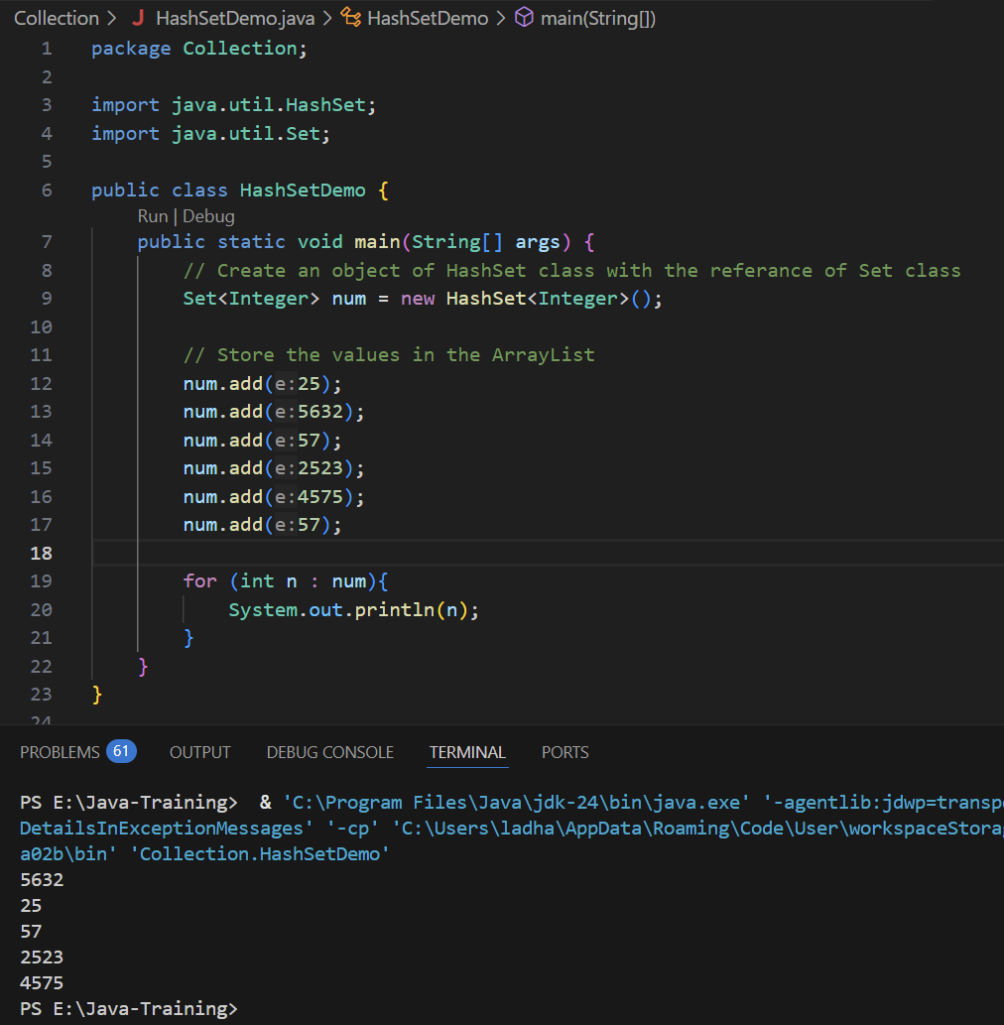

* + **Set with TreeSet():** 
    - Same as HashSet, TreeSet also cannot store duplicate elements but in the TreeSet, in whatever sequence we store the value, it will short it automatically.
    - While we use HashSet with Set, we need to import java.util.TreeSet package and java.util.Set package.
    - **TreeSet class is extends AbstractSet and implements NavigableSet. NavigableSet interface extends SortedSet which use to do sorting the elements.**
    - **We can also use Collection instead of Set**
      * **Collection<Integer> num = new TreeSet<Integer>();**

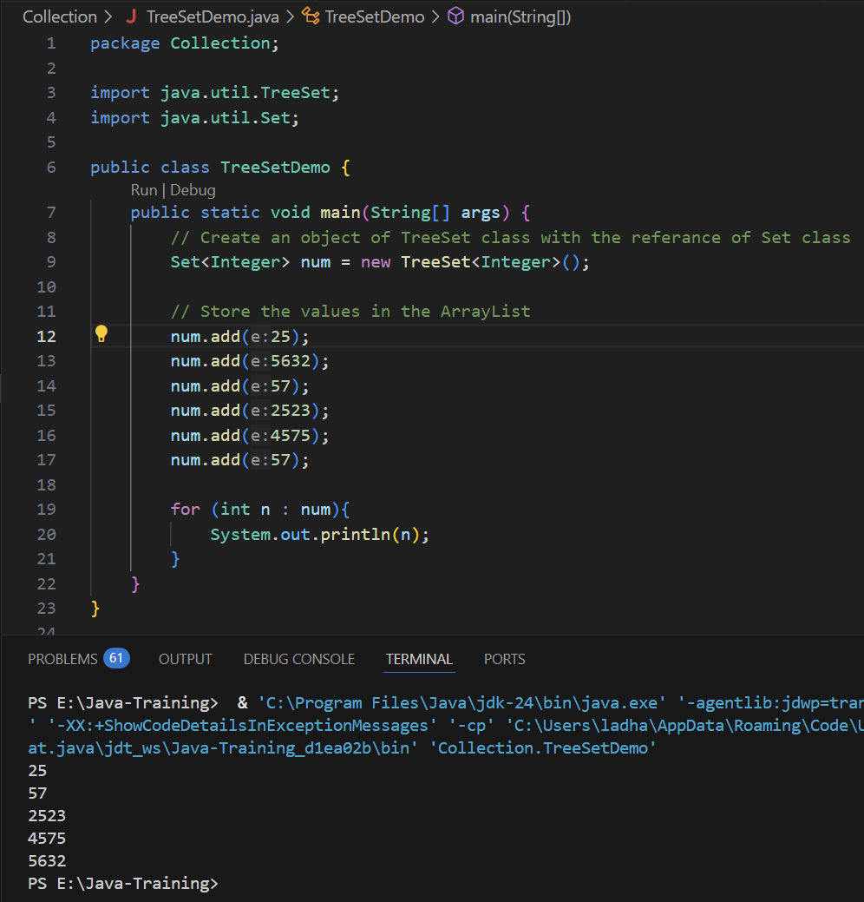

* + **Use Iterator with TreeSet():** 
    - In the above examples, we have For loop for iterations instead of that we can also use iterator() method of Iterator class to perform the same operation and use next() method to get next element. We need to put next() method into while loop using hasNext() method. Follow the syntax below:
    - **Syntax:**

Collection/Set/etc.<dataType> collectionObjectName = new CollectionClassName<dataType>();

Iterator<dataType> iteratorObjectName = collectionObjectName.iterator();

iteratorObjectName.next(); // This will give you next element but it will only give one element and if we want to fetch all the values then we need to put it in while loop

while(iteratorObjectName.hasNext()){

SOUT(iteratorObjectName.next());

}

* + - **Example:**

Collection<Integer> collectionNums = new TreeSet<Integer>();

Iterator<Integer> iteratorValue = collectionNums.iterator();

while(iteratorValue.hasNext()){

SOUT(iteratorValue.next());

}

* + - This will also not store duplicate values and do sorting.
    - We can Iterator with any other collection classes also.

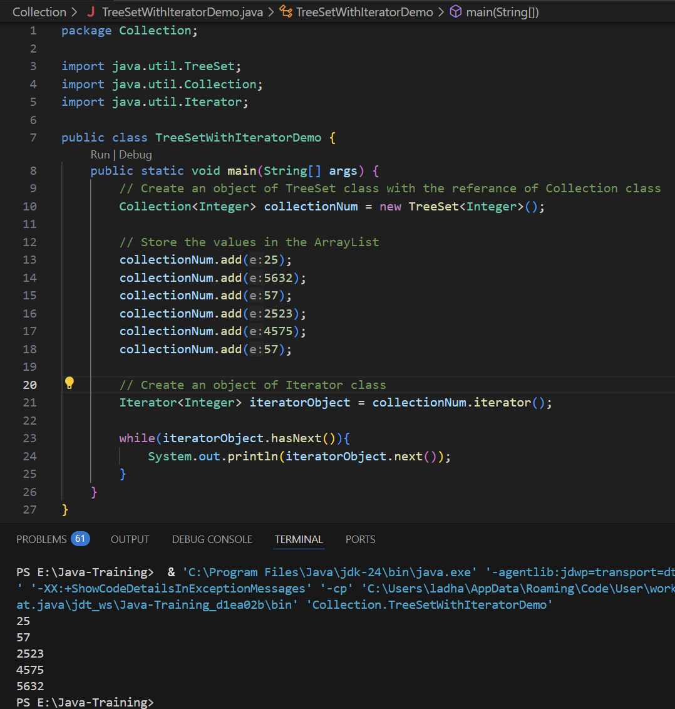

* + **Map:**
    - **Map does not belong to Collection interface but it is a part of Collection concept.**
    - The use of Map is, While working with a list of elements using List, ArrayList, or TreeSet, we typically access values by their index (e.g., 0, 1, 2, 3, ...). However, sometimes we need to assign meaningful names instead of numeric indexes. In such cases, we use a Map, which stores data as key-value pairs.
    - Map is collection of Key and Value pair and Map itself is an Interface.

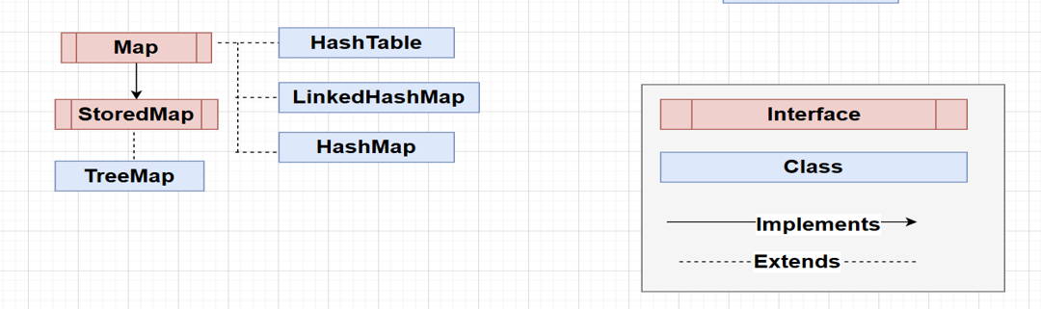

* + - **While we are defining a Map, we need to pass the dataType in the combination of Key and Value. We can use any combination of data types in the Key and Value. Its all depends on the code requirement. Follow the syntax below:**
    - **While we use Map with HashMap, we need to import java.util.HashMap package.**
    - **While we store values into HashMap, values will not be stored in the sequence same as we pass.**
    - **In the Map, key cannot be repeated but we can pass duplicate value of different keys.**
    - **Syntax:**

// Create an object of HashMap by taking Map class reference

Map<keyDataType, valueDataType> mapObjectName = new HashMap<>();

// Add values in the HashMap

mapObjectName.put(keyValue, valueValue);

// Print whole Map values

SOUT(mapObjectName);

* + - **Example:**

// Create an object of HashMap by taking Map class reference

Map<String, Integer> students = new HashMap<>();

// Add values in the HashMap using put() method.

students.put(“Harsh”, 23);

students.put(“Ashik”, 03);

// Print whole Map values

SOUT(students);

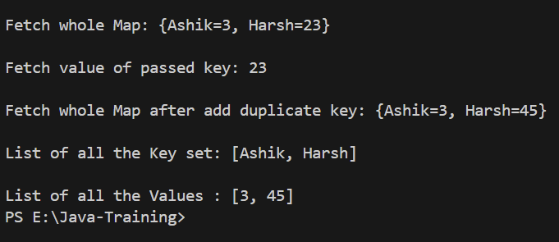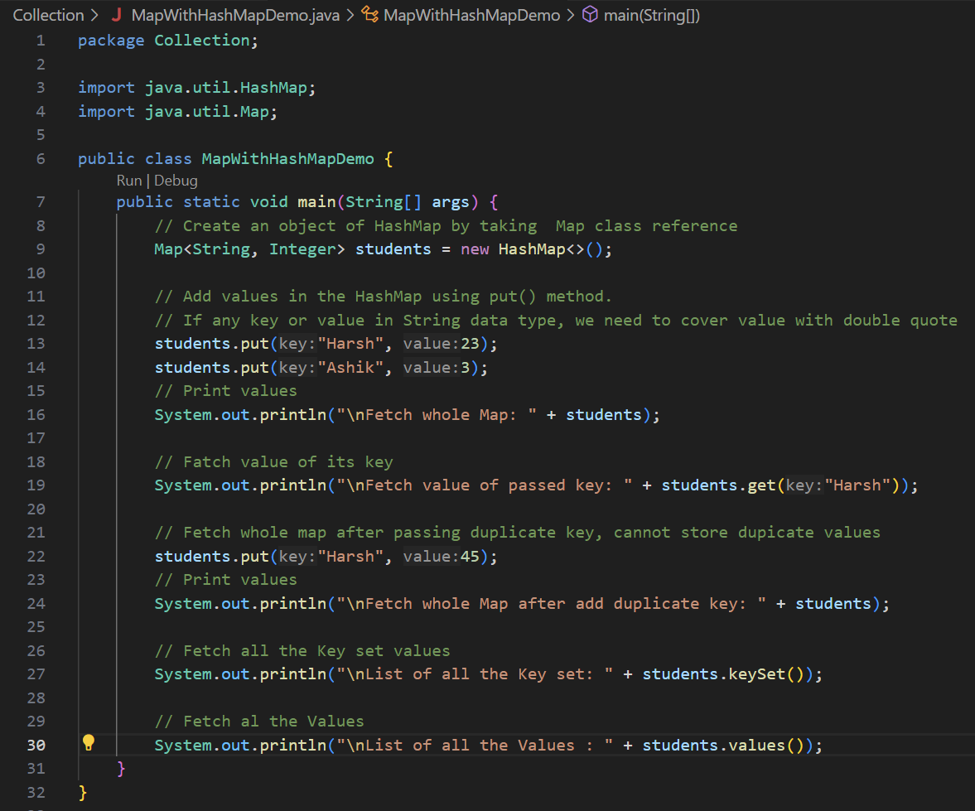

* + - To store the values into the Map, we need to use put() method.
      * mapObjectName.put(key, value);
    - To fetch the particular value with the help of its key, we need to use get(keyValue) method
      * mapObjectName.get(keyValue);
    - To fetch all the key set, we need to use keyset() method
      * mapObjectName.keyset();
    - To fetch all the Valus, we need to use values() method
      * mapObjectName.values();
    - In the Map, we can not pass duplicate Key but we can pass duplicate values to different keys.
      * If we pass {“Harsh”, 23} key-value and if we again pass {“Harsh”, 45}. So, it will replace {“Harsh”, 23} with {“Harsh”, 45} and store {“Harsh”, 45} key-value.
      * As per this, we can say that keys are Set and values are List here. So Map is the combination of List and Set.
    - Fetching the Kay and Values using for-loop in Map.

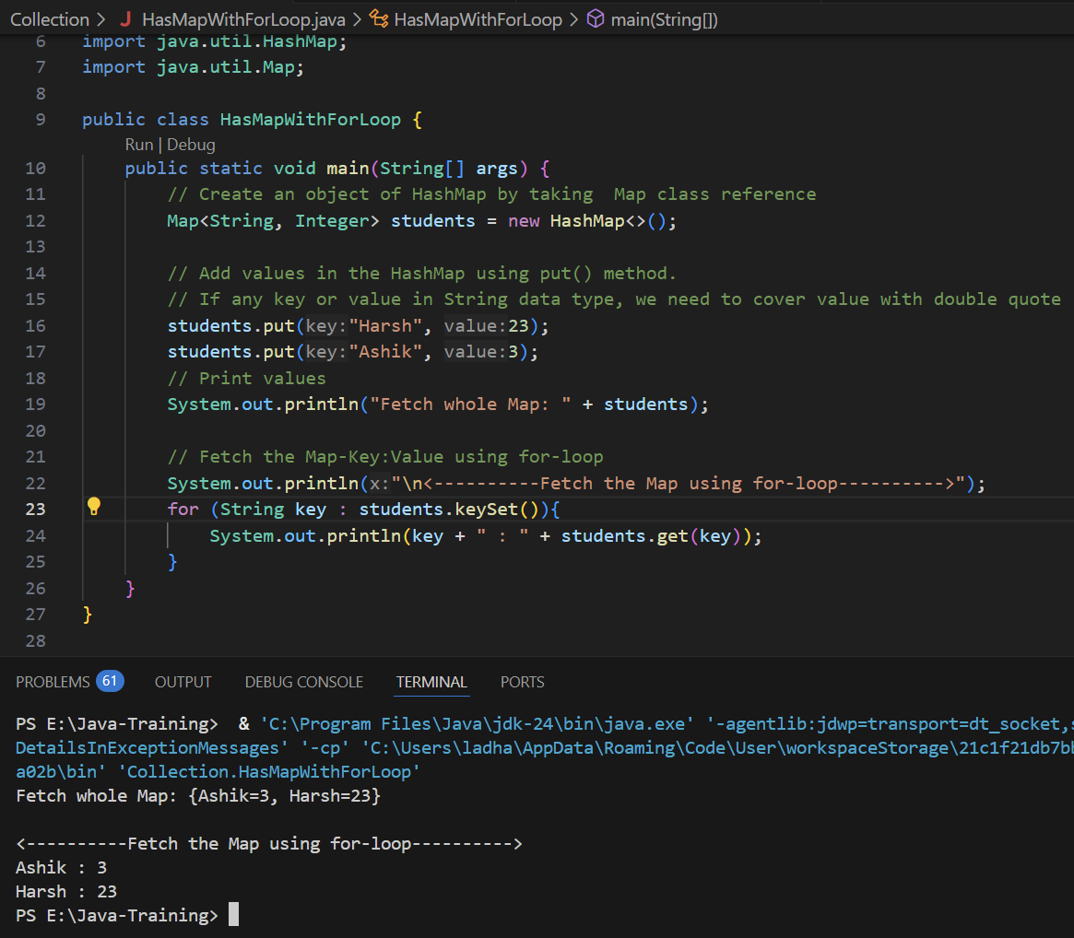

* + - In the given code, the for loop is used to iterate over the keys of the HashMap named students. The expression students.keySet() returns a set containing all the keys (i.e., the student names) stored in the map. The loop goes through each key one by one, and for each key, it retrieves the corresponding value (such as the student’s ID or age) using students.get(key). Inside the loop, the key and its associated value are printed in the format key : value. This approach provides a simple and effective way to access and display all entries in a HashMap using a traditional for-each loop.
  + **HashTable vs HashMap:**
    - **Thread Safety:**
      * Hashtable is thread-safe because all its methods are synchronized.
      * HashMap is not thread-safe unless you explicitly synchronize it.
    - **Performance:**
      * HashMap is generally faster because it doesn't have the overhead of synchronization.
      * Hashtable is slower due to synchronized methods.
    - **Null Keys and Values:**
      * HashMap allows one null key and multiple null values.
      * Hashtable does not allow null keys or null values.
    - **Legacy Status:**
      * Hashtable is a legacy class, introduced in Java 1.0.
      * HashMap is part of the Java Collections Framework, introduced in Java 1.2.
    - **Iterator Behavior:**
      * HashMap uses a fail-fast iterator, which throws ConcurrentModificationException if modified during iteration.
      * Hashtable uses a non-fail-fast Enumeration, which is not as robust.
    - **Preferred Use:**
      * HashMap is preferred in modern applications for non-threaded environments.
      * Hashtable is mostly discouraged and replaced by ConcurrentHashMap in multi-threaded use cases.

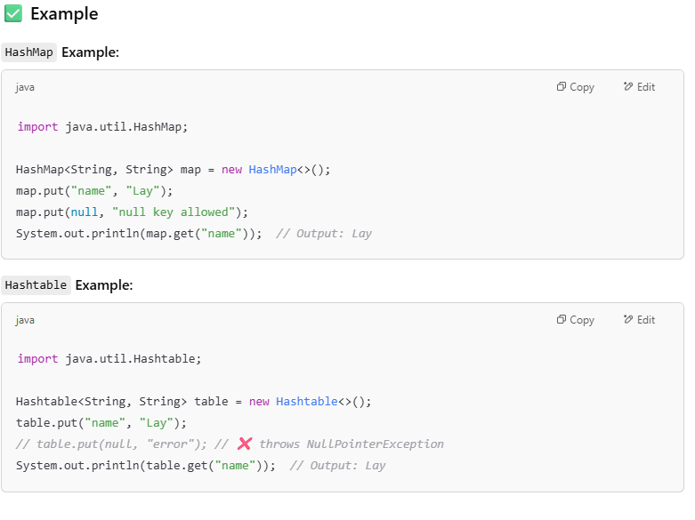

* **Comparator vs Comparable:**
  + **Simple Default way of sorting:**
    - In the simple way of sorting, first, we can define one List<> of ArrayList<>
      * List<dataType> objectName = new ArrayList<dataType>(); OR
      * List<dataType> objectName = new ArrayList<>();

**Here we have added data type besides List and also there is another <> brackets besides ArrayList in which we need to add same data type as we added besides List<> but in the new Java version, we just have to pass the data type besides List and we can keep empty <> brackets besides ArrayList<>.**

* + - * List<dataType> objectName = new ArrayList<>();

**List<Integer> nums = new ArrayList<>();**

* + - After define the List, we need to add the elements inside the List using add() method.
      * objectname.add(value);

nums.add(1); nums.add(43); nums.add(76); nums.add(86);

* + - For sorting, we need to use sort() method from Collection class and need to pass List object inside the method and we can simply print it.
      * Collection.sort(listObjectName);
      * SOUT(listObjectName);

Collection.sort(nums);

SOUT(nums);

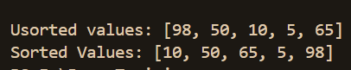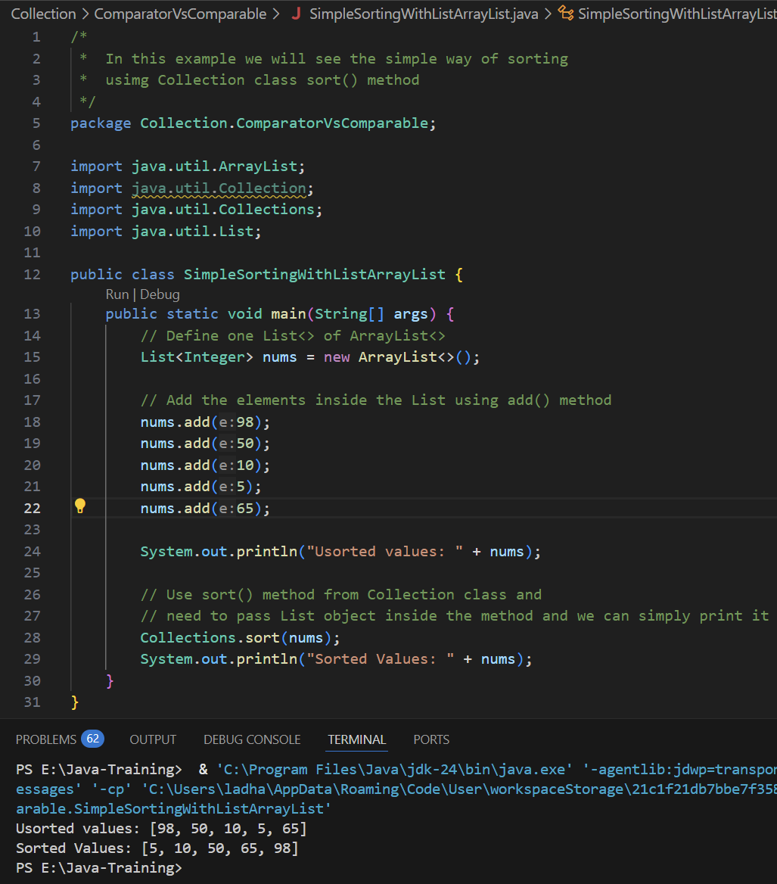

* + **Comparator:**
    - **In the above example, it is a default way of sorting the elements of the list but what-if, if we want to develop our own logic and create user defined way or custom way to sorting the elements then we need to use the Comparator.**
    - Comparator is an interface and to use it we can either create a child class that will implements Comparator interface or we can create an anonymous class and **need to use compare() method for implementation**.
    - **Syntax: by creating anonymous class**

Comparator<dataType> objectName = new Comparator<dataType>() {

// Use compare() method to compare the values

public int compare(Integer i, Integer j){

// Add logic for sorting

}

};

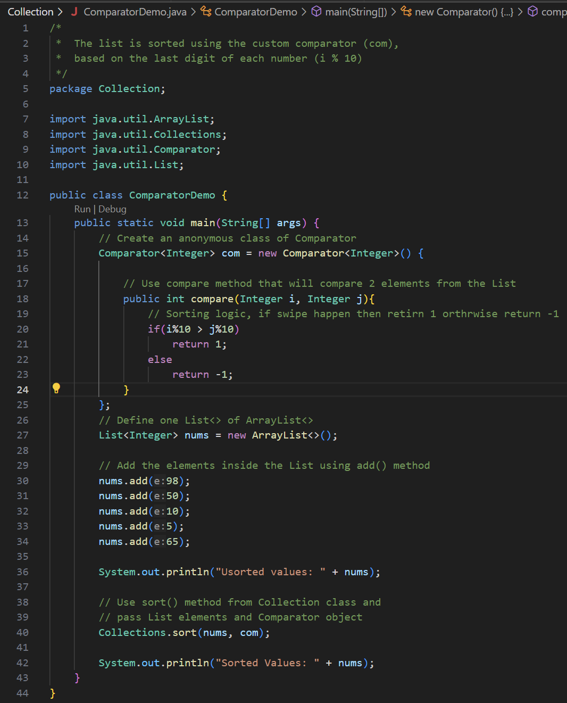

* + - In the above code, we implemented custom sorting method which will sort the elements based on the last digit of the number using Comparator.
    - This Java program demonstrates sorting a list of integers based on their last digit using a custom Comparator. An anonymous class implements the Comparator interface and overrides the compare method to compare integers by i % 10. A list of integers is created and populated, then sorted using Collections.sort(nums, com), which applies the custom logic. The result is a list sorted in ascending order based on the last digit of each number.
    - **Comparator is an interface and a concept using that we can specify our own logic or create a custom logic for sorting.**
    - 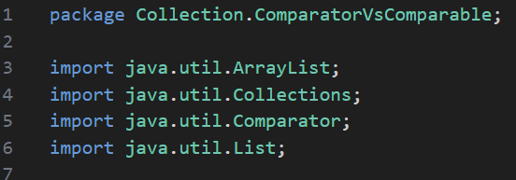We can also use Comparator with the custom created List such Student list which have Age and Name. We can also perform sorting using Comparator by applying our custom logic. See the example below:

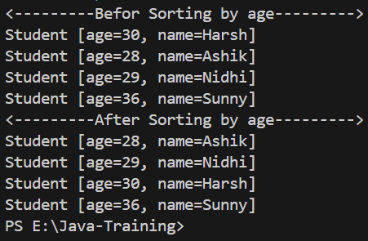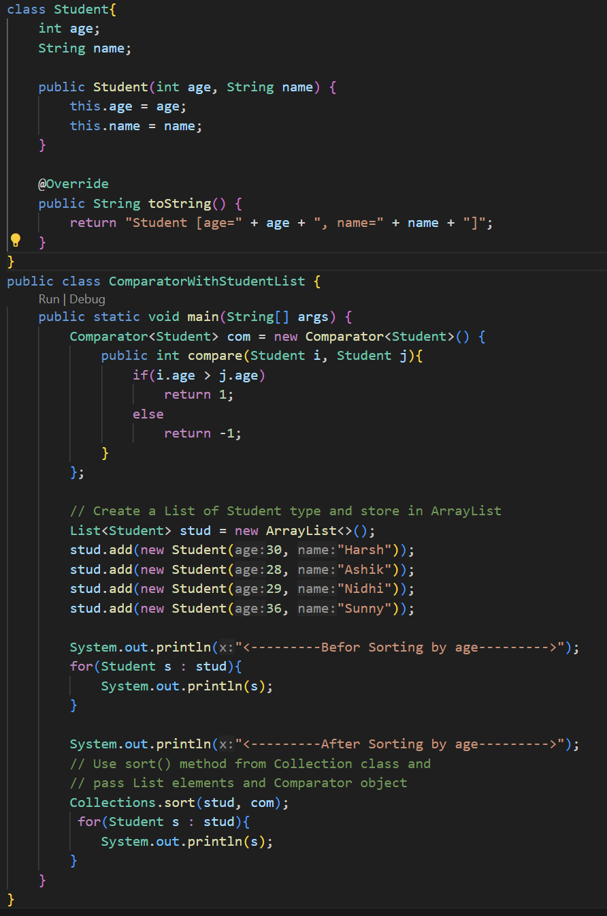

* + - Comparator is a Functional Interface so that we can also use Lambda expression while implementing it.

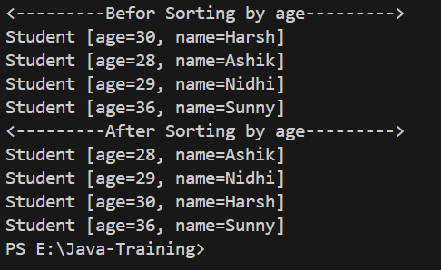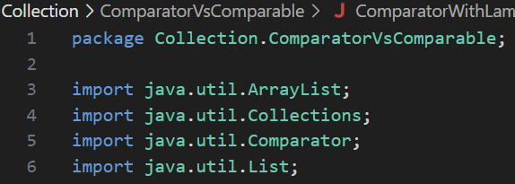 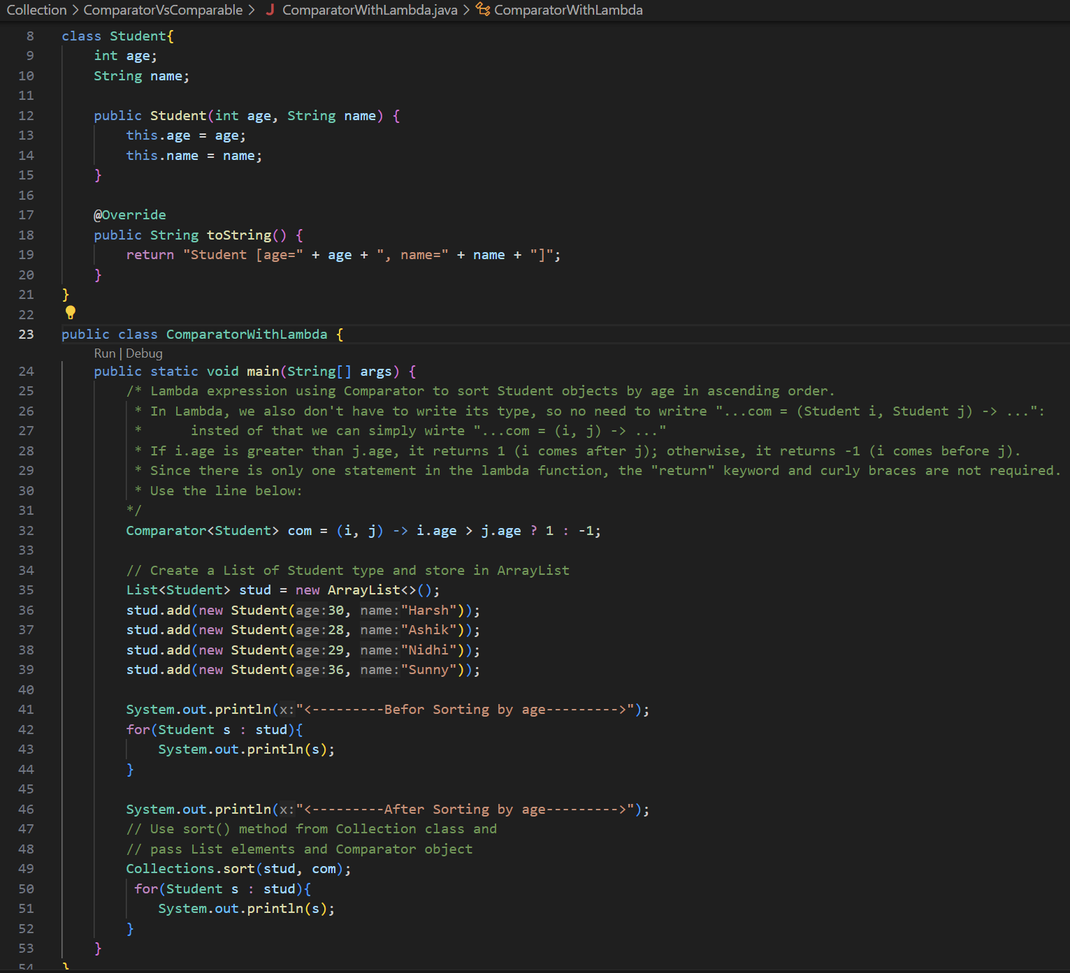

* + **Comparable:**
    - If we want to have a natural sorting then we need to use Comparable.
    - In Comparable, we need to implements Comparable interface and use compareTo() method.
    - If we use Comparable and implements interface Comparable, we can still overrides the logic of the Comparable using Comparator.

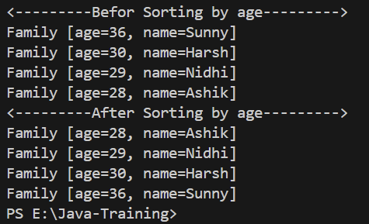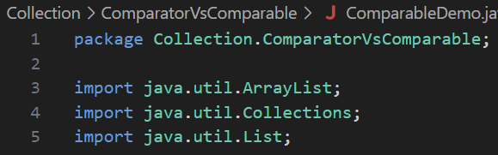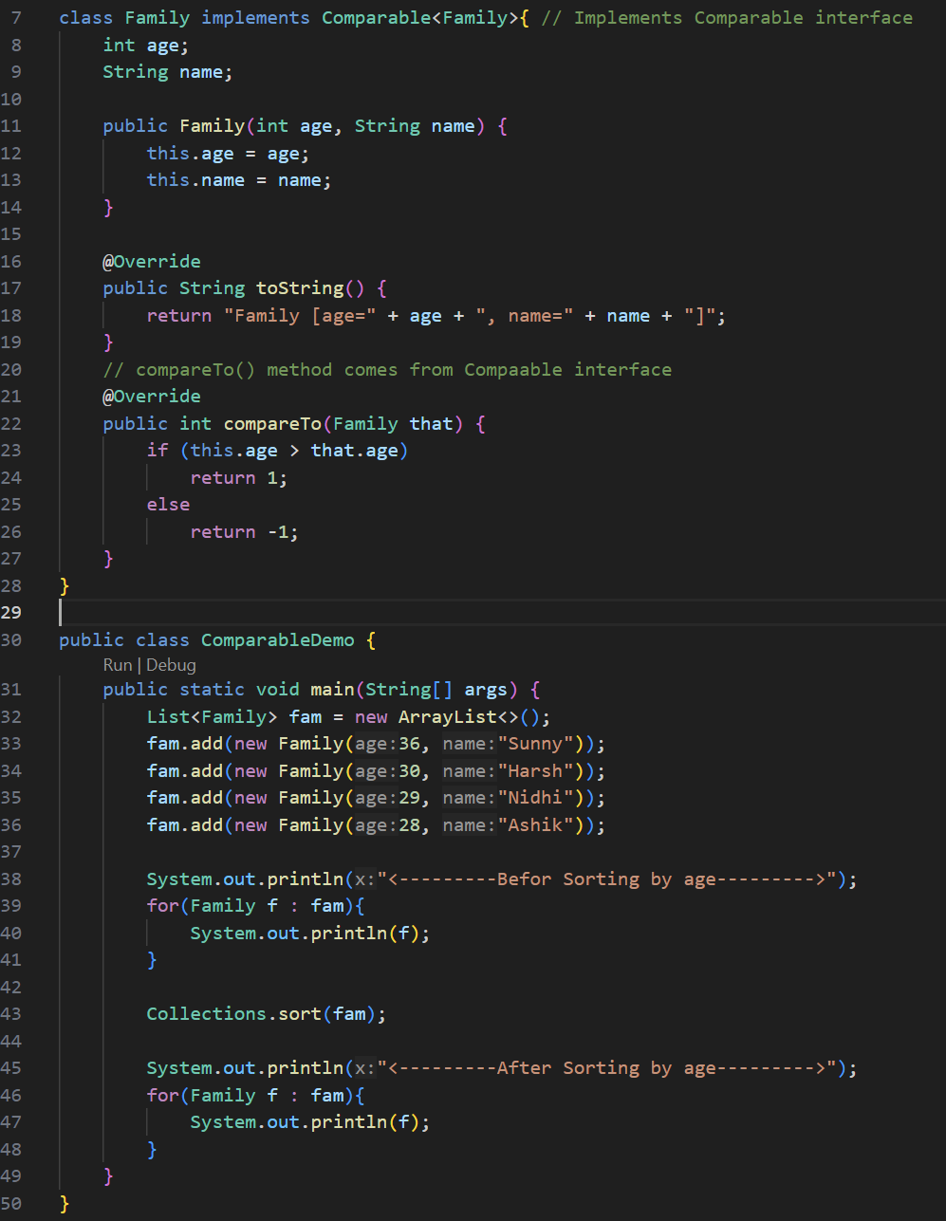

|  |  |
| --- | --- |
| **Comparator** | **Comparable** |
| If you want to specify on which logic you want to sort the elements, we can use Comparator. | If you want to give a power to class itself, or to compare itself or to compare its objects itself then we can use Comparable. |
| It is a Functional interface with have only one method*:* ***int compare(T o1, T o2);***  So, we can use Lambda expression with it. | Comparable is a normal interface which have **public int compareTo(T o);** method. |
| It comes under java.util package. | It comes under java.lang package. |
| Custom or multiple sorting (e.g., by name, date) | Natural sorting needed (e.g., by ID) |
| Sorting logic location is in a **separate class or inline as lambda** | Sorting logic location is in the **class itself** |

* ***for-each* Loop Method:**
  + for-each Loop Method is part of the List<> Interface
  + In for-each() method, it will give you one value at a time and we can perform whatever operation we want on the element.
  + **It does not work with simple Array.**
  + It is only work with Collection framework or any class which implements the Iterable interface such as List, Set, Queue, Map, Streams, etc.



* **Stream API:**
  + Stream API introduced in the Java v1.8.
  + It is an interface which provides multiple methods